Author1 Name: Grace P. Busch; Author2 Name: Evaline S. Cantarero; Author3 Name: Jackson S. Davis; Author4 Name: David P. Nowicki
FAMU-FSU College of Engineering 2525 Pottsdamer St. Tallahassee, FL. 32310

Team 505: RASSOR Arm
4/12/2022

Abstract
The RE-RASSOR project is a mining rover designed for STEM education. The project is based on NASA’s RASSOR that mines soil on different planets and moons. They both feature two rotating drums hinged to the body with a shoulder joint and arm. The drums spin from opposite sides allowing the rover to collect samples. As space exploration expands, this movement is crucial to excavate in locations with low gravitational forces.

The Florida Space Institute and NASA have appointed a team from the FAMU-FSU College of Engineering to design the shoulder joint and arm. The shoulder joint is responsible for moving the arm to the desired position during mining, transporting heavy loads, and adjusting the drums to travel through tough terrain. The goal is a light, inexpensive, and durable design that is cohesive to the rest of the rover. The project includes the design and selection of housing, gear box, motor, bearings, materials, and arm.

To make the rover affordable and accessible for schools, most parts need to be 3D printed. This ensures it is replicable and budget friendly (cost of supplies is $60). Since filament is fragile, the design will need to focus on the structural integrity of the housing, gearbox, and arm. The optimal weight of the design will allow it to be sturdy yet functional. Because filament is not optimal for bearings, bolts, and motors, they will be outsourced and selected based on their price and availability. The gearbox design needs to achieve the required torque from the motor to mobilize itself with added loads. The arm must withstand the loads and stressors that come with 270 degrees range of motion. A successful design will provide the necessary torque, range of motion, and support to perform its tasks with the given budget and power.

Keywords: RASSOR, RE-RASSOR, shoulder, NASA, FSI, regolith, gearbox, gears

Acknowledgement

- We would like to extend a big thank you to our sponsor for this project, Mr. Michael Conroy, who has been extremely helpful and responsive throughout this whole project. Without his help we would not have been able to find a high-level solution to this problem.
- Dr. Patrick Hollis has been a huge help with the technical aspects of our designs. He taught all of us many crucial skills needed for this project in his Mechanical Systems II class and starting with a high level of understanding about gear trains and failure modes made this project far smoother.
- Dr. Shayne McConomy has put in a great deal of effort to make sure that all members understand the engineering design process and he was also responsible for connecting us with the FSI so that we could tackle this problem for our senior design project.

Table of Contents
Abstract 1
Acknowledgement 2
Table of Contents 3
List of Tables 5
List of Figures 6
Notation 7
Chapter One: EML 4551C 8
1.1 Project Scope 9
1.2 Customer Needs 11
1.3 Functional Decomposition 18
1.4 Target Summary 23
1.5 Concept Generation 27
Concept 1. 28
Concept 2. 28
Concept 3. 28
Concept 4. 28
Concept 5. 29
Concept 6. 29
Concept 7. 29
Concept 8. 29
Concept 9. 29
Concept 10. 29
Concept 11. 29
Concept 12. 29
Concept 13. 29
Concept 14. 29
Concept 15. 29
Concept 16. 30
Concept 17. 30
Concept 18. 30
Concept 19. 30
Concept 20. 30
Concept 21. 30
Concept 22. 30
Concept 23. 30
Concept 24. 30
Concept 25. 30
Concept 26. 31
Concept 27. 31
Concept 28. 31
Concept 29. 31
Concept 30. 31
Concept 31. 31
Concept 32. 31
Concept 33. 31
Concept 34. 31
Concept 35. 31
Concept 36. 32
Concept 37. 32
Concept 38. 32
Concept 39. 32
Concept 40. 32
Concept 41. 32
Concept 42. 32
Concept 43. 32
Concept 44. 32
Concept 45. 32
Concept 46. 32
Concept 47. 33
Concept 48. 33
Concept 49. 33
Concept 50. 33
Concept 51. 33
Concept 52. 33
Concept 53. 33
Concept 54. 33
Concept 55. 33
Concept 56. 33
Concept 57. 34
Concept 58. 34
Concept 59. 34
Concept 60. 34
Concept 61. 34
Concept 62. 34
Concept 63. 34
Concept 64. 34
Concept 65. 34
Concept 66. 34
Concept 67. 34
Concept 68. 35
Concept 69. 35
Concept 70. 35
Concept 71. 35
Concept 72. 35
Concept 73. 35
Concept 74. 35
Concept 75. 35
Concept 76. 35
Concept 77. 35
Concept 78. 36
Concept 79. 36
Concept 80. 36
Concept 81. 36
Concept 82. 36
Concept 83. 36
Concept 84. 36
Concept 85. 36
Braking: 36
Concept 86. 36
Concept 87. 36
Concept 88. 37
Concept 89. 37
Concept 90. 37
Concept 91. 37
Concept 92. 37
Concept 93. 37
Concept 94. 37
Concept 95. 37
Concept 96. 37
Concept 97. 37
Concept 98. 37
Concept 99. 38
Concept 100. 38
1.6 Concept Selection 41
1.8 Spring Project Plan 49
Chapter Two: EML 4552C 49
2.1 Spring PlanRestated Project Scope 50
Project Plan. 50
Build Plan. 50
Appendices 51
Appendix A: Code of Conduct 51
Appendix B: Functional Decomposition 55
Appendix C: Target Catalog 56
￼Appendix D: Concept Selection 58
Appendix E: Figures and Tables 77
References 85
Appendix E: Operations Manuel 86
Appendix F: Engineering Drawings 86
Appendix G: Calculations 86
Appendix H: Risk Assessment 86

List of Tables
Table 1: Customer Responses and Interpreted Needs ………………......……………….6
Table 2: Functional Decomposition Cross Reference Chart……………...…...……….13
Table 3: Targets and Metrics Table………...…………….............……………………19
Table 4: Medium Fidelity Concepts …………………..……………………………….31
Table 5: High Fidelity Concepts ………...…..…….………….……………………….33
Table 6: House of Quality……...…...................................................................……….35
Table 8: House of Quality……………………….…………………………………….28
T Table 7: Pugh Chart Iteration 1……………………………………………………….36
Table 8: Final Pugh Chart Iteration………………...…..…………………………….37
Table 9: Legend……………...………..……............................……………………….37
Table 10: Spring Project Plan ……………………....................……………….…….41

List of Figures
Figure 1: Functional Decomposition Hierarchy Chart ……………………………….12

Notation
FSGC | Florida Space Grant Consortium
FSI | Florida Space Institute
NASA | National Aeronautics and Space Administration
RASSOR | Regolith Advanced Surface Systems Operations Robot
UCF | University of Central Florida
R | Number of Teeth of Ring Gear
H | Number of Teeth of Harmonic Gear
P | Number of Teeth of Planet Gear
S | Number of Teeth of Sun Gear
N | Number of Teeth
OD | Outer Diameter
PD | Pitch Diameter
BD | Base Diameter
BR | Base Radius
RD | Root Diameter
M | Module
A | Addendum
D | Dedendum
RPMy | Revolutions of Planet Carrier
RPMr | Revolutions of Ring Gear
RPMs | Revolution of Sun Gear
RPMp | Revolution of Planet Gear
RPMh | Revolution of Harmonic Gear
PA Pressure Angle
CTT Circular Tooth Thickness
WD Whole Depth
FR Filet Radius
Pi 3.14
t Position
NPG Number of planetary gears
X Distance measurement
FT Test Force
FS Spring Force
K Spring Constant
Delta_X Difference Between Distance Measurements
FM Force of Motor
W Weight
D Distance
Acc Acceleration
Nm Newton Meter
N Newton
mm Millimeters
m Meter
kg Kilograms
τ Torque
g Acceleration Due to Gravity
l Length
s Seconds
F Force

Chapter One: EML 4551C

1.1 Project Scope
Project Description
The RE-RASSOR project has been extended to both FAMU-FSU College of Engineering and the University of Central Florida (UCF) from the Florida Space Institute (FSI). The project is to design a scaled-down and more affordable version of the Regolith Advanced Surface Systems Operations Robot (RASSOR) that is currently in development at NASA’s research facility, Swamp Works. The project is broken up amongst multiple student teams with UCF, and our team at FAMU-FSU College of Engineering. Our focus is to design the shoulder blades that hold the shoulder in place, the shoulder joint housing that fits in between the shoulder blades and holds the motor and gearbox, and the gearbox. All components makeup the shoulder joint assembly which will serve as a connection between the body of the rover and its mechanical arm that can withstand a large amount of torque and stress.

Key Goals
Our goal for this project is to redesign and build a fully functioning prototype of the shoulder joint between the main body and excavation implement of the NASA RE-RASSOR. We aim to make the lightest combination of motor, gearbox, housing, and arm that is still able to withstand the loads, vibrations, and wear associated with mining on low gravity planets and moons. Another goal is to have as many components as possible will be 3D printed. We will also 3D print an arm that can withstand high amount of torque, stress, and to be able to lift as much weight as a 3D printed arm can.

Market
The RE-RASSOR is a project enlisted by NASA to FSI to be used on other planets. The primary market includes some big names such as NASA, Space X, Blue Origin, Lockhead Martin, and STEM Education while our secondary market is geared to companies actively pursuing space exploration. The robot is made for companies that are trying to export materials from the planets and build infrastructure for future colonization. The rover is also catered to the Florida Space Grant Consortium as the rover will be designed for education as well to help future teams and students expand the knowledge that we gain.. NASA wants a smaller and more affordable version of the RASSOR to mass produce the product and have multiple of them exploring new environments. This will help further our knowledge about the surface environment of new planets and moons.

Assumptions
From our meeting with our sponsor, Michael Conroy, we developed our assumptions to guide and focus our project. . First, there is no specific weight that the arm is required to lift, therefore we are testing to find the limits of our design. The materials we choose will be tested to see which is the strongest for handling the forces it will be experiencing in operation. Additionally, the materials and components will only need to be able to handle the environments of Earth. The system will not be seeled because we are assuming that our tests will not involve sand or grit. Our design is not strictly restricted to the joint housing provided but all components should be designed to fit within the housing. If our design cannot fit within the housing then we will talk with Michael about changing the housing design. We are assuming that all motion will be performed on a 2 dimensional x-y-plane.The system will be operated by an Arduino kit. The system is assumed to also run at 12 Volts.

Stakeholders
Some stakeholders in the development of this product are Florida Space Grant Consortium (FSGC), Florida Space Institute (FSI), and the National Aeronautics and Space Administration (NASA). Other stakeholders include Michael Conroy, Dr. Hollis, Dr. McConomy, Jayson Dickinson, and other companies actively pursuing space exploration.

1.2 Customer Needs
Interpreted Needs
The customer wants us to redesign the shoulder housing, gearbox, motor, arm, and wiring of the RE-RASSOR project. This means looking over the past NASA designs and seeing what can be improved. Some aspects of the design were good, just too expensive; for example, the gearbox cost $1,000. Therefore, the customer just wants a cheaper, smaller, and simpler design for these parts. Meeting the budget of this project ($60 for our final product, $1000 for the entire rover) means using readily available parts, or low-cost manufacturing techniques. These could keep costs down, but we have a time constraint, thus limiting us to select processes. The customer also stated that he wants as many of the parts to be 3D printed as possible for easy replication and prototyping from future groups. This will help us with the cost aspect as we already have access to printers and filament is inexpensive. Parts that can be excluded from 3D printing are the bearing, screws, motor, and anything else that may need to hold more load than plastic can support. These parts he wants to try to be bought on amazon to try to keep the cost down. The gears can be 3D printed like the past design; however, if it is easier and cheaper to just buy them then that is the approach we will take.
The problem the customer needs us to solve is lifting the arm with full drum weight and holding it in that position as well as moving it up and down for mining tasks. The drum weight will be calculated by getting the dimensions of the drum, what material NASA used, and then calculating out how much it will weigh. Once the weight is found, we need to design the arm and shoulder so that it can structurally support that load, and we will need to create a gearbox and motor combination that will be capable of moving that weight with ease. The arm only needs to rotate at “slow angular velocities” which we interpreted as somewhere between one radian per second and 0.2 radians per second. The faster the arm moves the stronger we will have to make it. Besides looking at the weight and force on the arm, the speed of the rotation of the drum will be needed to determine the torque on the arm while mining. This will be found by looking at the type of motor that is used in the bill of materials. Another aspect our customer wants us to focus on is the wire placement. The simple design is to do the wiring externally but preferably it would be wired internally. Looking over the whole arm design, shoulder design, gearbox placement, and motor placement will help find a solution to where the wires should be routed.
Our customer wants us to design for an Earth environment, not space or the environment that exists on either Mars or the Moon. Furthermore, we don’t need to design for extreme earth environments such as subzero temperatures of the poles or the dry high heat of the desert. We just need to design for indoor room temperatures and at the worst consider the temperature experienced out in a parking lot. The shoulder design will not encounter any external debris during testing and so using standard sealed bearings will be the extent of the system sealing needs. NASA’s RASSOR is being designed to be launched into space and will have to handle multiple G’s when it is launched. However, we are not designing for launch or reentry and will not consider it when we test our design. What the shoulder joint should be designed for is only the acceleration of Earth’s gravity,
Focusing more on the overall design we do not have a weight restriction. Our design is focused on function over weight; if the weight of the design inhibits the performance, then we will redesign to accommodate. Another element we have much freedom over is the arm’s dimensions which can play a part in how much the mechanism can lift. The arm’s dimensions will be constrained by the wheel and drum bucket at the end of the arm. The diameter of the drum with respect to the wheels will be the main constraints that determine the length of the arm. We can also take away or add elements to the arm in order to strengthen the arm as long as it is a similar design to the original. We have full rule over the materials of the arm as well and can make it out of whatever we need in order to strengthen it if necessary. However, the preferred material is plastic or composite 3D printing filament. Any changes we do to the arm will need to be discussed with the customer before we fully dive into the redesign.

Outcome
After discussing with Mike, doing our research and talking with our advisor Dr. Hollis, we have determined that we are to design and build a means of power transmission that can work in harmony with the rest of the rover. It needs to ideally be constrained to the original design of the shoulder blade, housing, and arm; however, if needed the components can be redesigned to accommodate our power transmission system. We will 3D print all necessary elements to test the system under a load that represents the weight of the drum bucket.
Table 1: Customer Needs Questions
Number | Questions Asked | Customer Statement
1 | What parts are we redesigning? | Shoulder housing, gearbox, motor, arm, wiring
2 | Can we change wire placement? | If you could run the wires all internally yes, but it’s okay to run them externally like the old design. If it is not easy or simple they will help us figure out a way to get wires to the front of the design.
3 | How fast does the drum rotate? | Given BOM with the motor used. We can interpolate
4 | How much weight does the arm need to lift? | Dimension of the drum and figure out how much it can lift from there
5 | What was the weight at which the gearbox failed? | The gearbox did not because it was $1000
6 | Do you prefer 3D printed gears or if we can buy them? | If that is the best way then yes (but should’ve gotten the data pack that has an example gearbox in it)
7 | How many parts do you want 3D printed? | As much as we can but are able to buy any necessary parts that can’t be 3D printed (e.g. bearing, screws, motors, etc.)
8 | Are we supposed to use a specific 3D material or are we free to use any 3D material? | Our Choice
9 | Are there assembly drawings with dimensions and other specs? | Drums attached to the wheels, motors inside the wheels, and the gear ratio is 43:1 (moves slow)
10 | How many volts can we source? | 12 V (whole RASSOR but we get all 12)
11 | What are the software components that we’ll need/ what language is running the bot? | ET RASSOR (can look at it on GitHub), but the easiest way is Ardunio board
12 | Do materials have to stand up to the space environment? | No, we can use materials that work with Earth’s atmosphere and don’t need to worry about the launch environment
13 | Do we need to consider some extreme temperatures that can be found on earth? | Room temperature, parking lot temperature
14 | Is there a target weight for the assembly? | No
15 | How long should the arm be? | Set by the size of the wheel and bucket drum
16 | Are we allowed to change the design of the arm? | Keep similar design but add elements to cause more strength
17 | Can we make the arm out of other materials? | Yes, can strengthen it with other materials but the preferred material is carbon fiber filament
18 | What gravity should we design for? | Design for earth gravity
19 | What is the budget? | The whole RASSOR should be about $300 but our is around $50-$60. https://floridaspacegrant.org/program/senior-design-projects/
20 | Can we change the shoulder blade? | Check it carefully (inside body probably not an issue but the outside body got to sit down and look at because close to the wheel)
21 | How fast do we need to raise and lower the arm? | slow
22 | Maximum allowed deflection of the arm? | Deflection isn’t a problem (stay within the elastic range don’t want it to fracture)
23 | Vibrational considerations? | Don’t need to worry about it when it comes to taking off
24 | Heat/wire insulation running thru arm | Place your motor based on how it works and if you have to, later on, worry about this then okay shouldn’t have to be using any heat reduction right now

1.3 Functional Decomposition
Introduction
An extensive amount of time has been discussed with the customer, Mike Conroy, for the scope of the project about what they want and need. The functional decomposition has been utilized to take the need and translate it into specific qualifications that the device and its components will need to meet. Through understanding the functions of the device, it can scope out the targets and metrics of the system better.

Data Generation
The functions were developed in Figure 1 by questioning what tasks the system will have to perform. Some questions were asked about what circumstances and environments the device would have to perform in. As a result, the major systems and subsystems that describe the device's operations were developed.

Flow Chart Reasoning
The functional decomposition hierarchy chart (Figure 1) is broken down into three major systems: “source power”, “support arm”, and “create motion”. This chart shows the basic breakdown of the project along with subsystems that are needed within the major systems.
The Source Power system deals with the battery, stepper motor, and gearbox. This has the battery transmitting power to the motor. The motor then converts electrical energy into mechanical energy which causes the gearbox to move. The gearbox will then drive the arm to move.
The Support Arm system breaks down into two subsystems: “withstand forces from the environment” and “support loads from gearbox and motor”. The support for the system should be able to withstand forces when the robot is digging, climbing, and moving. The robot will deal with forces and torques on either side due to it having two arms simultaneously digging. The robot also needs to support loads from the gearbox and motor. It needs to be able to keep both the motor and gearbox in place while in motion and not.
The Create Motion system needs to be able to move up and down. The arm will need to be able to go from one drum all the way to the other drum which is placed on either side of the robot.
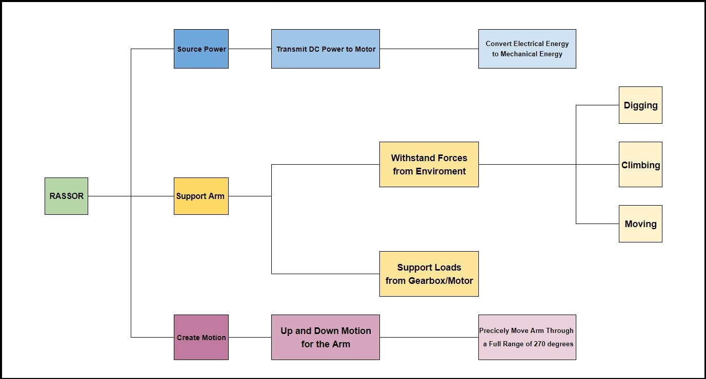
Figure 1: Functional Decomposition Hierarchy Chart

Connection to Systems
The functional decomposition cross reference chart (Table 2) shows how the functions relate to the systems. The three systems shown below are source power, support arm, and generate forces. Then there are five functions that correspond to different systems. The X shows what function belongs to which system.
The function called converts electrical energy to mechanical energy is under both source power and generate force due to converting the power source electrical energy into mechanical energy to be able to move the motor, gearbox, and arm. The motor and gearbox also have to be able to withstand certain forces; therefore, there has got to be an efficient amount of energy that is being converted into mechanical energy to withstand them.
The function named hold arm still in transit is under the system support arm. This is because while the robot is in motion, the arm has to be able to stay in place and not get damaged by any of its surroundings. Another function is applying downward force on the end of the arm during mining and this function deals with the support arm and generates a force system. This is due to the arm needing to be supported when it is mining so it won’t fracture. It also needs to be able to move and generate enough force to be able to mine and move.
The function uses the arm to lift the rover body up and down under the system support arm and generate force. The arm needs to be able to hold up the body and lift it up by using a certain amount of force. The last function is rotation along with the full range of motion which is under the system of generating forces. The arm needs to be able to generate an appropriate amount of force to be able to move the arm.
Table 2: Functional Decomposition Cross Reference Chart
RASSOR Shoulder functional decomposition
Function | Source Power | Support Arm | Generate Force
Convert electrical energy to mechanical energy | X |  | X
Hold arm still in transit |  | X
Apply downward force on the end of the arm during mining |  | X | X
Use the arm to lift the rover body up |  | X | X
Rotate along with a full range of motion |  |  | X

Smart Integration
The DC voltage that will be drawn from the batteries will need to be filtered and controlled before it is applied to the motor(s) we plan to use. This will require some form of a motor driver to interface between the battery, motor, and whatever microcontroller is used to control the rover. This motor-driver combo will be responsible for manipulating the arm up and down as well as overcoming whatever forces the arm encounters during its path. It will also be required to hold the arm still if the gearbox allows for the arm to be back-driven. None of this will be of consequence however if the strength of the motor mount and the arm is not high enough to withstand the forces imposed from the environment.

Action and Outcome
The shoulder will be able to perform exercises such as climbing, excavating, idle, etc. in low gravity. The mechanical energy that is needed to perform these various activities will need to be powered by the battery. This will entail wiring to a mechanism that will take in a voltage and translate that into mechanical energy.
Because the robot is being designed for other planets, the transit will be a bumpy process that will be necessary. This transition will produce multiple vibrations that will damage the wiring that will render the robot useless. To prevent the shoulder joint will need to keep the arm secure and reduce the vibration.
The main problem in excavating in low gravity is that the vertical force is not enough to dig down. The shoulder has to provide torque on both sides to push and translate the robot downward and allow the arms to penetrate the ground. This torque has to be great enough to propel the arms downward but also small where the arms do not break under the strain.
With this same concept, the shoulder has to provide the right amount of torque that will allow the arms to get under and lift the main body of the robot off the ground. These acrobats are important to navigate through different terrains and transport the specimens.
With that said, the shoulder joint has to provide a wide range of motions to move the arms in different directions to be able to move and perform its tasks. Too small of range will prevent the motion of the arms. On the other hand, a large range will be unnecessary and a waste of energy. It will also question the integrity of the structure by increasing the risk of injury.

Function Resolution
With all the tasks the robot will need to perform, our shoulder needs to effectively use energy to produce a controlled torque without a limiting range of motion to ensure it’s a support for the arm and the rest of the body.

1.4 Target Summary
Method of Validation and Discussion of Measurement
Using the metrics discussed below the targets will be validated using a simple digital scale. By varying the length of the lever arm coming off of the shoulder and applying different loads the motor-gearbox combination’s torque can be verified. The scale could also be used to test the arm strength, but hanging static weights off the end of the arm can suffice to verify that it can support the expected loads in any direction. The voltage and current requirements can be verified with a multimeter, or simply the output of the motor meeting its requirements.

Derivation of Targets and Metrics
After talking with Mike, and doing research on the RE-RASSOR arm, 3 key functions were developed that encompassed all the functionality of the arm. Our key functions are “Sourcing Power”, “Supporting the Arm”, “Generating Movement” and each function breaks down further into subfunctions. Targets and metrics were developed for these functions. The way the targets and metrics were developed by analyzing each function and determining its motion then determining the forces that would either help or prevent that motion. Consideration for the targets and metrics is that the mechanism is being tested and the limits of what it can do are ambiguous. The goal is to provide something the mechanism can likely achieve that is also in the range of what the customer is looking for.

Motion Targets and Metrics
The drum and body are connected through the arm. The shoulder joint is the union of the arm and the body. In order to produce motion in the arm consequently moving the drum, the shoulder joint needs to fix one end of the arm to allow the other end to move in a radial motion. The goal is to have theta, the measurement of degrees, be a variable and our radius constant.
The shoulder joint should have the mobility that allows the body to navigate through tough terrain. Our target is to provide a range of motion that allows the body to climb and lift itself up, but also a range to dig. To determine if the target was hit is to analyze how the RE-RASSOR performs with challenging heights and bumpy roads. The metric will be measured with the angle that is achieved.
In order for the body to stand upright, the drum must be right under the robot. To then climb over, the drums will need to correlate; One drum will have to reach up to the height of the obstacle while the other is past 90 degrees from a horizontal starting point underneath the body. Based on the radius of the wheels and drums, and the length of the arm, drums will have to have a range of motion of 270 degrees.

Power Targets and Metrics
The function “transmit DC power to the motor” is needed to be able to move the arm. The calculated voltage to run the stepper motor is 12 volts. This will be done by using a Lithium battery pack that is rechargeable. The battery pack should have 12 V with 6,000 Milliampere Hour. This electrical signal will be needed to move the motor which will convert the electrical energy to mechanical energy.
Based on the calculated mass of the T-shaped part of the rover, the arm and drum should weigh from 9 kilograms for an empty drum and 11 kilograms for a full drum. This however can change due to the fact the material hasn’t been fully selected. The torque range was calculated from this to be around 33 Newton-meter to 45 Nm. This will be needed for the function “converts electrical energy to mechanical energy”. This torque is required to lift the arm and drum up and down. This was calculated by the weight times the length of the T-shaped part with a respected gear ratio calculated to be 1:28. The gear ratio was calculated from the torque that was found.

Support Targets and Metrics
The functions of support include holding the arm still, applying downward force while digging, lifting the full load of the drum, and using the arm to lift the body of the rover. Generally, all targets pertaining to support functions are non-critical and serve as goals since we are testing the limits of our shoulder and arm. We are trying to find out what is possible for the mechanism to lift without failure. The targets and metrics describe the forces the mechanism must support.
Starting with the target weight, the RASSOR arm is expected to lift 13.6-kilograms, which is the weight of the drum when it has a full load of regolith. The target must be met with a range of 5-kilograms over or under the intended weight. The next target is the arm will need to support a moment of 2 Newton meters when the arm is lifting the drum or holding it still. The arm will also need to withstand 45.2 Nm of torque from the gearbox. All targets described above apply to all functions under support.

Targets Outside of Functions
A target to consider is the overall aesthetic. The design should be clean, crisp, and elegant. Since this design is going to be built upon by others, the design has to appeal to different groups. The metric will be the opinions of peers. An additional metric that applies specifically to the arm is The Arm will be subject to a force from the drum, the force will reach its max when the drum is at full capacity of regolith. Under this load, the arm whether in motion or being still should have no more than 5 degrees of deflection. This equates to 1.27 centimeters of deflection at the drum. Keeping a low deflection will also aid in aesthetics and provide confidence in the users.

Summary and Catalog
A summary of the targets and metrics are broken down with their system and function that they align with are shown below in Table 3. The bolded rows show which targets and metrics are most significant from each system. As the project continues the targets might vary due to change in materials or shape used for certain parts.
Table 3: Targets and Metric Table
System | Function | Target | Metric
Motion | Rotate Along with a Full Range of Motion | 270 degrees | Angle
Power | Transmits DC Power to the Motor | 12 V with 6,000 Milliampere Hour | Voltage
Power | Converts Electrical Energy to Mechanical Energy | 33 Nm to 45 Nm  1:28 | Torque and  Gear Ratio
Support | Arm is Expect to Lift a Certain Load | 13 kg to 18 kg | Weight
Support | Arm is Expected to Support a Moment while Lifting the Drum | 2 Nm | Moment
Support | Arm Needs to Withstand the Torque from the Gearbox | 45.2 Nm | Torque

1.5 Concept Generation
Introduction
Concept generation is an important part of the design process. It's where the designer gets to be creative and think of any possible solution to the problem statement. There are multiple ways to concept generate for example brainstorming, biomimicry, crapshoot, forced analogy, and use of a morphological chart. Once the team comes up with possible solutions for the project, the next step is concept selection. Concept selection tools are used to narrow down the most efficient solution to solve the problem. The team created one hundred ideas which are listed below.

100 Ideas
We have identified seven main categories which require design consideration and have broken down concepts in them for ease of reading below. We could have used a morphological chart with all of these combinations, but that would yield thousands of combinations, and including all of those would be a misuse of space and time. Some ideas are elaborated upon for understanding.
Motor (Drives the System):

Concept 1.
Stepper Motor

Concept 2.
DC Motor

Concept 3.
Big Magnet/Giant Stepper Motor (arranged around diameter of shoulder and blade, integrated)

Concept 4.
Electromagnetic Fluid

Concept 5.
Hydraulics (similar to those commonly used on arms of heavy machinery)

Concept 6.
Pneumatic muscles changing fluid pressure compresses and expands to provide motion

Concept 7.
Large Stepper (not necessarily integrated, still requiring gear reduction)

Concept 8.
Linear Motors

Concept 9.
Chain Driven

Concept 10.
Belt Driven

Concept 11.
Pulley

Concept 12.
Turbine

Concept 13.
Clutch

Concept 14.
Crank

Concept 15.
Brushless DC Motor

Concept 16.
Hysteresis Motor
Gearbox:

Concept 17.
Harmonic Gearbox

Concept 18.
CVT (Continuously Variable Transmission)

Concept 19.
Clutches (for different load stress)

Concept 20.
Worm Gear Set (cannot be back driven)

Concept 21.
Oscillatory Gearbox

Concept 22.
Planetary Gears

Concept 23.
Linkages Providing Speed Reduction

Concept 24.
Flywheel (constantly spinning in conjunction with a clutch)

Concept 25.
Reverse Gearbox

Concept 26.
Helical Inline Gearbox

Concept 27.
Make the Shoulder Housing the Gearbox (non-removable)

Concept 28.
Strain Wave Gearing

Concept 29.
Larger Gear Width to Deal with Stressed on 3D printed parts

Concept 30.
Dual Gear Sets on Either Side of the Shoulder

Concept 31.
Coaxial Helical Inline Gearbox

Concept 32.
Bevel Helical Gearbox

Concept 33.
Skew Bevel Helical Gearbox

Concept 34.
Hydraulic Torque Converter
Mount To Shoulder:

Concept 35.
Motor to Blade

Concept 36.
Gearbox to Shoulder

Concept 37.
Motor to Shoulder

Concept 38.
Gearbox to Blade

Concept 39.
Motor in Arm (connected to gearbox in shoulder)

Concept 40.
Shaft to Shoulder (from further in the arm, with speed reduction in arm)

Concept 41.
Stator on Shoulder (for integrated large stepper idea)

Concept 42.
Rotor on Blade

Concept 43.
Rotor on Shoulder

Concept 44.
Stator on Blade

Concept 45.
Linkage Attach to the Blade

Concept 46.
Motor Floats and Input Output/Mating is Controlled by Gear Sets

Concept 47.
Bearings (on both sides)

Concept 48.
Mount Rigidly to Housing (design is not easily disassembled)

Concept 49.
Compliant Shoulder Design (bending members instead of pin joint)

Concept 50.
Entire Arm and Shoulder are Compliant and Mounted Rigidly to Shoulder Blade
Arm:

Concept 51.
Cylindrical Tube (basic, what was being used)

Concept 52.
Generative Design

Concept 53.
Topology Optimization

Concept 54.
I-Beam

Concept 55.
Trusses
Infill for Arm:

Concept 56.
DNA Spiral (double helix)

Concept 57.
Spiderweb

Concept 58.
Cubic Infill

Concept 59.
Honeycomb

Concept 60.
Standard Slicer Infills

Concept 61.
Dowel Pin Supports

Concept 62.
Inlay (non-3D printed materials)

Concept 63.
Different Material Supports (3D printed)

Concept 64.
Retractable Arm (and extendable)

Concept 65.
Lattice

Concept 66.
Hexagonal

Concept 67.
Rectangular Pattern
Driver:

Concept 68.
Standard Motor Driver

Concept 69.
555 Timer Control Steps (with hardware)

Concept 70.
Stepper Specific Chip

Concept 71.
RAMPS Board

Concept 72.
Load Sensing with Feedback Loop
Materials:

Concept 73.
Nylon Filament

Concept 74.
Polycarbonate for Flexural Joints (compliant design)

Concept 75.
PEEK

Concept 76.
PLA (Polylactic acid)

Concept 77.
Carbon Fiber Composites

Concept 78.
ABS (Acrylonitrile Butadiene Styrene)

Concept 79.
Metal Infused Filament (increase strength)

Concept 80.
PET (PolyEthylene Terephthalate)

Concept 81.
PETT (PolyEthylene Trimethylene Terephthalate)

Concept 82.
Aluminum (Gears)

Concept 83.
Steel (Gears)

Concept 84.
Iron (Gears)

Concept 85.
Powered Metal (Gears)

Braking:

Concept 86.
Electro-Magnetic Brake

Concept 87.
Electromagnetic Fluid

Concept 88.
Rubber Band Type Friction

Concept 89.
Ratchet with Slip and Shaft Flips

Concept 90.
Phase Change Fluid to Restrict Motion

Concept 91.
Gate with Dampener

Concept 92.
Flat Straw Compressed by Rotation Thicker with No Torque, Provides Friction

Concept 93.
Spiral Torsion Spring and Friction Wrapped Cylinder

Concept 94.
Ratchet Mechanism

Concept 95.
Separate Servo Stopping Rotation

Concept 96.
Spring Loaded Arm Stopper when Power Off

Concept 97.
High-Speed Disk with Stopper

Concept 98.
Rubber Band Type Friction

Concept 99.
Toothed Gripped to Stop Rotation

Concept 100.
Emergency Brake Lever

Concept Generation Tools
The following tools were used to create the 100 concepts: brainstorming, morphological chart, crapshoot, biomimicry, and forced analogy. Brainstorming is a scamper technique that generates quick ideas. These ideas might not be extravagant due to the nature of how fast they are generated. Ideas can build off the design concept; these ideas may have limitations and restrictions to physics. Slight changes and alters to the previous concepts will allow for speedy generations of concepts.
The Morphological Chart is dividing the system into subsystems and generating individual ideas for the respective categories. Motors, Gearbox, Mount to Shoulder, Arm, Driver, and Materials are the categories that were used to create the Morphological chart for this design. Different options and solutions were then produced for the corresponding category. After coming up with concepts for each subset, they can then be paired with other concepts from the other sections. They can be rearranged to form multiple solutions.
Crapshoot lists 6 problems for 3 categories, and after letting a die decide the item, find a solution for said given item. Biomimicry is where solutions are inspired by nature. For example, a mole excavating through the ground has inspired some concepts that were generated. An animal shoulder joint can give insight into how the final solution may function.
Similarly, Forced Analogy is thinking of an ordinary item then creating a solution from said item. A Coffee sleeve, monkey, hammock, and hockey stick may have nothing to do with a robotic shoulder joint, but can still share a small resemblance in the future solution. A coffee sleeve tightly wraps around the coned cup gripping it with internal teeth. These teeth are similar to gears that can inspire the gear box design. This technique forces the designer to think outside of the box and find solutions in their surroundings.

Concept Selection
A total of eight concepts have been chosen, five are medium-fidelity concepts and three are high fidelity concepts. The five medium-fidelity concepts possess elements that are highly desirable for our project and what it needs to accomplish; however, they do not satisfy all the requirements of the project. They will be used to aid in concept selection when we compare concepts. The medium-fidelity concepts are shown in Table 4. The three high-fidelity concepts satisfy the requirements of the project and will be strongly considered for concept selection. The high-fidelity concepts are displayed in Table 5.

Table 4: Medium Fidelity Concepts
Concept | Description
Stepper motor with spring-loaded stopper transferring power through a planetary gearbox connected to a cylindrical arm | A Nema 23 stepper motor with a spring-loaded actuator that prevents back drive attached to the shoulder blade. It drives the planetary gearbox directly attached to the shoulder itself. The shoulder will lift a cylindrical tube that attaches to the drum.
Pneumatic muscles attached to the rover body and lift a cylindrical arm | Thin airbags that look like muscles attached to the arm and rover body. They are driven by a compressor and can’t be back-driven.
Stepper motor with electromagnetic brake driving a harmonic gearbox with a tapered cylindrical arm | A Nema 23 stepper motor with built-in electric brake to prevent back drive attached to the shoulder blade. It drives the harmonic gearbox directly attached to the shoulder itself. The shoulder will lift a tapered cylindrical tube that attaches to the drum.
Pneumatic air wrench inspired torque motor driving a cylindrical arm with an electromagnetic brake | Essentially, a torque wrench powered by an air compressor that attaches to the shoulder and shoulder blade and lifts the arm with no gearbox. There will be a magnetic brake to keep the system from being back-driven.
One large stepper motor that drives no gearbox and has a honeycomb structured arm | The stepper motor is the shoulder and mounts to the shoulder blade. It will provide enough torque for no gearbox. It will lift an arm with a honeycomb interior structure.

Table 5: High Fidelity Concepts
Concept | Description
Stepper motor attached to cycloidal drive transmission attached to a composite cylindrical arm | A Nema 23 that is mounted to the shoulder blade and a cycloidal drive gearbox that can’t be back driven attached to the shoulder. The arm would be a cylindrical arm made from carbon fiber.
Twin stepper motors with electromagnetic brake driving one harmonic gearbox attached to composite cylindrical tube | two Nema 17 stepper motors with built-in magnetic breaks attached to the shoulder blades. It drives the harmonic gearbox directly attached to the shoulder itself. The shoulder will lift a composite material cylindrical tube that attaches to the drum.
Stepper motor driving a worm gearbox that moves a cylindrical arm with dowel pin supports | A Nema 23 stepper motor attached to the arm’s dowel pin supports. It drives the worm gearbox directly attached to the shoulder blade. The arm will be able to drive itself up and down.

1.6 Concept Selection
Binary Pairwise
The binary pairwise main objective is to obtain a weight factor from the customer’s needs. The customer needs are the left column and top row. This graph can be referred to in table 1 in Appendix D. A diagonal across the graph is formed because these are the spaces that have the same needs comparing themselves. The scale is binary, therefore across the diagonal, the opposing number is present. Once the bottom half was filled out, the top portion was then flipped. The sum of either the columns or rows will give the weight factor for the given need.

House of Quality
The House of qualities is a tool that allows the customer's requirement to hold a numerical value. On the left-hand side of the graph, it has the requirements that were given by the customer such as: Inexpensive, 3D Printed Parts, Light, Durable, Can lift Loaded Arm, Move with Accuracy, and Fit within Current Constraints. These requirements are then graded based on how much it influences selected categories. These categories describe desired outcomes on our final design. The scale is 1-3-9; the reason why the numbers are vastly apart is to distinctly recognize the ranking.
After obtaining the weight factor from the customer needs a table, the ratings are then multiplied and summed resulting in the raw score. A higher raw score correlated to a higher ranking of the categories chosen. Our results in order from high to low ranking are Range of motion, Get Enough Torque from Motor, Support Load, Innovation, Reliability, Component weight, Complexity, and Speed.

Table 6: House of Quality
House of Quality
Units |  | deg | Nm | N | m/s | kg | Volts | N/A | N/A | N/A
Customer Requirements | Importance Weight Factor | Range of Motion | Get Enough Torque from Motor | Support Load | Speed | Component Weight | Efficiency | Reliability | Complexity(less +) | Innovation
Inexpensive | 3 |  | 9 |  | 3 | 3 | 1 |  | 1 | 1
3D Printed Parts | 3 |  |  | 9 |  | 3 | 1 | 3 | 1
Light | 0 |  |  | 3 | 1 | 9 | 3 | 1
Durable | 3 |  | 3 | 9 | 1 | 3 |  | 9 |  | 1
Can Lift Loaded Arm | 5 | 9 | 9 | 3 | 1 |  |  | 3 | 3 | 9
Move with Accuracy | 1 | 9 | 3 |  | 3 |  |  |  |  | 1
Fit within Current Constraints | 6 | 9 | 3 | 1 |  | 3 |  |  | 3 | 3
Raw Score | 350 | 108 | 102 | 75 | 20 | 45 | 6 | 51 | 39 | 70
Relative Weight % |  | 30.86 | 29.14 | 21.43 | 5.71 | 12.86 | 1.71 | 14.57 | 11.14 | 20.00
Rank Order |  | 1 | 2 | 3 | 8 | 6 | 9 | 5 | 7 | 4

Pugh Chart
Pugh charts and their iterations are part of the method of design selection. It takes the concepts and compares them to the selection criteria by a relative datum. The comparison was denoted by better (+), worse (-), or satisfactory (s). The number of better, worse, and satisfactory were counted and used to eliminate and rank ideas. The concepts were put into a legend to easily distinguish which number went with which concept, table 9.
In the first Pugh chart iteration, table 7, the first datum that was used was the NASA RASSOR. The eight concepts were compared by the datum for each selection criteria and then ranked. From this chart, the concepts that moved on to the second iteration, table 4 in Appendix D, were concepts one, two, six, seven, and eight.
In the final Pugh chart iteration, table 8, the last datum that was used to compare the concepts that moved on was concept two. Concepts one, six, and eight were then compared for the last time by the last datum for each selection criteria and then ranked. From this chart, the ranking for the concepts ended with one and six as a draw and concept eight in first. Eight won due to having the greatest number of pluses.
Table 7: Pugh Chart Iteration 1
 |  | Concepts
Selection Criteria | RASSOR | 1 | 2 | 3 | 4 | 5 | 6 | 7 | 8
Range of motion | Datum | s | s | s | s | s | s | s | s
Get Enough Torque from Motor |  | s | s | s | s | - | + | + | +
Support Load |  | + | - | - | s | - | + | - | +
Efficiency |  | s | + | - | - | + | + | - | s
Speed |  | s | s | s | s | + | + | + | +
Complexity (less +) |  | s | s | - | s | - | - | - | s
Reliability |  | - | + | - | - | - | - | + | -
Innovation |  | + | - | - | - | + | + | - | -
Component Weight |  | + | - | - | - | s | + | + | +
# of pluses |  | 3 | 2 | 0 | 0 | 3 | 6 | 4 | 4
# of minuses |  | 1 | 3 | 6 | 4 | 4 | 2 | 4 | 2
# of same |  | 5 | 4 | 3 | 5 | 2 | 1 | 1 | 3

Table 8: Final Pugh Chart Iteration
 |  | Concepts
Selection Criteria | Concept 2 | 1 | 6 | 8
Range of motion | Datum | s | s | s
Get Enough Torque from Motor |  | s | + | +
Support Load |  | - | - | +
Efficiency |  | - | s | -
Speed |  | s | + | +
Complexity (less +) |  | + | s | -
Reliability |  | + | - | -
Innovation |  | s | s | +
Component Weight |  | + | + | +
# of pluses |  | 3 | 3 | 5
# of minuses |  | 2 | 2 | 3
# of same |  | 4 | 4 | 1

Table 9: Legend
Legend
1 | Stepper, Harmonic gearbox, tapered arm, nylon gears, Carbon fiber arm, standard motor driver
2 | Stepper, Planetary gearbox, infill arm, nylon gears, ABS arm, electromagnetic brake, stepper specific driver
3 | Stepper, worm drive gearbox, cylindrical tube arm, Standard motor driver, nylon for gears, ABS arm, stepper specific driver
4 | Stepper, reduction gearbox, solenoid brake, stepper specific driver, nylon gears, carbon fiber composite cylindrical arm
5 | Big Magnet, cylindrical tube, PEEK arm, 555 timer control steps, Electro-Magnetic brake
6 | DC, stacked planetary gearbox, generative design arm, nylon gears, carbon fiber arm, DC motor driver, solenoid for locking
7 | DC, worm drive with gear reduction, Stepper specific chip, nylon gears, ABS arm, infill for arm
8 | DC, nylon for gears, DC motor driver, carbon fiber arm, harmonic gearbox, cylindrical tube arm with added dowl pins for additional support

Analytical Hierarchy Process
After determining through the pugh chart what our top concept was, the next step was to validate the criteria used to determine the top concept. For this, the Analytical Hierarchy Process (AHP) was utilized as a check for the weights of the criteria determining whether they were biased or not. The mathematical approach of AHP implements a “is criteria A better than criteria B?” with a ranking scale of 1, 3, 5, 7, 9 that the group uses to compare criteria. If “B” is better than “A” then the inverse rank is used. This is shown by Table 7 in Appendix D. The results can now be normalized and the weights can be found by taking the average of all the ranks for each criteria. The weights will be used for the next step of AHP.
The next step was to do the same process as described above only more in-depth. Here the top three concepts were compared to each other in the same manner the criteria were compared to each other in the previous tables. The concepts are being compared under each criteria individually forming a single table for each criteria. This can be shown in Tables 9-16 in Appendix D. The results of each table can be normalized in the same way as above to determine the weights of each concept for the individual criteria. These weights can then be used for determining what our final concept will be in the final steps.
Table 10: Analytical Hierarchy Process (Normalized)
Normalized
Pairwise Matrix (Normalized) | Range of Motion | Get Enough Torque from Motor | Support Load | Efficiency | Speed | Complexity (less +) | Reliability | Inovation | Component Weight | Criteria Weight { W }
Range of motion | 0.04 | 0.09 | 0.01 | 0.01 | 0.50 | 0.32 | 0.03 | 0.04 | 0.02 | 0.12
Get Enough Torque from Motor | 0.01 | 0.03 | 0.03 | 0.03 | 0.01 | 0.02 | 0.01 | 0.04 | 0.03 | 0.02
Support Load | 0.13 | 0.03 | 0.03 | 0.02 | 0.01 | 0.04 | 0.03 | 0.04 | 0.02 | 0.04
Efficiency | 0.31 | 0.09 | 0.16 | 0.10 | 0.07 | 0.04 | 0.10 | 0.04 | 0.16 | 0.12
Speed | 0.01 | 0.26 | 0.30 | 0.10 | 0.07 | 0.32 | 0.10 | 0.11 | 0.05 | 0.15
Complexity (less +) | 0.01 | 0.26 | 0.10 | 0.30 | 0.02 | 0.11 | 0.16 | 0.11 | 0.49 | 0.17
Reliability | 0.04 | 0.09 | 0.03 | 0.03 | 0.02 | 0.02 | 0.03 | 0.02 | 0.02 | 0.03
Innovation | 0.13 | 0.09 | 0.10 | 0.30 | 0.07 | 0.11 | 0.23 | 0.11 | 0.03 | 0.13
Component Weight | 0.31 | 0.14 | 0.23 | 0.10 | 0.22 | 0.04 | 0.30 | 0.53 | 0.16 | 0.22
Sum | 0.99 | 1.06 | 1.00 | 1.00 | 1.00 | 1.00 | 1.00 | 1.00 | 1.00 | 1.005423646

Final Selection
After narrowing down our ideas to the three best using the analytical hierarchy process, we compared each of the top three against each individual selection criteria (as described above). The results from this can be seen in the final rating matrix which is table 17 in appendix D. From this we assembled our final rating (table 18 in appendix D) which was the following: DC motor, nylon for gears, DC motor driver, carbon fiber arm, harmonic gearbox, cylindrical tube arm with added dowel pins for additional support.
Because there were so many combinations of materials, arms, gearboxes, motors, and drivers we could not compare every combination, however, when using these concept selection tools we could start seeing advantages to certain designs over others. We also had to consider our sponsor’s wants, some of which are difficult to weigh.
Our final selection closely matches the concept which won and has the following components: DC motor and driver (we may have to do a stepper and ramps board if the sponsor would prefer), carbon fiber polymer filament to print a tapered cylindrical arm (sponsor would prefer we only use 3d printed parts), a harmonic gearbox printed with nylon filament (may still require further reduction), and a solenoid with a ratchet-type mechanism to prevent the arm from being back driven. We believe this design will be robust, cost-effective, and meet all motion requirements for this project.

1.8 Spring Project Plan
WBS # | Task Name | Subtask Names | Assigned to | Due date | Duration (days) | Progress %
1 | First Week Begins
1.1 |  | First Day of Classes | Everyone | 1/5/2022 | 1 | 0
1.2 |  | Email Adivser/Sponcor | Everyone | 1/5/2022 | 1 | 0
1.3 |  | Set Up Meetings | Everyone | 1/5/2022 | 1 | 0
2 | Ordering
2.1 |  | Order Parts from BOM through the School | David | 1/10/2022 | 1 | 0
2.2 |  | Order Filament from BOM through the School | David | 1/10/2022 | 1 | 0
3 | Sponsor Meeting 1
3.1 |  | Meesting Agenda | Everyone | 1/10/2022 | 1 | 0
3.2 |  | Sponsor Meeting | Everyone | 1/11/2022 | 1 | 0
3.3 |  | Meeting Minutes | Everyone | 1/11/2022 | 1 | 0
4 | Advisor Meeting 1
4.1 |  | Meesting Agenda | Everyone | 1/12/2022 | 1 | 0
4.2 |  | Meesting Minutes | Everyone | 1/13/2022 | 1 | 0
4.3 |  | Advisor Meeting | Everyone | 1/13/2022 | 1 | 0
5 | Design
5.1 |  | Harmonic Gearbox Design ( All Individual Pieces) | Jackson & David | 1/10-23/2022 | 14 | 0
5.2 |  | STL Files of Gearbox Desgin | Jackson & David | 1/22-24/2022 | 3 | 0
5.3 |  | Arm Design | David | 1/10-15/2022 | 6 | 0
5.4 |  | STL Files of Arm Design | David | 1/16-18/2022 | 3 | 0
5.5 |  | Shoulder Blade Design | Grace | 1/18-23/2022 | 6 | 0
5.6 |  | STL FIles of Shoulder Blade | Grace | 1/22-24/2022 | 3 | 0
5.7 |  | Shoulder joint housing Design | Evaline | 1/18-23/2022 | 6 | 0
5.8 |  | STL FIles of Shoulder joint housing | Evaline | 1/22-24/2022 | 3 | 0
6 | Printing
6.1 |  | Print Gearbox (All Pieces Individually) | David | 1/25-28/2022 | 4 | 0
6.2 |  | Print Shoulder | David | 1/29-30/2022 | 2 | 0
6.3 |  | Print Arm | David | 1/30-31/2022 | 2 | 0
6.4 |  | Print Shoulder Blade | David | 1/31/2022 - 2/1/2022 | 2 | 0
7 | Test Parts
7.1 |  | Test Stepper Motor | Evaline | 2/1/2022 | 1 | 0
7.2 |  | Test Gearbox | David | 2/1-4/2022 | 4 | 0
7.3 |  | Test Arm (Size is Correct and Strength) | Jackson | 2/1/2022 | 1 | 0
7.4 |  | Test Shoulder Blade (Size is Correct) | Grace | 2/1/2022 | 1 | 0
7.5 |  | Test Shoulder (Size is Correct) | Grace | 2/1/2022 | 1 | 0
7.6 |  | Test Full Assembly | Everyone | 2/1-14/2022 | 14 | 0
8 | Sponsor Meeting
8.1 |  | Email Adivser | Everyone | 2/10/2021 | 1 | 0
8.2 |  | Meesting Agenda | Everyone | 2/10/2022 | 1 | 0
8.3 |  | Sponsor Meeting | Everyone | 2/11/2022 | 1 | 0
8.4 |  | Meeting Minutes | Everyone | 2/11/2022 | 1 | 0
9 | Adviser Meeting
9.1 |  | Email Adivser | EveryOone | 2/12/2021 | 1 | 0
9.2 |  | Meesting Agenda | Everyone | 2/12/2022 | 1 | 0
9.3 |  | Meesting Minutes | Everyone | 2/13/2022 | 1 | 0
9.4 |  | Advisor Meeting | Everyone | 2/13/2022 | 1 | 0
10 | Re-Design(If needed)
10.1 |  | Harmonic Gearbox Design ( All Individual Pieces) | Jackson & David | 2/15-28/2022 | 14 | 0
10.2 |  | STL Files of Gearbox Desgin | Jackson & David | 2/27/2022 - 3/1/2022 | 3 | 0
10.3 |  | Arm Design | David | 2/15-20/2022 | 6 | 0
10.4 |  | STL Files of Arm Design | David | 2/21-23/2022 | 3 | 0
10.5 |  | Shoulder Blade Design | Grace | 2/23-28/2022 | 6 | 0
10.6 |  | STL FIles of Shoulder Blade | Grace | 2/27/2022 - 3/1/2022 | 3 | 0
10.7 |  | Shoulder joint housing Design | Evaline | 2/23-28/2022 | 6 | 0
10.8 |  | STL FIles of Shoulder joint housing | Evaline | 2/27/2022 - 3/1/2024 | 3 | 0
11 | Printing
11.1 |  | Print Gearbox (All Pieces Individually) | David | 3/2-5/2022 | 4 | 0
11.2 |  | Print Shoulder | David | 3/6-7/2022 | 2 | 0
11.3 |  | Print Arm | David | 3/7-8/2022 | 2 | 0
11.4 |  | Print Shoulder Blade | David | 3/8-9/2022 | 2 | 0
12 | Test Parts
12.1 |  | Test Stepper Motor | Evaline | 3/9/2022 | 1 | 0
12.2 |  | Test Gearbox | David | 3/9-12/2022 | 4 | 0
12.3 |  | Test Arm (Size is Correct and Strength) | Jackson | 3/9/2022 | 1 | 0
12.4 |  | Test Shoulder Blade (Size is Correct) | Grace | 3/10/2022 | 1 | 0
12.5 |  | Test Shoulder (Size is Correct) | Grace | 3/11/2022 | 1 | 0
12.6 |  | Test Full Assembly | Everyone | 3/9-22/2022 | 14 | 0
13 | Sponsor Meeting
13.1 |  | Email Adivser | Everyone | 3/10/2021 | 1 | 0
13.2 |  | Meesting Agenda | Everyone | 3/10/2022 | 1 | 0
13.3 |  | Sponsor Meeting | Everyone | 3/11/2022 | 1 | 0
13.4 |  | Meeting Minutes | Everyone | 3/11/2022 | 1 | 0
14 | Adviser Meeting
14.1 |  | Email Adivser | EveryOone | 3/12/2021 | 1 | 0
14.2 |  | Meesting Agenda | Everyone | 3/12/2022 | 1 | 0
14.3 |  | Meesting Minutes | Everyone | 3/13/2022 | 1 | 0
14.4 |  | Advisor Meeting | Everyone | 3/13/2022 | 1 | 0
15 | Assembly
15.1 |  | Assemble the Whole Project | Everyone | 3/23-24/2022 | 2 | 0
16 | Test of the Whole Project
16.1 |  | Test Whole Project | Everyone | 3/25/2022 - 4/7/2022 | 14 | 0
16.2 |  | Fix Anything that Needs to be Changed | Everyone | 3/29/2022 - 4/11/2022 | 14 | 0
16.3 |  | Test Changes | Everyone | 4/2-15/2022 | 14 | 0
17 | Engineering Design
17.1 |  | Engineering Design Day | Everyone | 4/1/2022 | 1 | 0
17.2 |  | Poster Made | Everyone | 3/31/2022 | 1 | 0
17.3 |  | Presentation | Everyone | 4/1/2022 | 1 | 0
17 | Finals |  | Everyone | 4/22-28/2022 | 1 | 0
18 | Graduation |  | Everyone | 4/30/2022 | 1 | 0
WBS # | Task Name | Subtask Names | Assigned to | Due date | Duration (days) | Progress %

Chapter Two: EML 4552C

Restated Project Scope
This project includes the redesign of the shoulder joint and the arm of the RE-RASSOR. The shoulder blades (the interface between shoulder and chassis) have also been modified to reduce the total part count. All parts need to be made from 3D printed PLA, and the shoulder joint will be driven by a NEMA 23 stepper motor. The stepper motor and gearbox must fit inside constraints imposed by the main body and must allow for 270 degrees of motion, likewise the arm must fit inside the room between the drums and allow for wires to be routed through it.

Results

2.2.1 Material Testing
The material used for the final project is polylactic acid (PLA), and parts are made using fused deposition modeling (3D printing). Another material tested was nylon which proved to be smoother for gearsets, also acrylonitrile butadiene styrene (ABS) and polycarbonate (PC) were tested, and both had a higher strength to weight ratio than PLA. The reason for the final material selection is due to the customer’s needs: low cost, easy to print, low toxicity, and high accessibility; PLA is the best filament in all of these categories. While strength and friction are considered in the selection process, good design made up for PLA’s shortcomings in these categories.
Print orientation is important when printing gears and rotating parts. When printing parts for this project the axis of rotation of the part should be normal to the print bed so that layer lines do not create friction against each other. On the previous version large, expensive bearings were used on the shoulder joint. The new design has integrated bearings which use 4.5mm steel BBs and the bearing tracks are designed into the 3D printed parts. It is also imperative that the parts which contact the ball bearings are printed with the axis of rotation normal to the print bed.
Standard PLA print parameters are used for these parts, which almost all machines are capable of replicating. Multiple different 3D printers have been used with slightly different parameters (whatever prints best for that specific printer) and all parts have worked well together.

2.2.2 Motor Testing
The motor used for the final project is a NEMA 23 Stepper Motor. Two NEMA 23 motors with different specifications were tested for this project. The first one has a holding torque of 1.2 Nm with a body length of 56 mm. The actual torque was measured by seeing how much an arm can push once attached to the motor. The arm is 90 mm long and the first motor can push 0.2 kg. Then the amount of weight that the motor can lift was tested by using a force gauge. The first motor applied 0.6 N. The second motor has a holding torque of 1.9 Nm with a body length of 76 mm. The actual torque of this motor was also measured. When using a 90 mm long arm, the second motor can push 2.1 kg. The amount of weight that the second motor can lift was also tested by using a force gauge. It applied a force of 3.6 N.

2.2.3 Gearbox Testing
We used a few different methods to conduct testing on our gearboxes. The first method consisted of general testing such as fitment and printability. Fitment testing was conducted by changing several variables of each type of gearboxes such as module, face width, pressure angle, and gear ratio. By changing these variables, we can easily see varied sizes of gearboxes and compare them to the size of the T-joint housing. We also checked different stacks of gears to achieve better ratios and how easily they would fit in the T-joint's constraints. Testing for printability was conducted simultaneously with testing for fitment. Testing for printability consisted of simply printing different gears and seeing whether the 3D printer could match the tooth profile. We tried different modules and pressure angles to see how the printer would handle the design. We also tried different layouts of the prints to achieve better prints.
The second method of testing is a little more hardcore in that we needed to test how easily the motor could be stalled if a force were acting against it through the gearbox. The gearboxes used for this test were designed with a slot to allow a pin to go in. We could then hold the pin stationary with our hands to prevent the motor from turning. This test gives an idea as to which gearbox would perform the best in the final method of testing.
The final method of testing required us to have officially picked the gearbox we intended to use. This last test tested the strength of the final selected gearbox and allowed us to refine the design to best match the final product. For every failure we would go back and redesign parts to improve the design's performance.

2.3 Discussion

2.3.1 Motor
To calculate the actual torque output from the motor, the Equation (1) below was used:

Τ = Wgl (1)
Equation (1) is mass multiplied by acceleration due to gravity, 9.81 m/s², multiplied by distance, 90 mm. The first motor outputs a mass of 0.2 kg; therefore, by using the Equation (1) the motor outputs a torque of 0.2 Nm. This is significantly lower than what the speciation sheet says of 1.2 Nm. Next the amount of weight the motor can lift on its own was found by using the Equation (2) below:
$W=\frac{F}{g}$ (2)
Equation (2) is the force applied from the gauge length divided by the acceleration due to gravity. The first motor applied 0.6 N. By using Equation (2) the amount of mass the first motor can lift on its own is about 0.0612 kg. Due to these findings, the first motor was not used in the final project.
Once the second motor came in and was tested immediately. The second motor outputs a mass of 2.1 kg. By using Equation (1) the applied torque was found to be 1.85 Nm. This is close to the specification sheet of the applied torque of 1.9 Nm. Next, the amount of weight that the second motor can lift on its own is found. The amount of force applied was 3.6 N. This was then used in Equation (2) which found the amount of weight that the motor can lift on its own to be 0.567 kg. Due to these findings, the second motor was used in the final project.

2.3.2 Drivers
Another issue is that the motors were dealt with by the motor drivers. The drivers that were used in L298N motor drivers. At 1.2 Amps, the drivers would start to overheat when using a NEMA 23 stepper motor. This would cause the motor to stall, skip steps, or not work properly. To overcome this, power must be shut off to the motor drivers for a minute to let them cool off after a run. If multiple runs occurred, then power must be shut off for about 3 to 5 minutes to let the drivers fully cool off.

2.3.3 Gearbox
The gearboxes that we tested were planetary, cycloidal, harmonic, and hybrid. During the first stage of testing related to fitment and printability we found that the planetary gearbox provided great sizing for gear ratios of 4:1 to 6:1. However the required gear ratio needed to be much higher which required a stack of planetary gear sets which compromised the fitment advantage the gearbox had initially. When it came to the cycloidal gearbox, we still needed to stack two of them to achieve the appropriate gear ratio. However, although the stacked gearbox fits the constraints it was difficult to integrate the gearbox into the t-joint housing or even find a way to mount it to the t-joint housing or shoulder blade. The harmonic gearbox offered us one of the best gear ratios for its size and would be one that we could easily integrate into the design. The hybrid gearbox offered a great ratio for its size as well and offered an uncomplicated way to integrate into the t-joint housing.
When it came to printability it depended on the shape of the part being printed, tooth profile and tooth count of the gear. For certain parts if there was a large enough edge there would need to be a support structure to allow the print to be done properly. In the case of the cam used for the cycloidal gearbox, it was ruined by the support structure because after it was moved the surface that the gear ran along was rough. Another example of a difficult print related to the number of teeth a gear had in relation to its size. The largest of our gears could be 115 mm (about 4.53 in), this meant that to print a gear the number of teeth could not exceed 120 before the tooth profile was too small to be printed. This made the cycloidal and planetary gearboxes a challenge; however, the hybrid, which is a combination of the harmonic and planetary gearbox never had a tooth count over 104 which allowed for quality prints.
We concluded from these results that the hybrid gearbox would be the best suited for the job, based on its ability to have a high gear ratio for the small size constraints that we had. The gearbox required no stacking and allowed for stronger more durable prints than what a cycloidal gearbox could offer. Previous testing done by other researchers concluded that the rods that connect to the output would fail if enough torque were applied to the system; this was due to how thin the rods were. The hybrid gearbox eliminates this issue by having a thick sun gear and planet gears to drive the system. The outer flexible gear relied on compliant design to give the gear its flexible nature, this improved upon the design of the harmonic gear by reducing its overall height but keeping the same amount of flexibility.
At this point we could finally test the gearbox with the motor and determine if it was strong enough to prevent stalling. After designing the first prototype we found that the motor would not stall and would be able to overcome the force that we applied without any significant issues. After conducting this test, we went and designed a prototype that would have the final products dimensions and began doing testing with a load.
The next test showed us how much of a load the gearbox could support. This test also tested the strength of the arm. We found that the arm on the first run could lift a maximum of 3.40 kg which was 1.1 kg shy of our goal. This was because the flexible gear of the hybrid was slipping on the planetary gears. We resolved this by increasing the thickness of the compliant mechanism which increased the strength of compression from the flexible gear. After reprinting and reassembling we were able to lift 6.8 kg of weight which was 2.3 kg over our goal. However, at this weight we were not able to lower the weight without the gearbox slipping. We have tried to resolve this issue by increasing the thickness of the compliant mechanism even more, but with no change in the result. This is where the project stands now.

2.3.4 Arm
The arm serves two main functions on the RE-RASSOR: support loads applied to the drums, and house wires running from the shoulder joint to the drums. Based on static and dynamic principles, the best shape to withstand both torsional and shear forces is the hollow cylindrical tube, which places the most material (and thus the most strength) on the outside of the cylinder’s diameter. Other options tested included a high infill cylinder with a small wire channel, a hollow cylinder with an X running the length of the cylinder, and a cylinder with tapered walls (thickest section at the bottom). None of these designs failed under the loads expected except for the tapered cylinder with very thin walls. The cylindrical tube is the best option because it is light, strong, prints fast, and leaves plenty of room for wires to dissipate their heat inside. The simplest design has proven to be the best solution for this problem.

2.4 Conclusions
The harmonic-planetary hybrid gearbox is the best option for this project due to its ability to work smoothly with PLA filament. It also offers a large (160:1) gear reduction which increases the stepper motor’s torque enough to move the drum with a 4 kg load. When printed with the right parameters, the arm and other structural pieces made of PLA supported the load with ease, making the shoulder joint and arm ready to be integrated with the rest of the RE-RASSOR system.

2.5 Future Work
What is left to do for this project is to publish our CAD, STL, and code files for Swamp Works and FSI. This will allow them to use the parts we made and complete the assemble of the whole RE-RASSOR rover from each individual group. Once the rover is fully assembled, then any troubleshooting that needs to be done will be assessed. Finally, when the RE-RASSOR is completed and all bugs are worked out then it is ready to be distributed to schools.

2.6 References
Showcase, A. P. (2021, August 6). 2020 RE-RASSOR ARM. Florida Space Institute. Retrieved
September 13, 2021, from https://fsi.ucf.edu/2020re-rassorarm/.
Showcase, A. P. (2021, August 6). 2020 RE-RASSOR Gold team. Florida Space Institute.
Retrieved September 13, 2021, from https://fsi.ucf.edu/2020goldteam/.

Appendices

Appendix A: Code of Conduct
Mission Statement: To critically employ the engineering design process with the goal of producing the best possible solution for the problem described by our customer. The problem described is building a more affordable gearbox, housing, and arm that can withstand a large amount of torque and stress to move the arm up and down. Our group intends to apply the knowledge and experience we have gained about the engineering design process over the course of our student engineering careers. The goal is not only to produce a fantastic product but to learn through application, how to be a “good” engineer.
Outside obligations: Member’s work and class schedules will be tracked in google calendar for ease of access and tracking. Times that everyone is available throughout the week are listed below.
 | Mon | Tue | Wed | Thurs | Fri | Sat | Sun
All Free |  | 8 PM-9 PM | 1 PM - 2 PM | 8 AM -  10:30 AM  6:30 PM – 9 PM | 9 PM - 9PM | 8 AM - 10 AM | 8 AM - 11AM  1 PM - 5 PM

Team Roles:
Grace Busch: Dynamic Systems Engineer. She will be working on the torque and stress calculations and figuring out how to overcome large amounts of it.
Evaline Cantarero: Mechatronics Engineer. The sponsor talked about using Arduino robots to move the arm; therefore, she will be the lead in working with that.
Jackson Davis: Materials Engineer. He will research different types of materials to figure out what will be the best material to use for this project.
David Nowicki: Design Engineer. He will be lead to work on the main design of the shoulder.
Communication: Text Message, Discord, Zoom, and Email will be used, and the group must respond within 24 hours. Text messaging is the main form of contact between group members for scheduling meetings or asking each other questions. Emails are the main form of contact with the sponsor and advisor. Discord is where meetings are held with the sponsor and with the group when they need to be held remotely. Zoom is used for meetings with the advisor.
Group Notification: Text messages should be used for time-sensitive issues, and may refer to emails. Group members are expected to reply and take action on any text addressed to them or their functional group within 24 hours. Members are expected to check their primary email at least once per business day. If this can’t be met, then the group will meet and discuss solutions. If the issue persists then the TA’s will be contacted, we will only go to Dr. McConomy if the situation requires it.
Meetings: Standard group meetings will be held after class on Tuesday and Thursday evenings. Meetings with our sponsor will be on Friday at 9:30 am. Meeting with the advisor will be held every two weeks at 4:00 pm on Mondays.
Meeting Conduct: Members are expected to respond respectfully in texts and emails. Profanity and humor are not allowed in texts or emails. Discussion of non-project-related topics is permitted but the conversation should be focused on the project alone within the group chat. When conversing with sponsors we should keep it professional regardless of medium.
Attendance Policy: Attendance will be taken at the beginning of all meetings and kept in the meeting minutes. Members should attend all meetings. If a member misses three meetings we will have a meeting with the whole group to discuss solutions. If more meetings are missed then we will go to TAs to discuss the next course of action, we will only go to Dr. McConomy if the situation requires it.
Dress Code: Members are expected to dress casually to bi-weekly classes and group meetings. Members are expected to dress in business attire for presentations. Members are expected to dress business casual for meetings with sponsors and advisors. Casual refers to basic clothing that isn’t athletic leisure. Business attire refers to nice dress pants and a button-down dress shirt; dress skirts are acceptable as well. Business casual refers to a nice pair of pants or jeans and a nice shirt that isn’t a t-shirt.
Dr. McConomy’s response: For the hopefully rare occasions that Dr. McConomy must get involved, we ask that he help mediate the problem. We ask that he take disciplinary action if necessary.
Document Amendation: To change any of the contents of or add to the code of conduct all group members must meet and discuss the proposed change. There must be 3 out of 4 members that agree to the rule change or addition in order for it to be done.

Signatures:
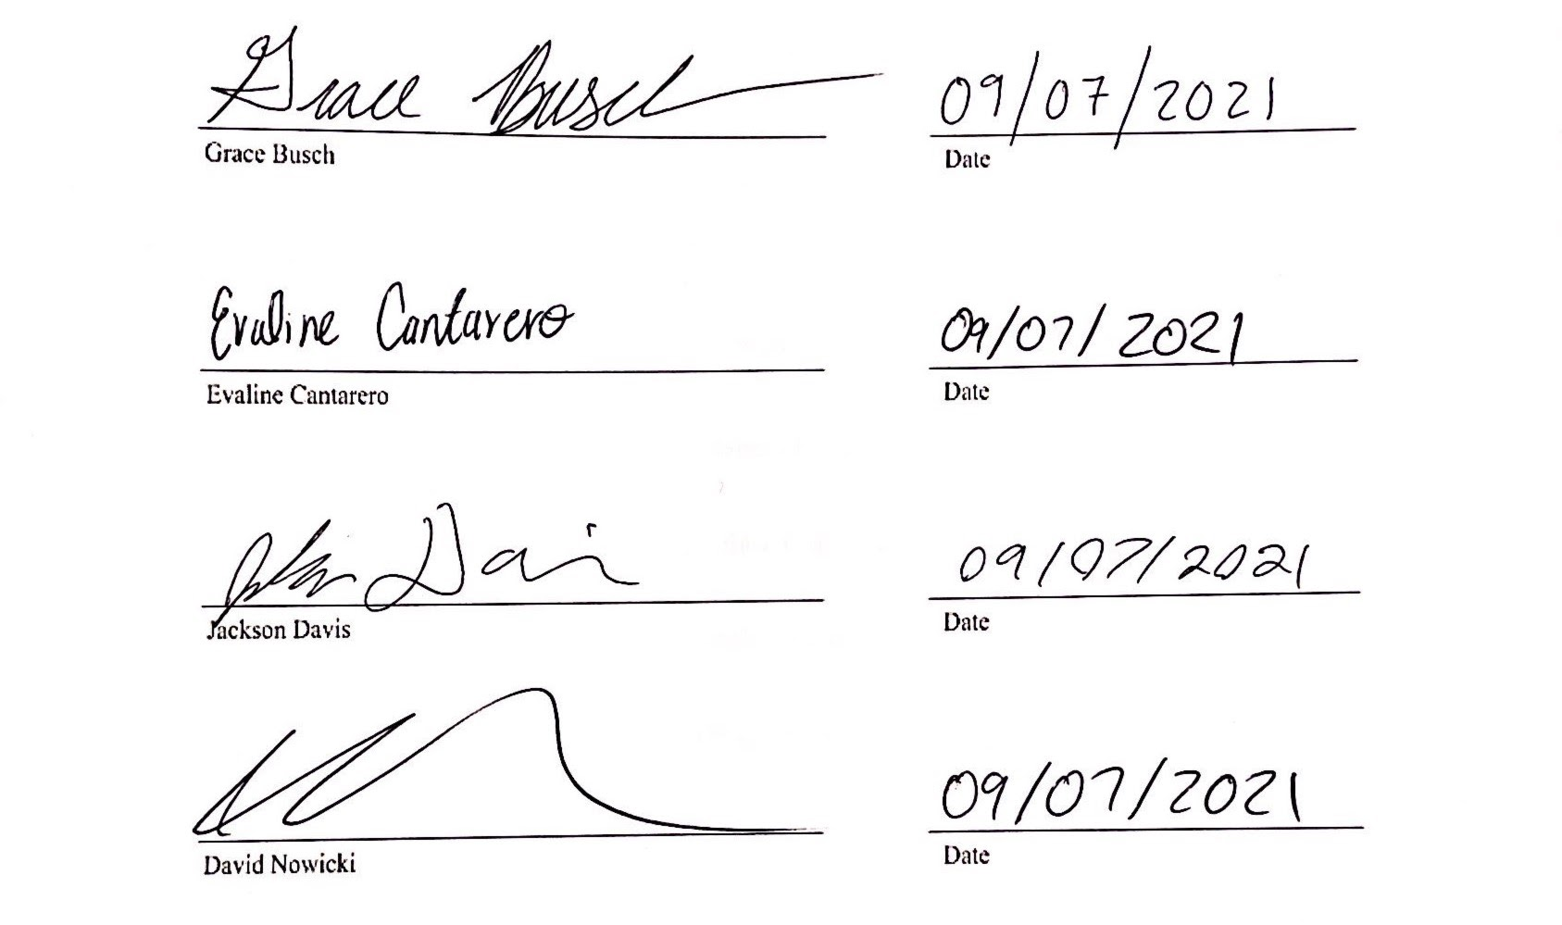

Appendix B: Functional Decomposition
Figure 1
This is a figure of our functional decomposition hierarchy chart.

Appendix C: Target Catalog
Table 2
This is a table of our Functional Decomposition Cross Reference Chart.
RASSOR Shoulder functional decomposition
Function | Source Power | Support Arm | Generate Force
Convert electrical energy to mechanical energy | X |  | X
Hold arm still in transit |  | X
Apply downward force on the end of the arm during mining |  | X | X
Use the arm to lift the rover body up |  | X | X
Rotate along with a full range of motion |  |  | X

Table 3
This is a table of our Targets and Metric.
System | Function | Target | Metric
Motion | Rotate Along with a Full Range of Motion | 270 degrees | Angle
Power | Transmits DC Power to the Motor | 12 V with 6,000 Milliampere Hour | Voltage
Power | Converts Electrical Energy to Mechanical Energy | 33 Nm to 45 Nm  1:28 | Torque and  Gear Ratio
Support | Arm is Expect to Lift a Certain Load | 13 kg to 18 kg | Weight
Support | Arm is Expected to Support a Moment while Lifting the Drum | 2 Nm | Moment
Support | Arm Needs to Withstand the Torque from the Gearbox | 45.2 Nm | Torque

Appendix D: Concept Selection
Table 1
This is a table of the Binary Pairwise Table.
Customer Needs | Inexpensive | 3D Printed Parts | Light | Durable | Can Lift Loaded Arm | Move with Accuracy | Fit within Current Constraints | Sum
Inexpensive | - | 1 | 1 | 0 | 0 | 1 | 0 | 3
3D Printed Parts | 0 | - | 1 | 1 | 0 | 1 | 0 | 3
Light | 0 | 0 | - | 0 | 0 | 0 | 0 | 0
Durable | 1 | 0 | 1 | - | 0 | 1 | 0 | 3
Can Lift Loaded Arm | 1 | 1 | 1 | 1 | - | 1 | 0 | 5
Move with Accuracy | 0 | 0 | 1 | 0 | 0 | - | 0 | 1
Fit within Current Constraints | 1 | 1 | 1 | 1 | 1 | 1 | - | 6

Table 2
This is a table of the House of Quality.
House of Quality
Units |  | deg | Nm | N | m/s | kg | Volts | N/A | N/A | N/A
Customer Requirements | Importance Weight Factor | Range of Motion | Get Enough Torque from Motor | Support Load | Speed | Component Weight | Efficiency | Reliability | Complexity (less +) | Innovation
Inexpensive | 3 |  | 9 |  | 3 | 3 | 1 |  | 1 | 1
3D Printed Parts | 3 |  |  | 9 |  | 3 | 1 | 3 | 1
Light | 0 |  |  | 3 | 1 | 9 | 3 | 1
Durable | 3 |  | 3 | 9 | 1 | 3 |  | 9 |  | 1
Can Lift Loaded Arm | 5 | 9 | 9 | 3 | 1 |  |  | 3 | 3 | 9
Move with Accuracy | 1 | 9 | 3 |  | 3 |  |  |  |  | 1
Fit within Current Constraints | 6 | 9 | 3 | 1 |  | 3 |  |  | 3 | 3
Raw Score | 350 | 108 | 102 | 75 | 20 | 45 | 6 | 51 | 39 | 70
Relative Weight % |  | 30.86 | 29.14 | 21.43 | 5.71 | 12.86 | 1.71 | 14.57 | 11.14 | 20.00
Rank Order |  | 1 | 2 | 3 | 8 | 6 | 9 | 5 | 7 | 4

Table 3
This is a table of the first iteration of the Pugh Chart.
 |  | Concepts
Selection Criteria | RASSOR | 1 | 2 | 3 | 4 | 5 | 6 | 7 | 8
Range of motion | Datum | s | s | s | s | s | s | s | s
Get Enough Torque from Motor |  | s | s | s | s | - | + | + | +
Support Load |  | + | - | - | s | - | + | - | +
Efficiency |  | s | + | - | - | + | + | - | s
Speed |  | s | s | s | s | + | + | + | +
Complexity (less +) |  | s | s | - | s | - | - | - | s
Reliability |  | - | + | - | - | - | - | + | -
Innovation |  | + | - | - | - | + | + | - | -
Component Weight |  | + | - | - | - | s | + | + | +
# of pluses |  | 3 | 2 | 0 | 0 | 3 | 6 | 4 | 4
# of minuses |  | 1 | 3 | 6 | 4 | 4 | 2 | 4 | 2
# of same |  | 5 | 4 | 3 | 5 | 2 | 1 | 1 | 3

Table 4
This is a table of the second iteration of the Pugh Chart.
 |  | Concepts
Selection Criteria | Concept 4 | 1 | 2 | 6 | 7 | 8
Range of motion | Datum | s | s | s | s | s
Get Enough Torque from Motor |  | s | s | + | + | +
Support Load |  | + | + | s | + | +
Efficiency |  | + | + | + | - | +
Speed |  | s | s | + | + | +
Complexity (less +) |  | + | - | - | - | s
Reliability |  | s | + | - | + | +
Innovation |  | + | + | + | - | s
Component Weight |  | + | - | + | + | +
# of pluses |  | 5 | 4 | 5 | 5 | 6
# of minuses |  | 0 | 2 | 2 | 3 | 0
# of same |  | 4 | 3 | 2 | 1 | 3

Table 5
This is a table of the third iteration of the Pugh Chart.
 |  | Concepts
Selection Criteria | Concept 2 | 1 | 6 | 8
Range of motion | Datum | s | s | s
Get Enough Torque from Motor |  | s | + | +
Support Load |  | - | - | +
Efficiency |  | - | s | -
Speed |  | s | + | +
Complexity (less +) |  | + | s | -
Reliability |  | + | - | -
Innovation |  | s | s | +
Component Weight |  | + | + | +
# of pluses |  | 3 | 3 | 5
# of minuses |  | 2 | 2 | 3
# of same |  | 4 | 4 | 1

Table 6
This is a table of the legend.
Legend
1 | Stepper, Harmonic gearbox, tapered arm, nylon gears, Carbon fiber arm, standard motor driver
2 | Stepper, Planetary gearbox, infill arm, nylon gears, ABS arm, electromagnetic brake, stepper specific driver
3 | Stepper, worm drive gearbox, cylindrical tube arm, Standard motor driver, nylon for gears, ABS arm, stepper specific driver
4 | Stepper, reduction gearbox, solenoid brake, stepper specific driver, nylon gears, carbon fiber composite cylindrical arm
5 | Big Magnet, cylindrical tube, PEEK arm, 555 timer control steps, Electro-Magnetic brake
6 | DC, stacked planetary gearbox, generative design arm, nylon gears, carbon fiber arm, DC motor driver, solenoid for locking
7 | DC, worm drive with gear reduction, Stepper specific chip, nylon gears, ABS arm, infill for arm
8 | DC, nylon for gears, DC motor driver, carbon fiber arm, harmonic gearbox, cylindrical tube arm with added dowl pins for additional support

Table 7
Pairwise Matrix | Range of motion | Get Enough Torque from Motor | Support Load | Efficiency | Speed | Complexity (less +) | Reliability | Inovation | Component Weight
Range of motion | 1 | 3.000 | 0.333 | 0.143 | 7 | 3 | 1 | 0.333 | 0.143
Get Enough Torque from Motor | 0.333 | 1 | 1.000 | 0.333 | 0.111 | 0.143 | 0.333 | 0.333 | 0.200
Support Load | 3.000 | 1.000 | 1 | 0.200 | 0.111 | 0.333 | 1.000 | 0.333 | 0.143
Efficiency | 7.000 | 3.000 | 5.000 | 1 | 1.000 | 0.333 | 3.000 | 0.333 | 1.000
Speed | 0.143 | 9.000 | 9.000 | 1.000 | 1 | 3.000 | 3.000 | 1.000 | 0.333
Complexity (less +) | 0.333 | 7.000 | 3.000 | 3.000 | 0.333 | 1 | 5.000 | 1.000 | 3.000
Reliability | 1.000 | 3.000 | 1.000 | 0.333 | 0.333 | 0.200 | 1 | 0.143 | 0.111
Innovation | 3.000 | 3.000 | 3.000 | 3.000 | 1.000 | 1.000 | 7.000 | 1 | 0.200
Component Weight | 7.000 | 5.000 | 7.000 | 1.000 | 3.000 | 0.333 | 9.000 | 5.000 | 1
Sum | 22.809 | 35.000 | 30.333 | 10.009 | 13.888 | 9.342 | 30.333 | 9.475 | 6.13
This is a table of the Analytical Hierarchy Process.

Table 8
This is a table of the Normalized Analytical Hierarchy Process.
Normalized
Pairwise Matrix (Normalized) | Range of Motion | Get Enough Torque from Motor | Support Load | Efficiency | Speed | Complexity (less +) | Reliability | Inovation | Component Weight | Criteria Weight { W }
Range of motion | 0.04 | 0.09 | 0.01 | 0.01 | 0.50 | 0.32 | 0.03 | 0.04 | 0.02 | 0.12
Get Enough Torque from Motor | 0.01 | 0.03 | 0.03 | 0.03 | 0.01 | 0.02 | 0.01 | 0.04 | 0.03 | 0.02
Support Load | 0.13 | 0.03 | 0.03 | 0.02 | 0.01 | 0.04 | 0.03 | 0.04 | 0.02 | 0.04
Efficiency | 0.31 | 0.09 | 0.16 | 0.10 | 0.07 | 0.04 | 0.10 | 0.04 | 0.16 | 0.12
Speed | 0.01 | 0.26 | 0.30 | 0.10 | 0.07 | 0.32 | 0.10 | 0.11 | 0.05 | 0.15
Complexity (less +) | 0.01 | 0.26 | 0.10 | 0.30 | 0.02 | 0.11 | 0.16 | 0.11 | 0.49 | 0.17
Reliability | 0.04 | 0.09 | 0.03 | 0.03 | 0.02 | 0.02 | 0.03 | 0.02 | 0.02 | 0.03
Innovation | 0.13 | 0.09 | 0.10 | 0.30 | 0.07 | 0.11 | 0.23 | 0.11 | 0.03 | 0.13
Component Weight | 0.31 | 0.14 | 0.23 | 0.10 | 0.22 | 0.04 | 0.30 | 0.53 | 0.16 | 0.22
Sum | 0.99 | 1.06 | 1.00 | 1.00 | 1.00 | 1.00 | 1.00 | 1.00 | 1.00 | 1.005423646

Table 9
This is a table of the comparison of the range of motion.
Comparison (Range of Motion) |  |  |  |  | Comparison (Range of Motion) Normalized
 | 1 | 6 | 8 |  |  | 1 | 6 | 8 | Weight { W }
1 | 1 | 0.143 | 0.5 |  | 1 | 1.00 | 0.11 | 0.08 | 0.39
6 | 7 | 1 | 5 |  | 6 | 0.70 | 1.00 | 0.77 | 0.82
8 | 2 | 0.2 | 1 |  | 8 | 0.20 | 0.15 | 0.15 | 0.17
Sum | 10 | 1.343 | 6.5 |  | Sum | 1.90 | 1.26 | 1.00 | 1.39

Table 9
This is a table of the comparison of get enough torque from motor.
Comparison (Get Enough Torque from Motor) |  |  |  |  | Comparison (Get Enough Torque from Motor) Normalized
 | 1 | 6 | 8 |  |  | 1 | 6 | 8 | Weight { W }
1 | 1 | 0.2 | 1 |  | 1 | 0.14 | 0.13 | 0.20 | 0.16
6 | 5 | 1 | 3 |  | 6 | 0.71 | 0.65 | 0.60 | 0.66
8 | 1 | 0.333 | 1 |  | 8 | 0.14 | 0.22 | 0.20 | 0.19
Sum | 7 | 1.533 | 5 |  | Sum | 1.00 | 1.00 | 1.00 | 1.00

Table 10
This is a table of the comparison of support load.
Comparison (Support Load) |  |  |  |  | Comparison (Support Load)
 | 1 | 6 | 8 |  |  | 1 | 6 | 8 | Weight { W }
1 | 1 | 0.143 | 5 |  | 1 | 0.12 | 0.11 | 0.33 | 0.19
6 | 7 | 1 | 9 |  | 6 | 0.85 | 0.80 | 0.60 | 0.75
8 | 0.2 | 0.111 | 1 |  | 8 | 0.02 | 0.09 | 0.07 | 0.06
Sum | 8.2 | 1.254 | 15 |  | Sum | 1.00 | 1.00 | 1.00 | 1.00

Table 11
This is a table of the comparison of efficiency.
Comparison (Efficiency) |  |  |  |  | Comparison (Efficiency)
 | 1 | 6 | 8 |  |  | 1 | 6 | 8 | Weight { W }
1 | 1 | 5 | 0.333 |  | 1 | 0.24 | 0.38 | 0.23 | 0.28
6 | 0.2 | 1 | 0.143 |  | 6 | 0.05 | 0.08 | 0.10 | 0.07
8 | 3 | 7 | 1 |  | 8 | 0.71 | 0.54 | 0.68 | 0.64
Sum | 4.2 | 13 | 1.476 |  | Sum | 1.00 | 1.00 | 1.00 | 1.00

Table 12
This is a table of the comparison of speed.
Comparison (Speed) |  |  |  |  | Comparison (Speed)
 | 1 | 6 | 8 |  |  | 1 | 6 | 8 | Weight { W }
1 | 1 | 7 | 5 |  | 1 | 0.74 | 0.64 | 0.79 | 0.72
6 | 0.143 | 1 | 0.333 |  | 6 | 0.11 | 0.09 | 0.05 | 0.08
8 | 0.2 | 3 | 1 |  | 8 | 0.15 | 0.27 | 0.16 | 0.19
Sum | 1.343 | 11 | 6.333 |  | Sum | 1.00 | 1.00 | 1.00 | 1.00

Table 13
This is a table of the comparison of complexity.
Comparison (Complexity) |  |  |  |  | Comparison (Complexity)
 | 1 | 6 | 8 |  |  | 1 | 6 | 8 | Weight { W }
1 | 1 | 0.2 | 0.2 |  | 1 | 0.07 | 0.05 | 0.13 | 0.08
6 | 5 | 1 | 0.333 |  | 6 | 0.33 | 0.24 | 0.22 | 0.26
8 | 9 | 3 | 1 |  | 8 | 0.60 | 0.71 | 0.65 | 0.66
Sum | 15 | 4.2 | 1.533 |  | Sum | 1.00 | 1.00 | 1.00 | 1.00

Table 14
This is a table of the comparison of reliability.
Comparison (Reliability) |  |  |  |  | Comparison (Reliability)
 | 1 | 6 | 8 |  |  | 1 | 6 | 8 | Weight { W }
1 | 1 | 0.2 | 0.143 |  | 1 | 0.08 | 0.05 | 0.10 | 0.07
6 | 5 | 1 | 0.333 |  | 6 | 0.38 | 0.24 | 0.23 | 0.28
8 | 7 | 3 | 1 |  | 8 | 0.54 | 0.71 | 0.68 | 0.64
Sum | 13 | 4.2 | 1.476 |  | Sum | 1.00 | 1.00 | 1.00 | 1.00

Table 15
This is a table of the comparison of innovation.
Comparison (Innovation) |  |  |  |  | Comparison (Innovation)
 | 1 | 6 | 8 |  |  | 1 | 6 | 8 | Weight { W }
1 | 1 | 3 | 9 |  | 1 | 0.69 | 0.72 | 0.53 | 0.65
6 | 0.333 | 1 | 7 |  | 6 | 0.23 | 0.24 | 0.41 | 0.29
8 | 0.111 | 0.143 | 1 |  | 8 | 0.08 | 0.03 | 0.06 | 0.06
Sum | 1.444 | 4.143 | 17 |  | Sum | 1.00 | 1.00 | 1.00 | 1.00

Table 16
This is a table of the comparison of weight.
Comparison (Component Weight) |  |  |  |  | Comparison (Component Weight)
 | 1 | 6 | 8 |  |  | 1 | 6 | 8 | Weight { W }
1 | 1 | 3 | 0.111 |  | 1 | 0.10 | 0.27 | 0.09 | 0.15
6 | 0.333 | 1 | 0.143 |  | 6 | 0.03 | 0.09 | 0.11 | 0.08
8 | 9 | 7 | 1 |  | 8 | 0.87 | 0.64 | 0.80 | 0.77
Sum | 10.333 | 11 | 1.254 |  | Sum | 1.00 | 1.00 | 1.00 | 1.00

Table 17
This is a table of the final rating matrix.
Final Rating Matrix
Selection Criteria | 1 | 6 | 8
Range of motion | 0.39 | 0.82 | 0.17
Get Enough Torque from Motor | 0.16 | 0.66 | 0.19
Support Load | 0.19 | 0.75 | 0.06
Efficiency | 0.28 | 0.07 | 0.64
Speed | 0.72 | 0.08 | 0.19
Complexity | 0.08 | 0.26 | 0.66
Reliability | 0.07 | 0.28 | 0.64
Innovation | 0.65 | 0.29 | 0.06
Component Weight | 0.15 | 0.08 | 0.77

Table 18
This is a table of the final rating.
Final Rating
1 | 0.3324
6 | 0.2699
8 | 0.4405

Appendix E: Figures and Tables
Table 1
This is a table of our customer needs question and answers.
Number | Questions Asked | Customer Statement
1 | What parts are we redesigning? | Shoulder housing, gearbox, motor, arm, wiring
2 | Can we change wire placement? | If you could run the wires all internally yes, but it’s okay to run them externally like the old design. If it is not easy or simple they will help us figure out a way to get wires to the front of the design.
3 | How fast does the drum rotate? | Given BOM with the motor used. We can interpolate
4 | How much weight does the arm need to lift? | Dimension of the drum and figure out how much it can lift from there
5 | What was the weight at which the gearbox failed? | The gearbox did not because it was $1000
6 | Do you prefer 3D printed gears or if we can buy them? | If that is the best way then yes (but should’ve gotten the data pack that has an example gearbox in it)
7 | How many parts do you want 3D printed? | As much as we can but are able to buy any necessary parts that can’t be 3D printed (e.g. bearing, screws, motors, etc.)
8 | Are we supposed to use a specific 3D material or are we free to use any 3D material? | Our Choice
9 | Are there assembly drawings with dimensions and other specs? | Drums attached to the wheels, motors inside the wheels, and the gear ratio is 43:1 (moves slow)
10 | How many volts can we source? | 12 V (whole RASSOR but we get all 12)
11 | What are the software components that we’ll need/ what language is running the bot? | ET RASSOR (can look at it on GitHub), but the easiest way is Ardunio board
12 | Do materials have to stand up to the space environment? | No, we can use materials that work with Earth’s atmosphere and don’t need to worry about the launch environment
13 | Do we need to consider some extreme temperatures that can be found on earth? | Room temperature, parking lot temperature
14 | Is there a target weight for the assembly? | No
15 | How long should the arm be? | Set by the size of the wheel and bucket drum
16 | Are we allowed to change the design of the arm? | Keep similar design but add elements to cause more strength
17 | Can we make the arm out of other materials? | Yes, can strengthen it with other materials but the preferred material is carbon fiber filament
18 | What gravity should we design for? | Design for earth gravity
19 | What is the budget? | The whole RASSOR should be about $300 but our is around $50-$60. https://floridaspacegrant.org/program/senior-design-projects/
20 | Can we change the shoulder blade? | Check it carefully (inside body probably not an issue but the outside body got to sit down and look at because close to the wheel)
21 | How fast do we need to raise and lower the arm? | slow
22 | Maximum allowed deflection of the arm? | Deflection isn’t a problem (stay within the elastic range don’t want it to fracture)
23 | Vibrational considerations? | Don’t need to worry about it when it comes to taking off
24 | Heat/wire insulation running thru arm | Place your motor based on how it works and if you have to, later on, worry about this then okay shouldn’t have to be using any heat reduction right now

Table 4
This is a table of our medium fidelity concepts.
Concept | Description
Stepper motor with spring-loaded stopper transferring power through a planetary gearbox connected to a cylindrical arm | A Nema 23 stepper motor with a spring-loaded actuator that prevents back drive attached to the shoulder blade. It drives the planetary gearbox directly attached to the shoulder itself. The shoulder will lift a cylindrical tube that attaches to the drum.
Pneumatic muscles attached to the rover body and lift a cylindrical arm | Thin airbags that look like muscles attached to the arm and rover body. They are driven by a compressor and can’t be back-driven.
Stepper motor with electromagnetic brake driving a harmonic gearbox with a tapered cylindrical arm | A Nema 23 stepper motor with built-in electric brake to prevent back drive attached to the shoulder blade. It drives the harmonic gearbox directly attached to the shoulder itself. The shoulder will lift a tapered cylindrical tube that attaches to the drum.
Pneumatic air wrench inspired torque motor driving a cylindrical arm with an electromagnetic brake | Essentially, a torque wrench powered by an air compressor that attaches to the shoulder and shoulder blade and lifts the arm with no gearbox. There will be a magnetic brake to keep the system from being back-driven.
One large stepper motor that drives no gearbox and has a honeycomb structured arm | The stepper motor is the shoulder and mounts to the shoulder blade. It will provide enough torque for no gearbox. It will lift an arm with a honeycomb interior structure.

Table 5
This is a table of our high-fidelity concepts.
Concept | Description
Stepper motor attached to cycloidal drive transmission attached to a composite cylindrical arm | A Nema 23 that is mounted to the shoulder blade and a cycloidal drive gearbox that can’t be back driven attached to the shoulder. The arm would be a cylindrical arm made from carbon fiber.
Twin stepper motors with electromagnetic brake driving one harmonic gearbox attached to composite cylindrical tube | two Nema 17 stepper motors with built-in magnetic breaks attached to the shoulder blades. It drives the harmonic gearbox directly attached to the shoulder itself. The shoulder will lift a composite material cylindrical tube that attaches to the drum.
Stepper motor driving a worm gearbox that moves a cylindrical arm with dowel pin supports | A Nema 23 stepper motor attached to the arm’s dowel pin supports. It drives the worm gearbox directly attached to the shoulder blade. The arm will be able to drive itself up and down.

References
Showcase, A. P. (2021, August 6). 2020 RE-RASSOR ARM. Florida Space Institute. Retrieved September 13, 2021, from https://fsi.ucf.edu/2020re-rassorarm/.
Showcase, A. P. (2021, August 6). 2020 RE-RASSOR Gold team. Florida Space Institute. Retrieved September 13, 2021, from https://fsi.ucf.edu/2020goldteam/.

Appendix E: Operations Manuel
Project Overview
The RE-RASSOR is based on NASA’s RASSOR. This rover is engineered to mine in low gravity which will aid in space exploration and colonization. The RE-RASSOR is a scaled-down version of NASA’s original RASSOR that is used for educational purposes. Our project needs to be affordable and easily replicated. The rover uses two rotating drums attached to arms with shoulder joints to the body with four wheels. When the drums are co-planar to the ground and rotating, they propel the body downwards. The RE-RASSOR is using the same physics with the fraction of size and cost. Our projected scope is redesigning the shoulder joint and arm.

Component/Module Description
All Creo files can be downloaded at the link below:
https://drive.google.com/drive/folders/1Avh1IvApap6hp3sFqu2n_We7LlbtJ-01?usp=sharing
All STL files can be downloaded at the link below:
https://drive.google.com/drive/folders/1ramL2J5DWkxRTX-dNWjKdK5XjYMY8uas?usp=sharing
There are a total of 14 distinct parts that make up the shoulder joint; the parts are listed in the Bill of materials in Figure 1. 9 of the parts were 3D-printed and are shown in the drawings from Figures 2-11. The remaining 7 parts are the motor and the nuts and bolts that fasten the shoulder to the mount, motor mount, and the shoulder assembly. Below are instructions of how to recreate the drawings in Creo Parametric, convert them to STL files and slice them for printing.
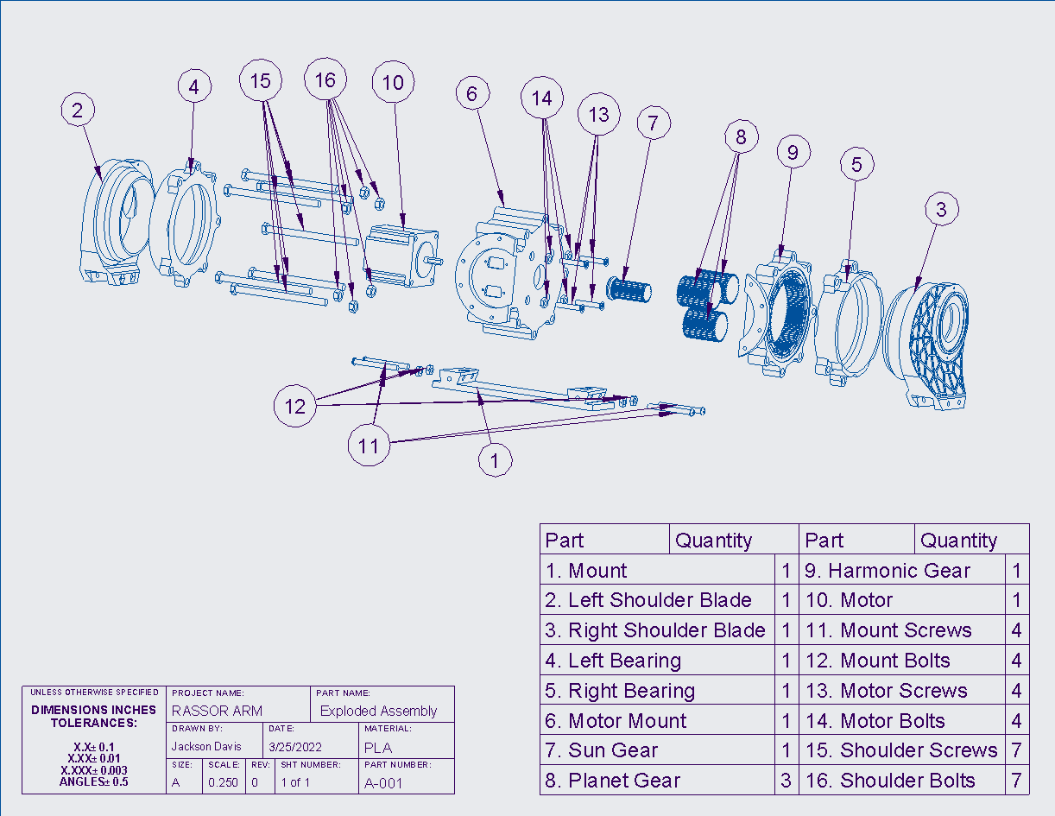
Figure 1: Exploded View and Bill of Materials
Below in Figure 4 is the mount for the shoulder joint, its dimensions are shown and can be used to recreate the part in Creo.
Creating the part in Creo starts by making a rectangular extrusion on the bottom plane. This is shown in Figures 2a and 2b. Next you can use the Sweep Blend tool to create the two flanges that the shoulder blades slide on. This is shown in Figure 2c. The mirror tool will be useful in this step shown in figure 2d. Finally, you can make the two holes by performing another extrusion on the top surface of the two flanges and using the round tool where necessary as shown in Figure 2e. Once the part is created you can save it shown in Figure 2e-f.
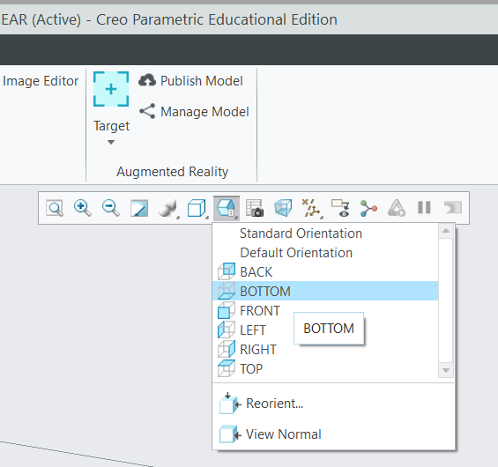
Figure 2a
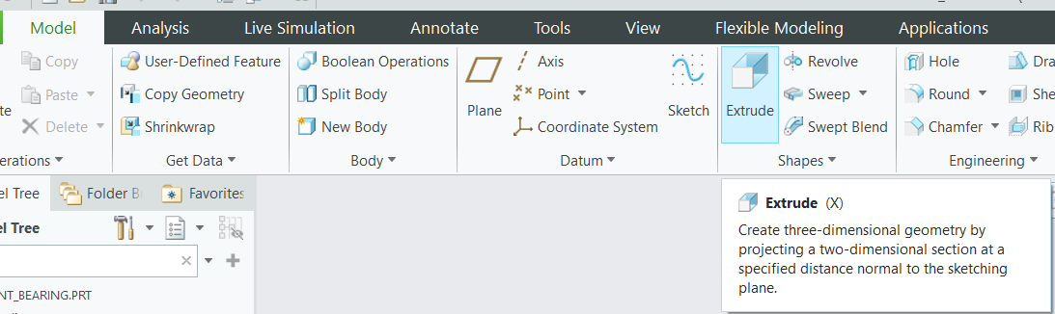
Figure 2b
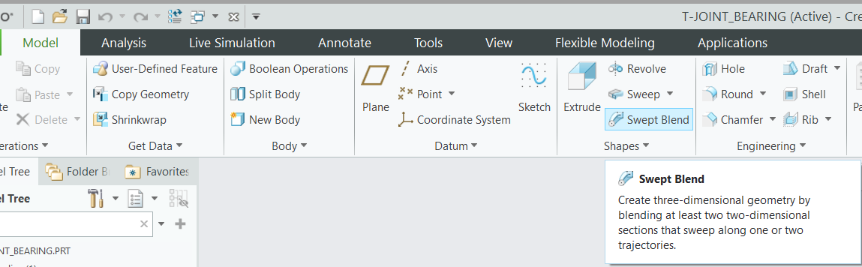
Figure 2c
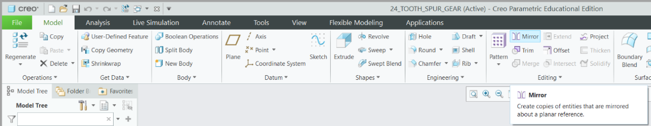
Figure 2d
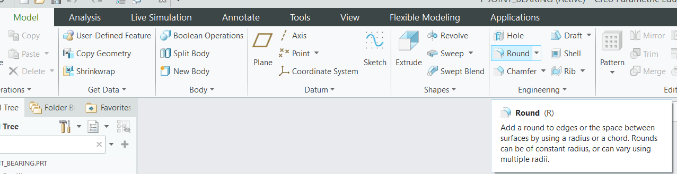
Figure 2e
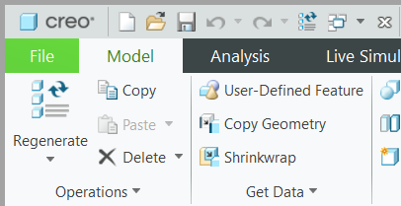
Figure 2f
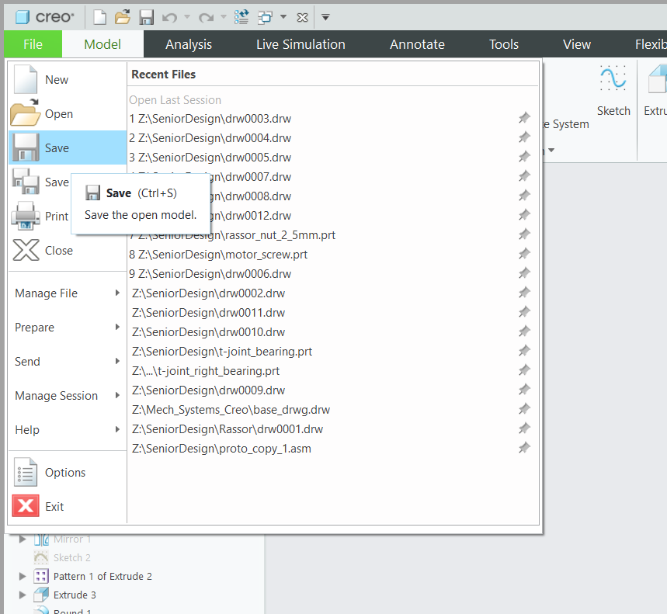
Figure 2g
After saving you can save a copy of the part and set it as an STL file shown in Figure 3a-c. From here you can upload the file to whatever slicing software you have. For this part you will set the layer thickness to whatever is appropriate for your printer, set the wall thickness to between 2.8 and 3.2 mm (about 0.13 in) and set the infill to 30%. This is the setting we used during testing. For this part support structures are needed for the holes in the flanges. Additionally, the part should be centered with the bottom of the part on the platform. The way the part is oriented is shown below in Figure 5.
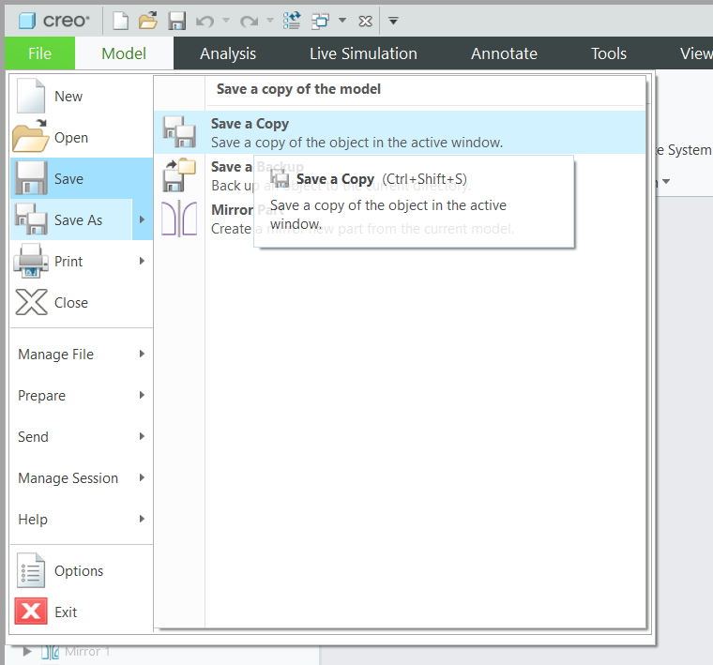
Figure 3a
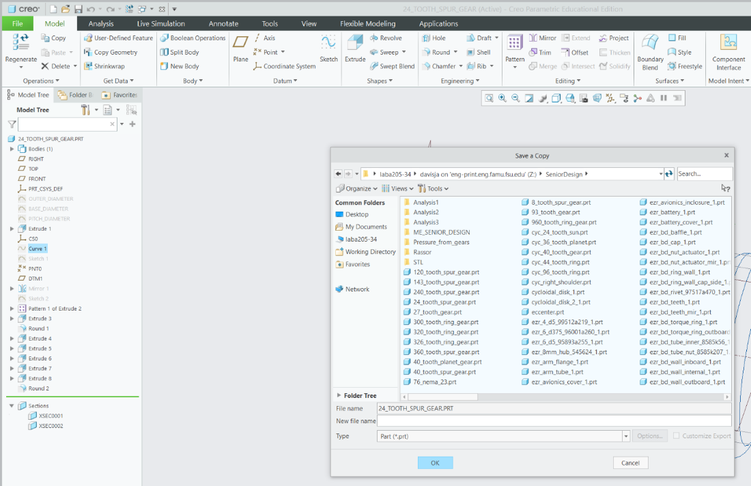
Figure 3b
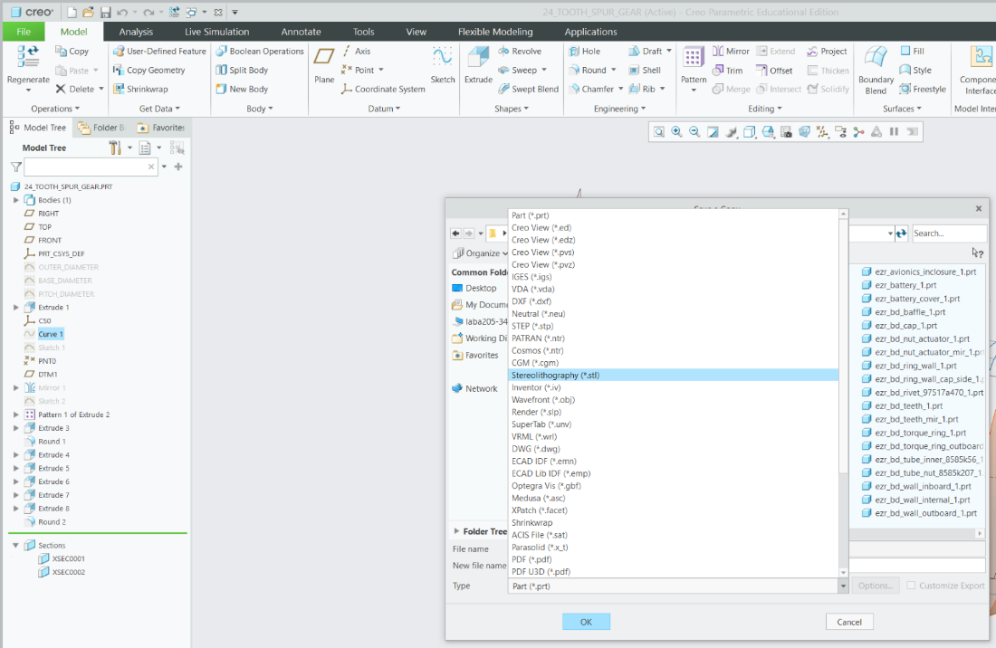
Figure 3c
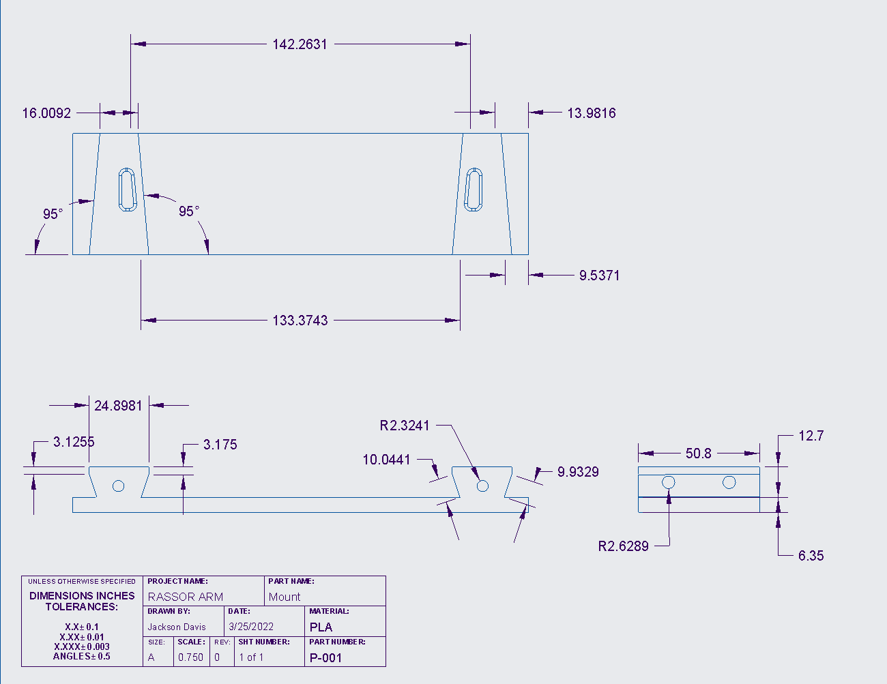
Figure 4: Part Drawing of the Mount
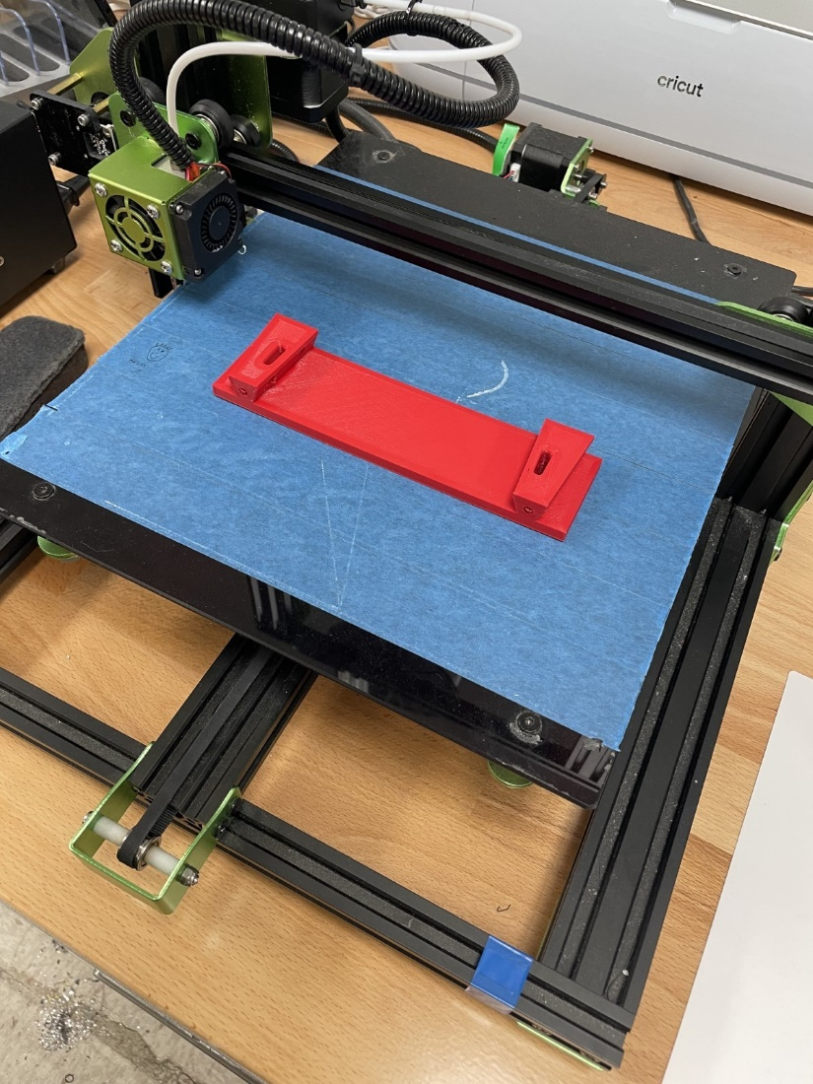
Figure 5: 3D-Print Layout for Mount
Below in Figures 7 and 8 is the Right Shoulder Blade, it serves as the guide on the opposing side of the gearbox and has a slot designed to allow the mount to slide into the shoulder blade. The part’s dimensions are shown and can be used to recreate the part in Creo.
Creating the part in Creo starts by selecting the bottom plane shown in Figure 2a and drawing the overall profile of the blade that can be seen if you look at the part from the front view shown in Figure 6a. Next you can select the drawing you just made and extrude it shown in Figure 2b. After the extrusion is made you can select different surfaces and make the proper extrusions to subtract material. You can also use the revolve tool to aid in removing material shown in Figure 6b. After the part is finished you can save it as shown in Figures 3a-c.
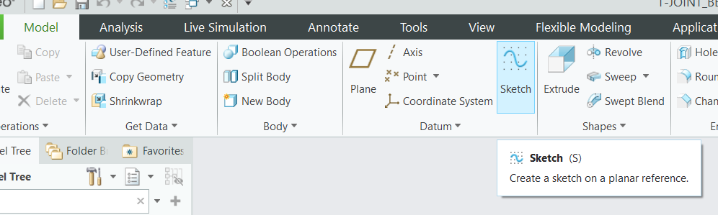
Figure 6a
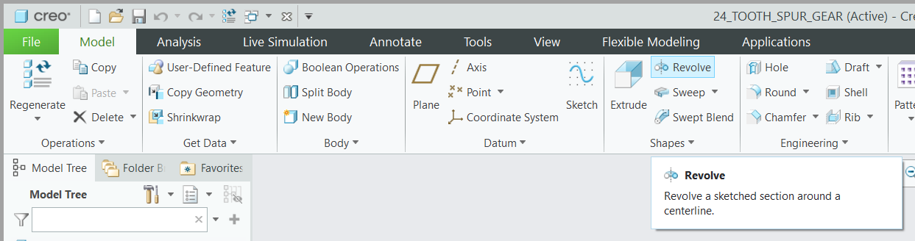
Figure 6b
After saving you can save a copy of the part and set it as an STL file shown in Figure 3a-c. From here you can upload the file to whatever slicing software you have. For this part you will set the layer thickness to whatever is appropriate for your printer, set the wall thickness to between 2.4 mm (about 0.09 in) and set the infill to 20-25%. This is the setting we used during testing. The reason for the drop in infill and wall thickness settings is since there is not as much stress on the part during its operation. For this part support structures are needed for the holes and to support the structure during the printing process. This part should be centered with the bottom of the part on the platform. The way the part is oriented is shown below in Figure 9.

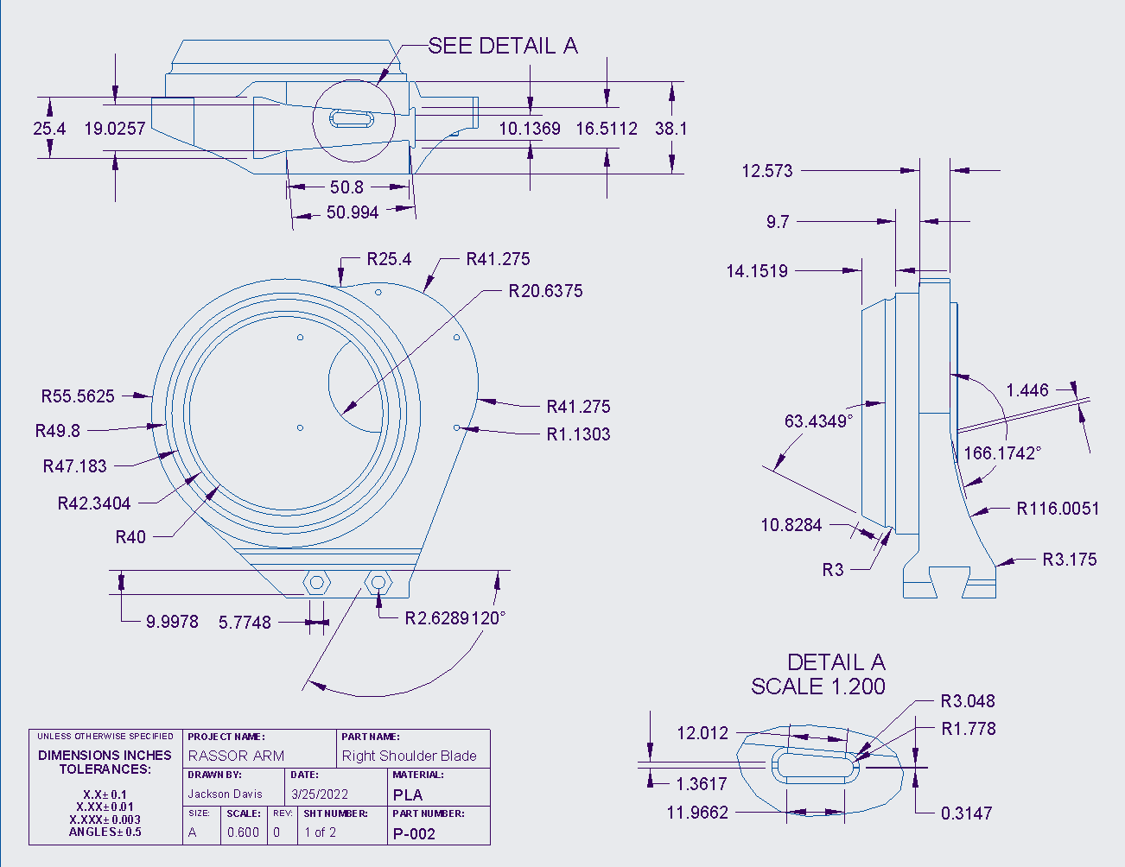
Figure 7: Drawing 1 of the Right Shoulder Blade
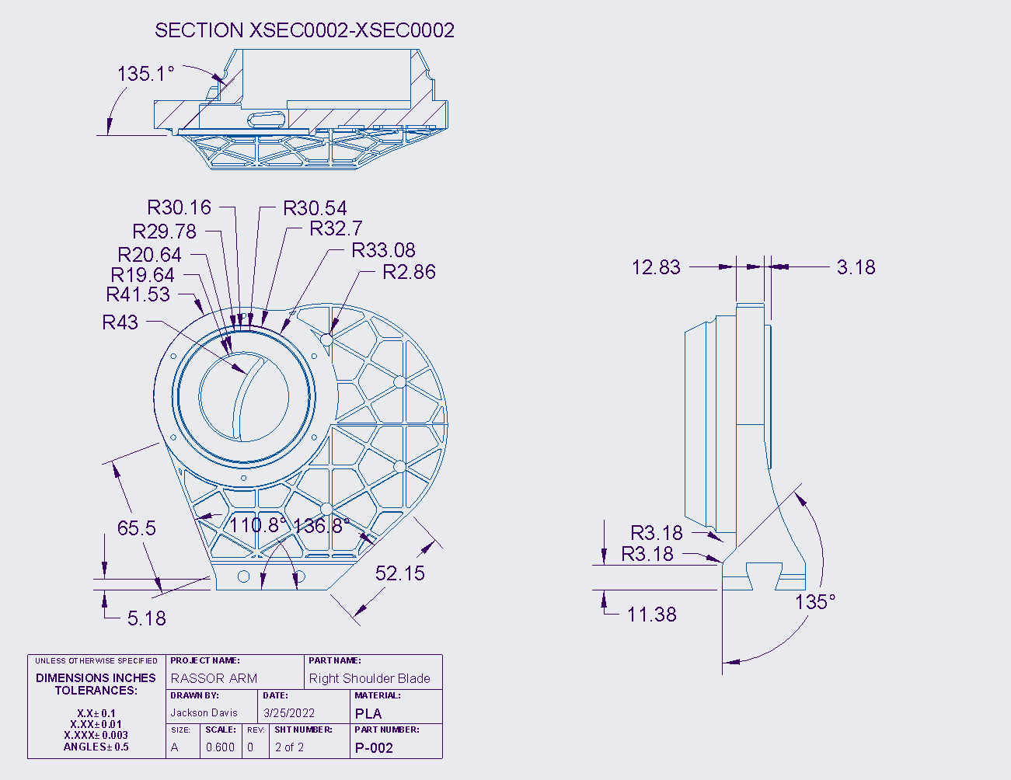
Figure 8: Drawing 2 of the Right Shoulder Blade
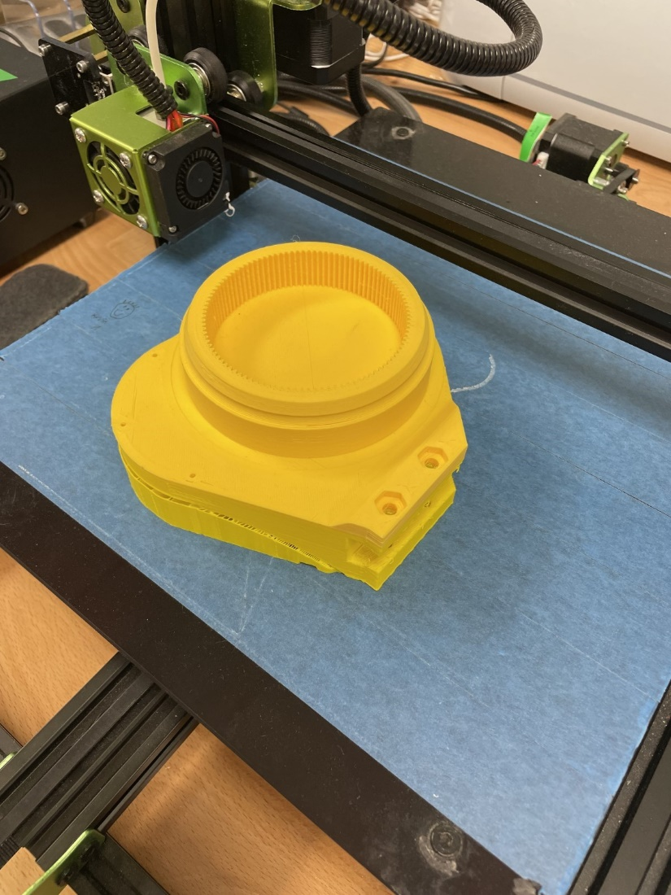
Figure 9: 3d-Print Layout for Right Shoulder Blade
Below in Figure 11 is the Left Shoulder Blade, it serves as the ground for our gearbox and has a slot designed to allow the mount to slide into the shoulder blade. The part’s dimensions are shown and can be used to recreate the part in Creo.
Creating the part in Creo starts by selecting the bottom plane and drawing the overall profile of the blade that can be seen if you look at the part from the front. Next you can select the drawing you just made and extrude it. After the extrusion is made you can select different surfaces and make the proper extrusions to subtract material. You can also use the revolve tool to aid in removing material.
At this point you can upload the parameters given at the bottom of the note on the drawing by selecting the tool tab and then selecting parameters Shown in Figure 10a and c. Then you can set the relations which are given at the top of the note by selecting the tool tab again and selecting relations after shown in Figure 10d. From here you can use these parameters to make the outer diameter, root diameter, pitch diameter, and base diameter. With these diameters you can use the datum line tool to create an involute profile for the teeth shown in Figure 10e and f. You can do this by selecting the line datum and selecting datum line by equation. The equation that you will use is the last portion of the not given in the drawing. After making the involute curve you can set a drawing that starts from the edge of the involute curve and travels along the pitch diameter until it reaches the circular tooth thickness. You can then place a datum point halfway on the line shown in Figure 10g. With this datum point you can mirror the involute line to the other side and finish the profile of the gear tooth. Next you can extrude this profile and pattern is around the center axis of the part. There should be 104 teeth for this part. After the part is finished you can save it.
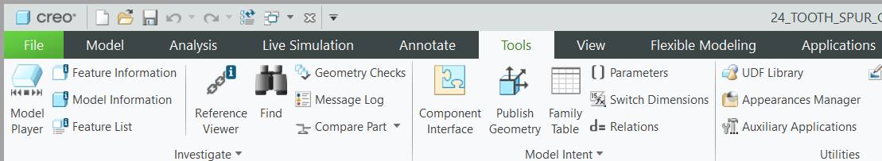
Figure 10a
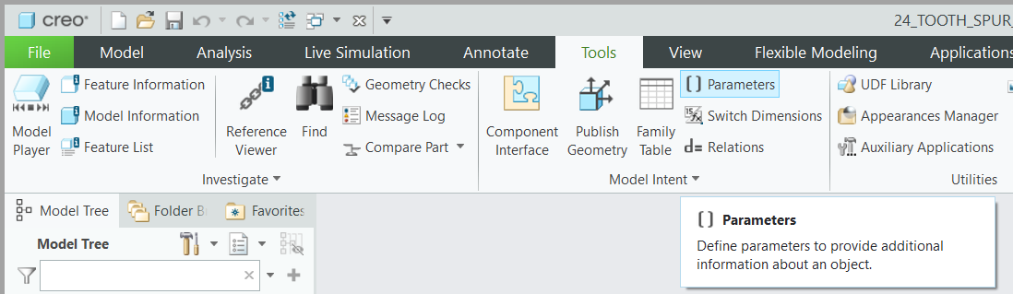
Figure 10b
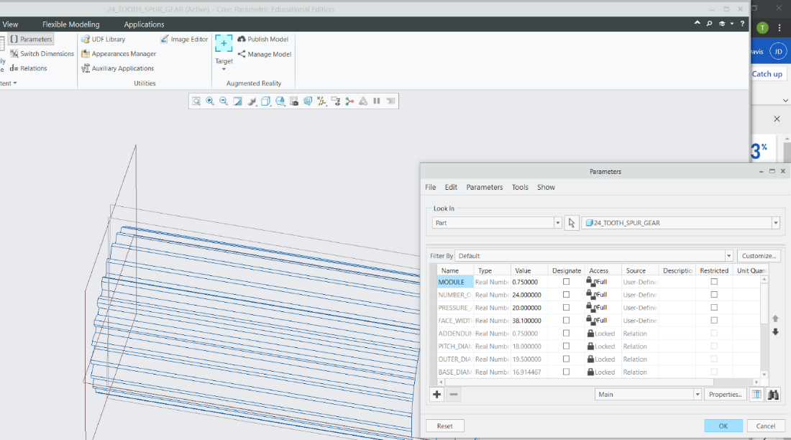
Figure 10c
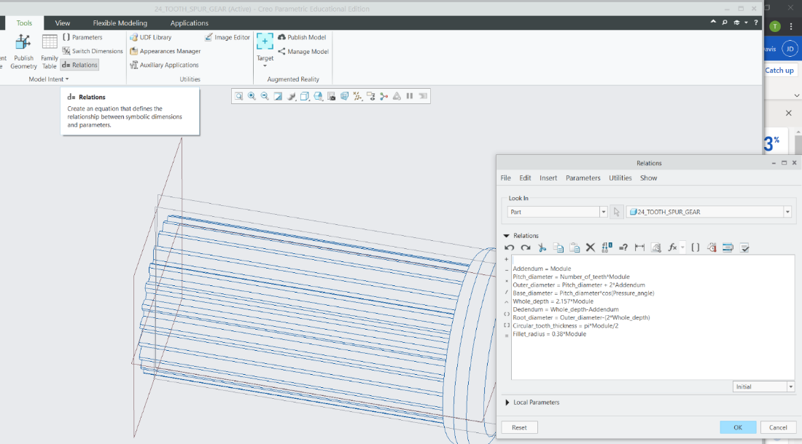
Figure 10d
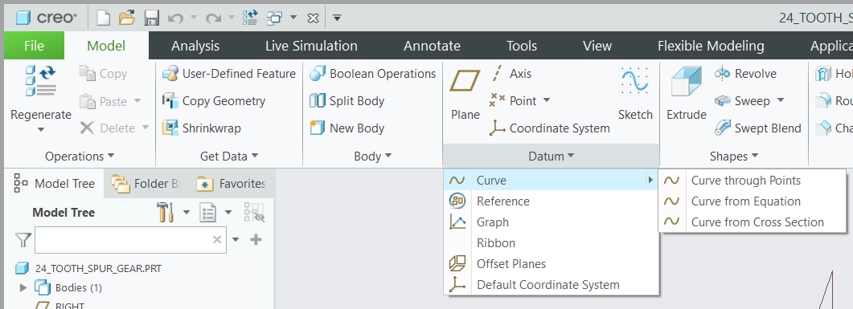
Figure 10e
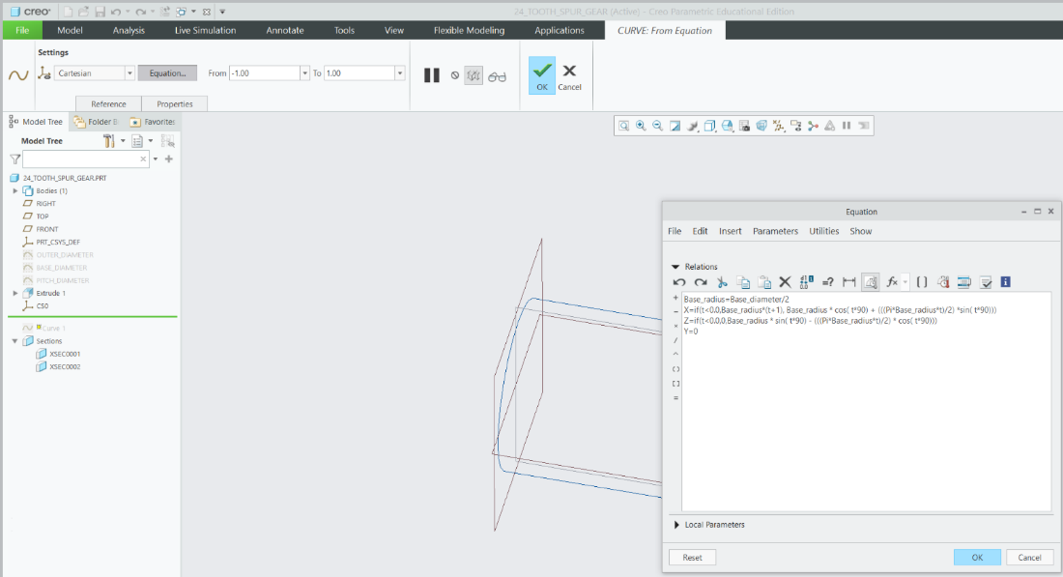
Figure 10f
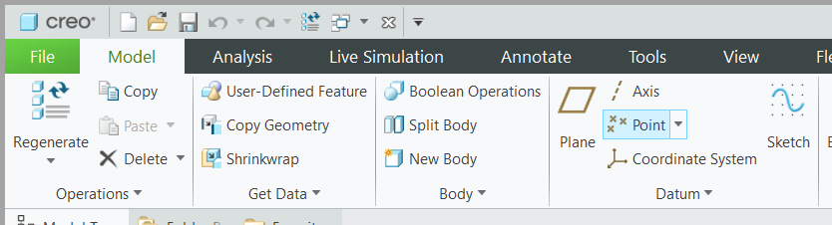
Figure 10g
After saving you can save a copy of the part and set it as an STL file. From here you can upload the file to whatever slicing software you have. For this part you will set the layer thickness to whatever is appropriate for your printer, set the wall thickness to between 2.8 and 3.2 mm (about 0.13 in) and set the infill to 30%. This is the setting we used during testing. For this part support structures are needed for the holes and to support the structure during the printing process. This part should be centered with the bottom of the part on the platform. The way the part is oriented is shown below in Figure 12.

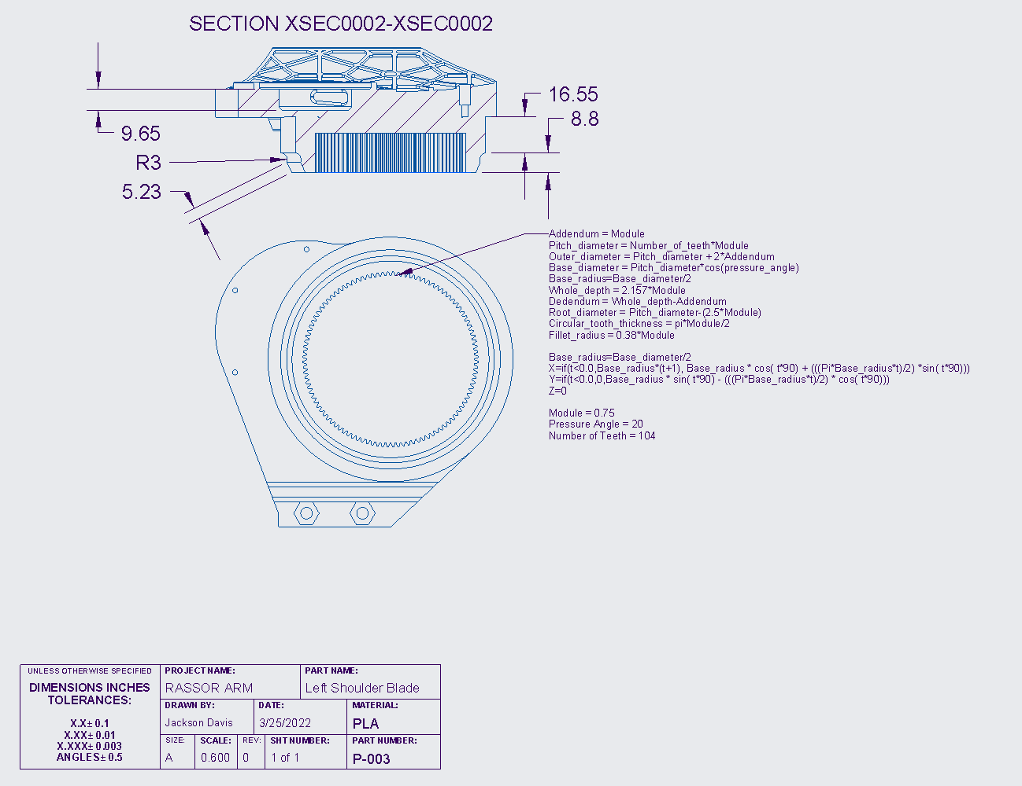
Figure 11: Drawing of the Left Shoulder Blade

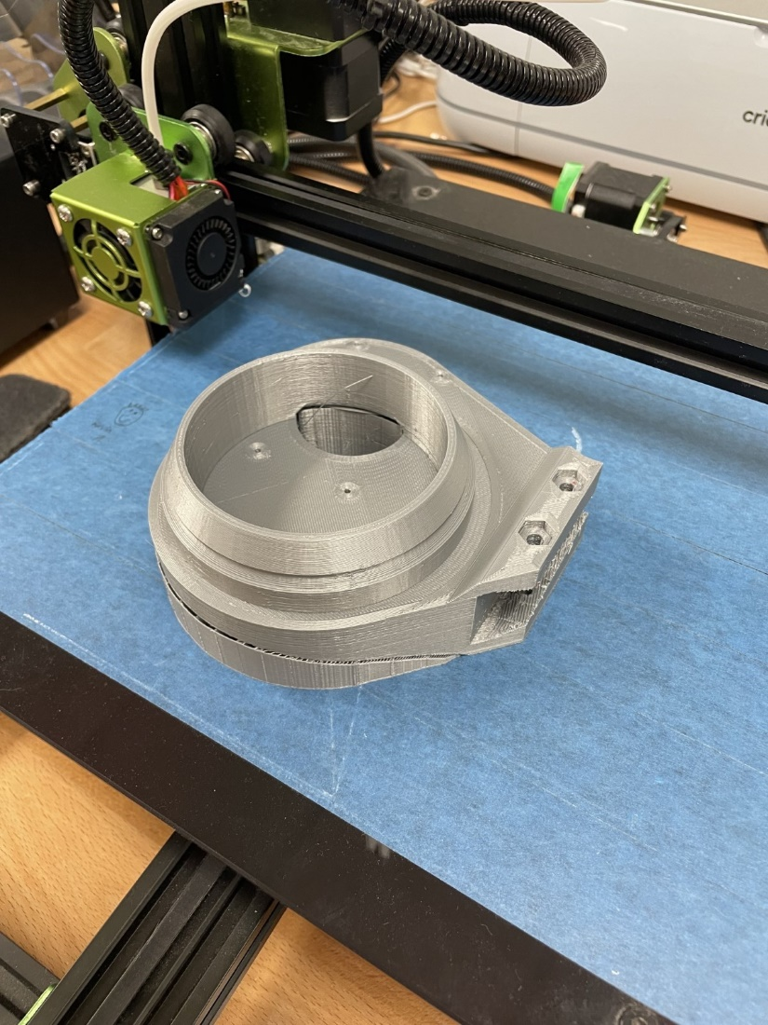
Figure 12: 3D-Print Layout of Left Shoulder Blade
Below in Figure 13 is the Left Bearing, it connects to the Left Shoulder Blade and is the second half of the left bearing that is used to reduce friction in the system and to keep the entire system in line. The bearing carries no load. The part’s dimensions are shown and can be used to recreate the part in Creo.
Creating the part in Creo starts by selecting the bottom plane and drawing the overall profile of the bearing that can be seen if you look at the part from the front view. Next, you can select the drawing you just made and extrude it. Note that the part's external holes are oriented in a specific way. 3 holes are arranged to where one is at the bottom dead center and the remaining two flanks on either side 90 degrees from the first hole. The remaining 4 holes are placed 40 degrees from the two flanking holes. After the extrusion is made you can select different surfaces and make the proper extrusions to subtract material. You can also use the revolve tool to aid in removing material.
After the part is finished you can save it. After saving you can save a copy of the part and set it as a STL file. From here you can upload the file to whatever slicing software you have. For this part you will set the layer thickness to whatever is appropriate for your printer, set the wall thickness to between 2.4 mm (about 0.09 in) and set the infill to 20-25%. This is the setting we used during testing. For this part support structures are not needed. This part should be centered with the bottom of the part on the platform. The way the part is oriented is shown below in Figure 14.

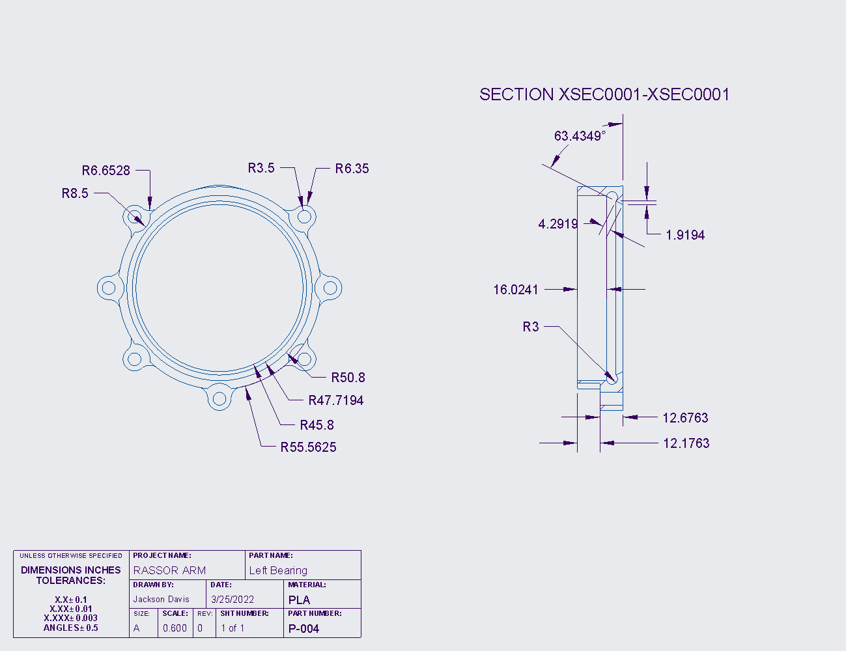 Figure 13: Drawing of the Left Bearing

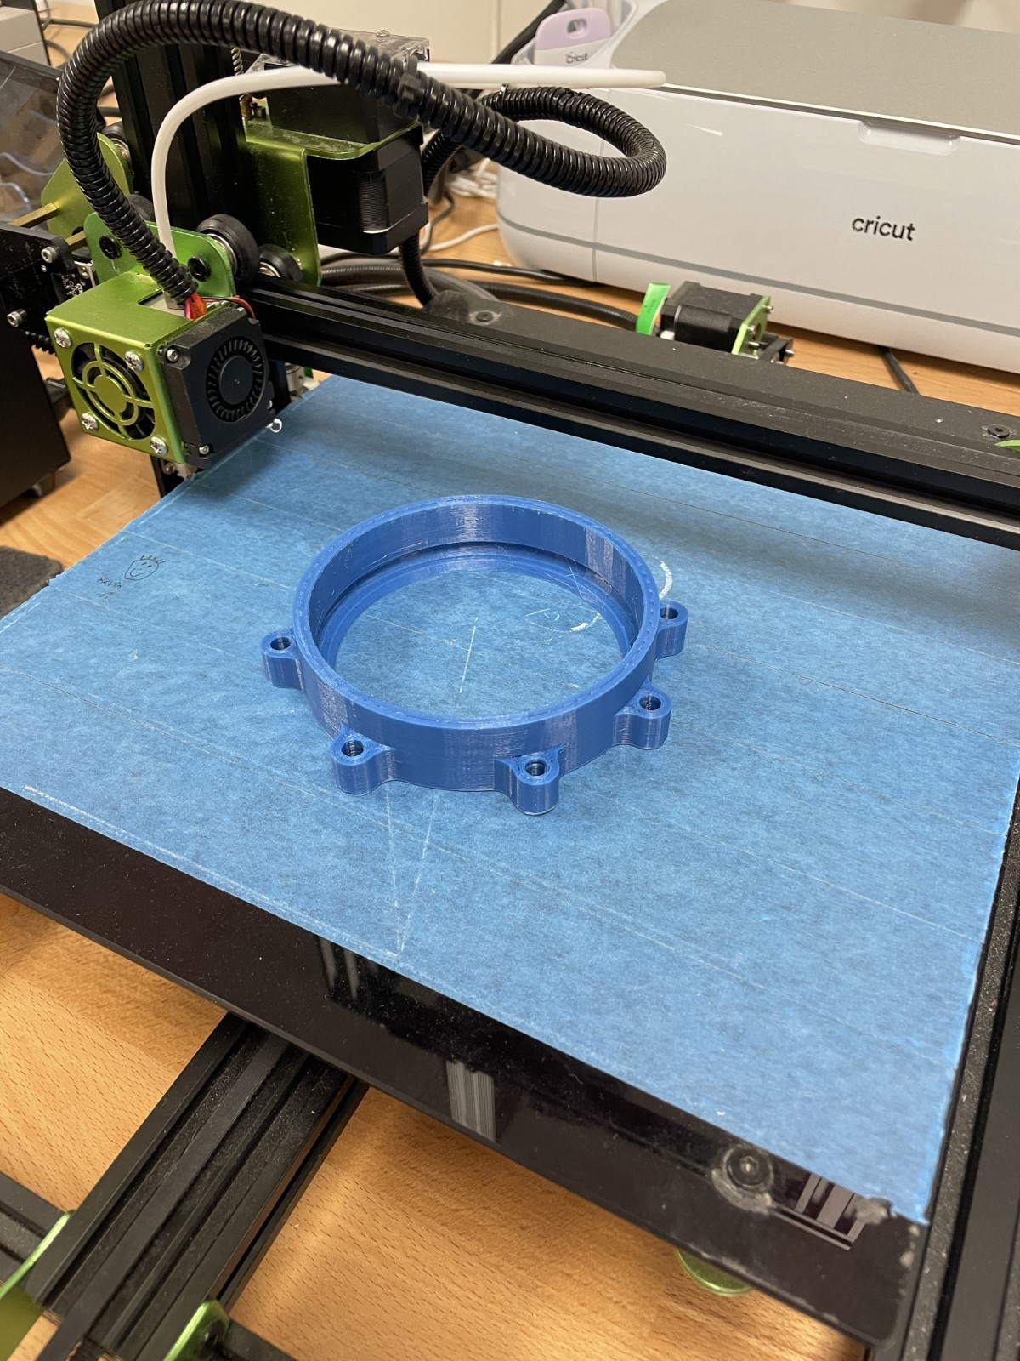 Figure 14: 3D-Print Layout of Left and Right Bearing
Below in Figure 15 is the Right Bearing, it connects to the Right Shoulder Blade and is the second half of the Right bearing that is used to reduce friction in the system and to keep the entire system in line. The bearing carries no load. The part’s dimensions are shown and can be used to recreate the part in Creo.
Creating the part in Creo starts by selecting the bottom plane and drawing the overall profile of the bearing that can be seen if you look at the part from the front view. Next you can select the drawing you just made and extrude it. Note that the parts external holes are oriented a specific way. 3 holes are arranged to where one is at bottom dead center and the remaining two flank either side 90 degrees from the first hole. The remaining 4 holes are placed 40 degrees from the two flanking holes. After the extrusion is made you can select different surfaces and make the proper extrusions to subtract material. You can also use the revolve tool to aid in removing material.
After the part is finished you can save it. After saving you can save a copy of the part and set it as a STL file. From here you can upload the file to whatever slicing software you have. For this part you will set the layer thickness to whatever is appropriate for your printer, set the wall thickness to between 2.4 mm (about 0.09 in) and set the infill to 20-25%. This is the setting we used during testing. For this part support structures are not needed. This part should be centered with the bottom of the part on the platform. The way the part is oriented is shown below in Figure 14.
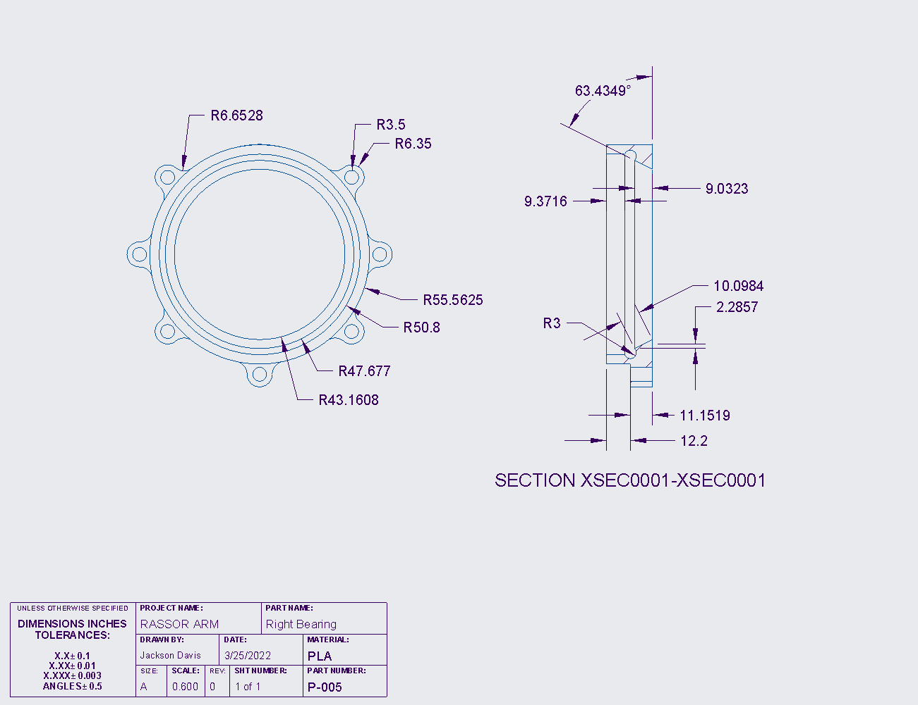 Figure 15: Drawing of the Right Bearing
Below in Figure 16 is the Motor Mount, it holds the motor in place during operation and serves as a mount for the arm. The Motor Mount carries a load when the system is running. The part’s dimensions are shown and can be used to recreate the part in Creo.
Creating the part in Creo starts by selecting the bottom plane and drawing the overall profile of the Motor mount that can be seen if you look at the part from the bottom view. Next you can select the drawing you just made and extrude it. Note that the parts external holes are oriented a specific way. 3 holes are arranged to where one is at bottom dead center and the remaining two flank either side 90 degrees from the first hole. The remaining 4 holes are placed 40 degrees from the two flanking holes. After the extrusion is made you can select different surfaces and make the proper extrusions to subtract material. You can also use the revolve tool to aid in removing material.
To make the flange that holds the arm you can make a drawing on the front plane that matches the profile to the interior of the flange with an external offset of 3.175mm (about 0.12 in). You can then extrude this drawing. By using the extrude tool you can make the flange by removing and adding material.
After the part is finished you can save it. After saving you can save a copy of the part and set it as an STL file. From here you can upload the file to whatever slicing software you have. For this part, you will set the layer thickness to whatever is appropriate for your printer, set the wall thickness to between 2.8-3.2 mm (about 0.13 in) (about 0.13 in), set the infill to 30%. This is the setting we used during testing. For this, part support structures are needed. This part should be centered with the bottom of the part on the platform. The way the part is oriented is shown below in F in Figure 17.
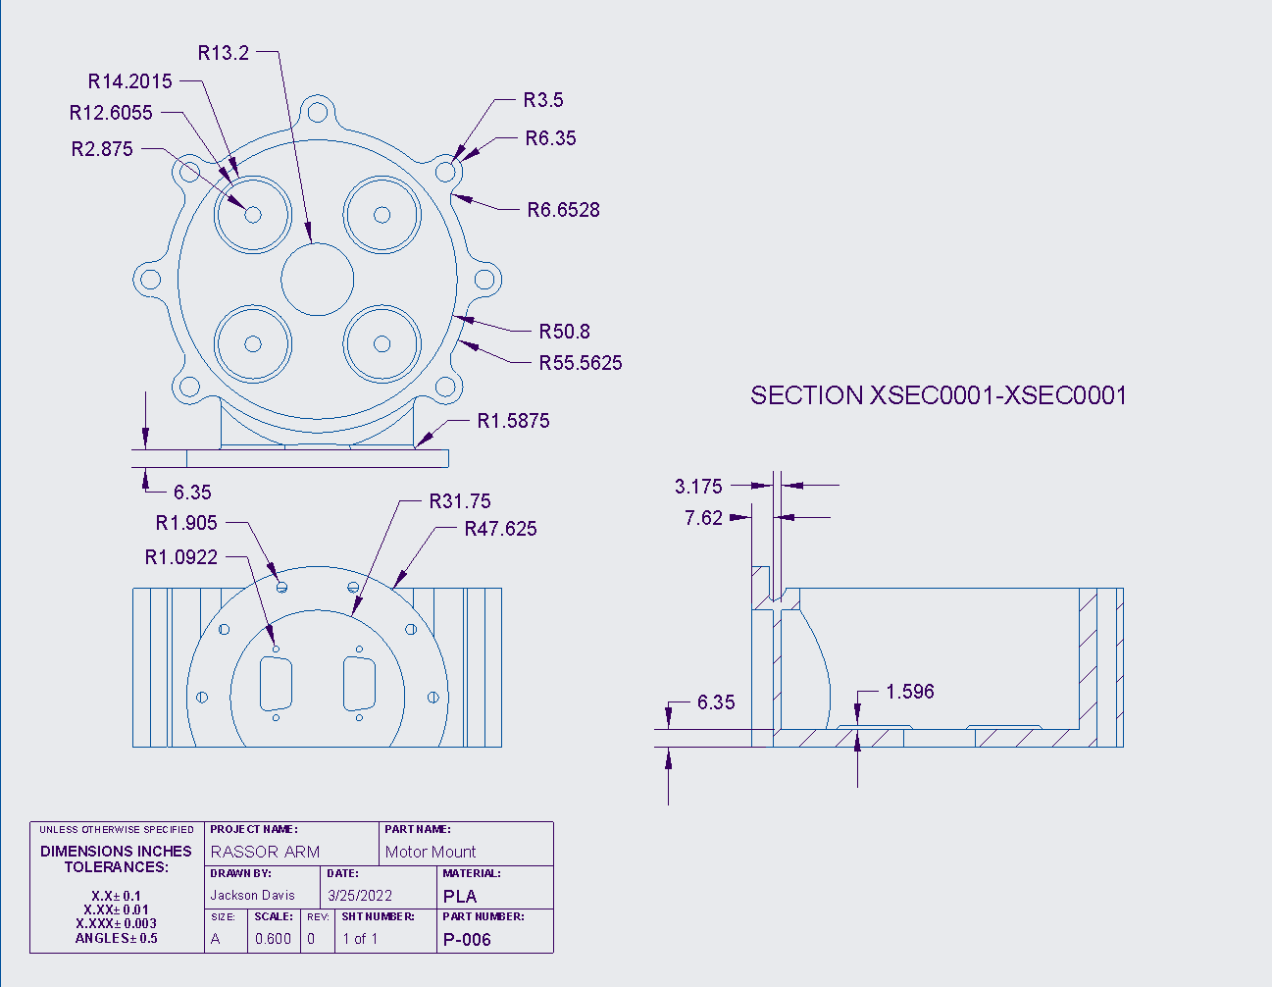 Figure 16 Drawing of the Motor Mount

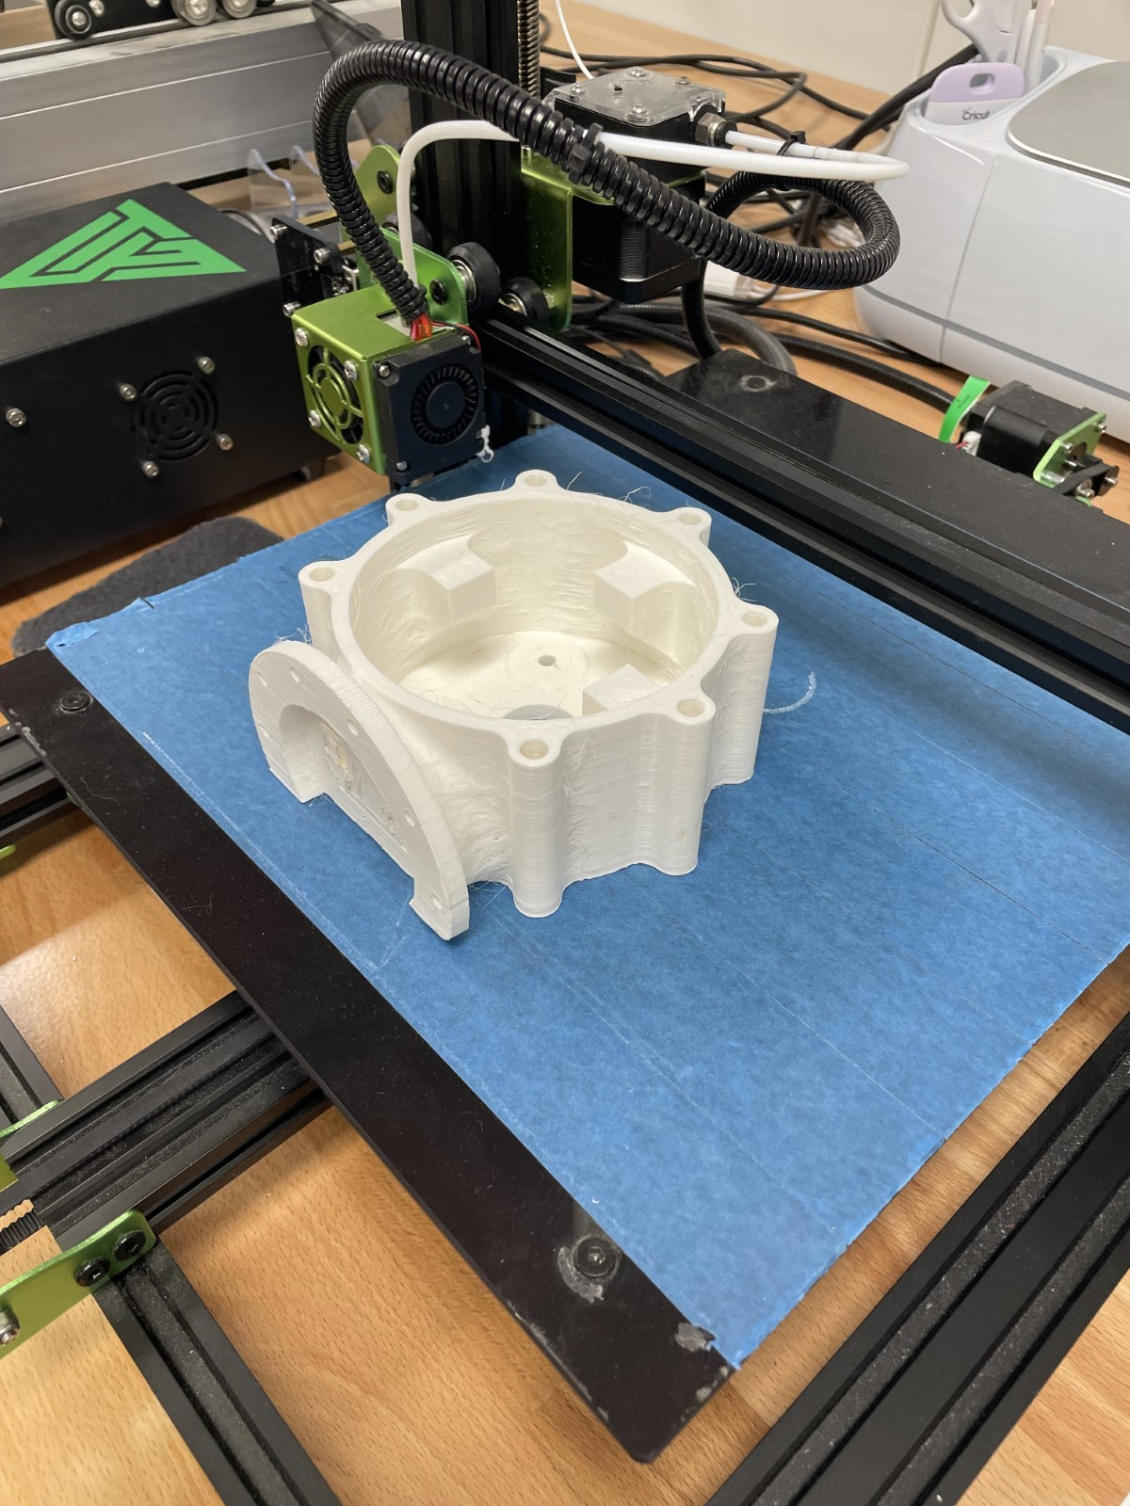 Figure 17 3D-Print Layout for Motor Mount

Below in Figure 18 is the Sun Gear, it is the input gear to the system and attaches directly to the Motor. The part carries a small load in comparison to the rest of the load bearing parts. The part’s dimensions are shown and can be used to recreate the part in Creo.
Creating the part in Creo starts by selecting the bottom plane and drawing a circle to the outer diameter given and extruding it. Next you can upload the parameters given at the bottom of the note on the drawing by selecting the tool tab and then selecting parameters. Then you can set the relations which are given at the top of the note by selecting the tool tab again and selecting relations after. From here you can use these parameters to make the outer diameter, root diameter, pitch diameter, and base diameter. With these diameters you can use the datum line tool to create an involute profile for the teeth. You can do this by selecting the line datum and selecting datum line by equation. The equation that you will use is the last portion of the not given in the drawing. After making the involute curve you can set a drawing that starts from the edge of the involute curve and travels along the pitch diameter until it reaches the circular tooth thickness. You can then place a datum point halfway on the line. With this datum point you can mirror the involute line to the other side and finish the profile of the gear tooth. Next you can extrude this profile and pattern is around the center axis of the part. There should be 24 teeth for this part. After the part is finished you can save it.
After saving you can save a copy of the part and set it as an STL file. From here you can upload the file to whatever slicing software you have. For this part you will set the layer thickness to whatever is appropriate for your printer, set the wall thickness to between 2.8-3.2 mm (about 0.13 in) and set the infill to 30-75%. This is the setting we used during testing. For this part support structures are needed. This part should be centered with the bottom of the part on the platform. The way the part is oriented is shown below in Figure 19.

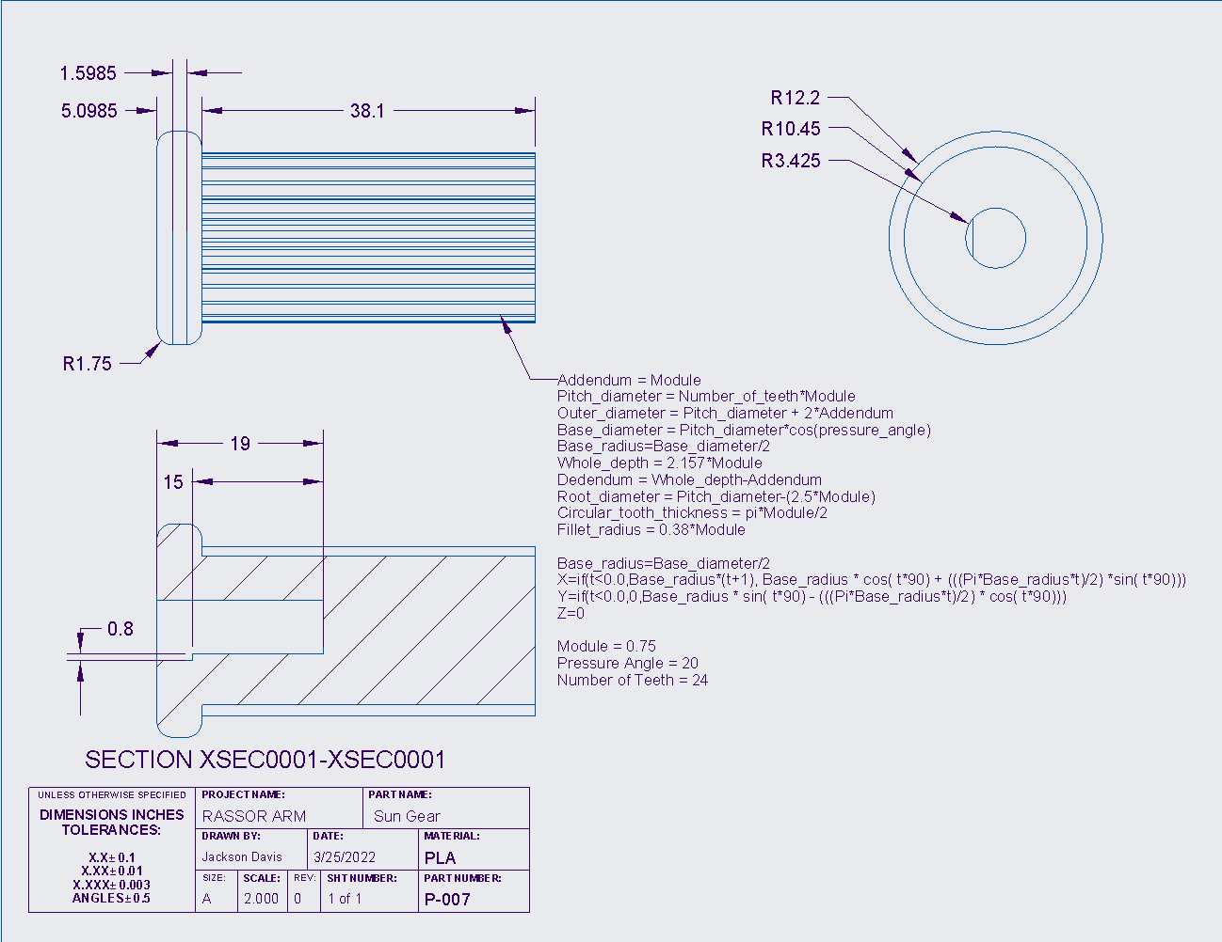 Figure 18: Drawing of the Sun Gear

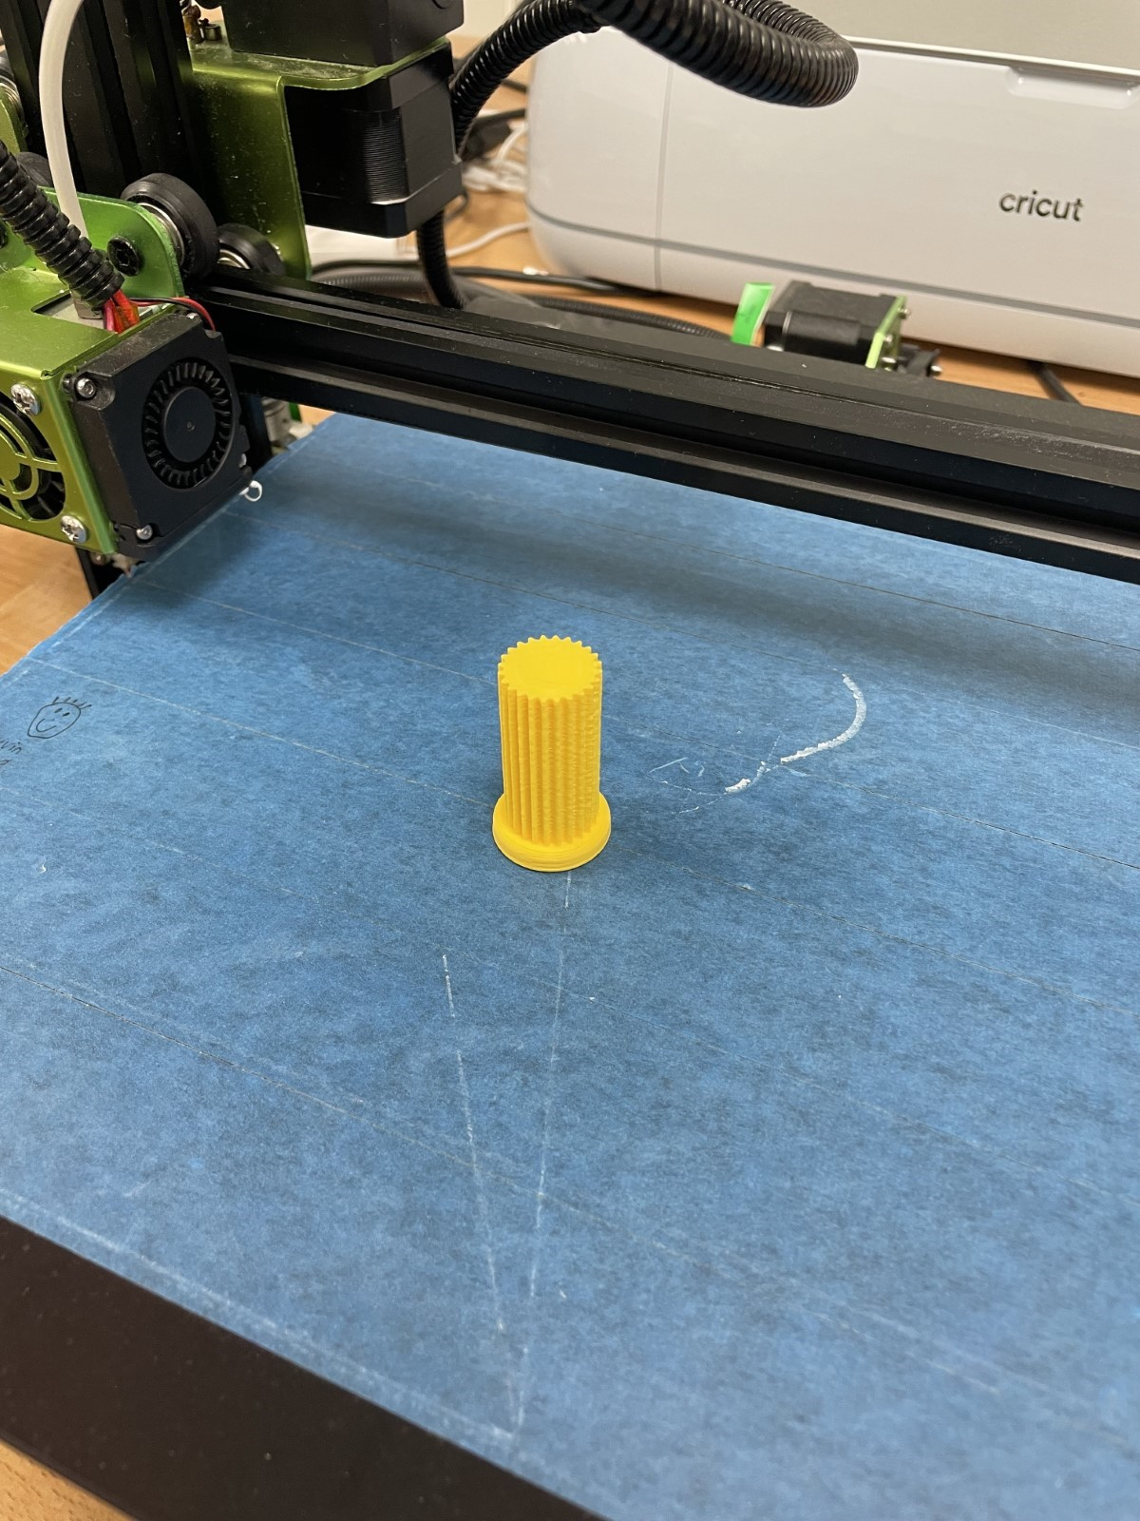 Figure 19: 3D-Print Layout for Sun Gear

Below in Figure 20 is the Planet Gear, it is 1 of 3 planet gears that are used to press the harmonic gear to the same diameter as the right shoulder blade’s gear diameter. There is a spring force from the harmonic gear and a torque from the gearbox’s operation that is applied to the planetary gears generating a larger load than what the sun gear experiences. The part’s dimensions are shown and can be used to recreate the part in Creo.
Creating the part in Creo starts by uploading the parameters given at the bottom of the note on the drawing by selecting the tool tab and then selecting parameters. Then you can set the relations which are given at the top of the note by selecting the tool tab again and selecting relations after. From here you can use these parameters to make the outer diameter, root diameter, pitch diameter, and base diameter. With these diameters you can use the datum line tool to create an involute profile for the teeth. You can do this by selecting the line datum and selecting datum line by equation. The equation that you will use is the last portion of the not given in the drawing. After making the involute curve you can set a drawing that starts from the edge of the involute curve and travels along the pitch diameter until it reaches the circular tooth thickness. You can then place a datum point halfway on the line. With this datum point you can mirror the involute line to the other side and finish the profile of the gear tooth. Next you can extrude this profile and pattern is around the center axis of the part. There should be 40 teeth for this part.
After the part is finished you can save it. After saving you can save a copy of the part and set it as an STL file. From here you can upload the file to whatever slicing software you have. For this part you will set the layer thickness to whatever is appropriate for your printer, set the wall thickness to between 2.8-3.2 mm (about 0.13 in) and set the infill to 30-75%. This is the setting we used during testing. For this part support structures are not needed. This part should be centered with the bottom of the part on the platform. The way the part is oriented is shown below in Figure 21.
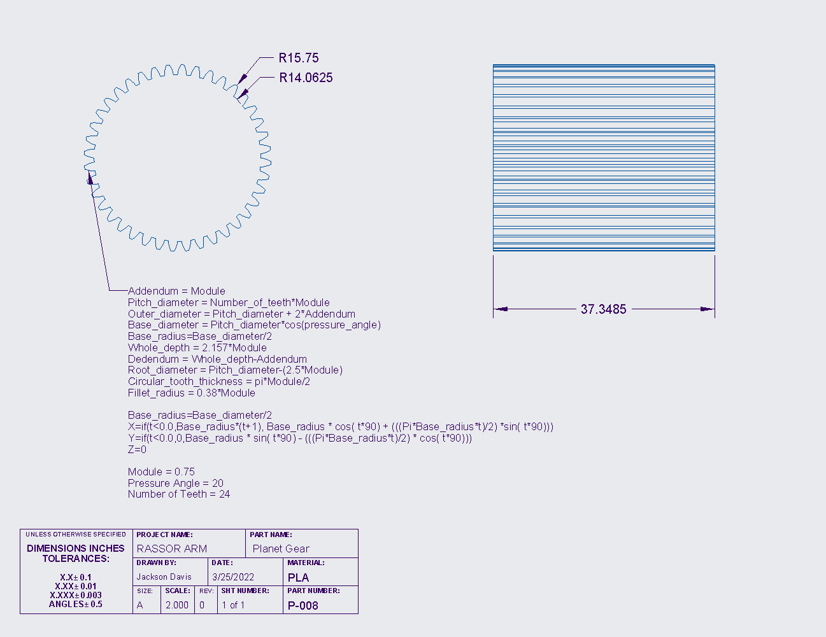 Figure 20: Drawing of Planetary Gear

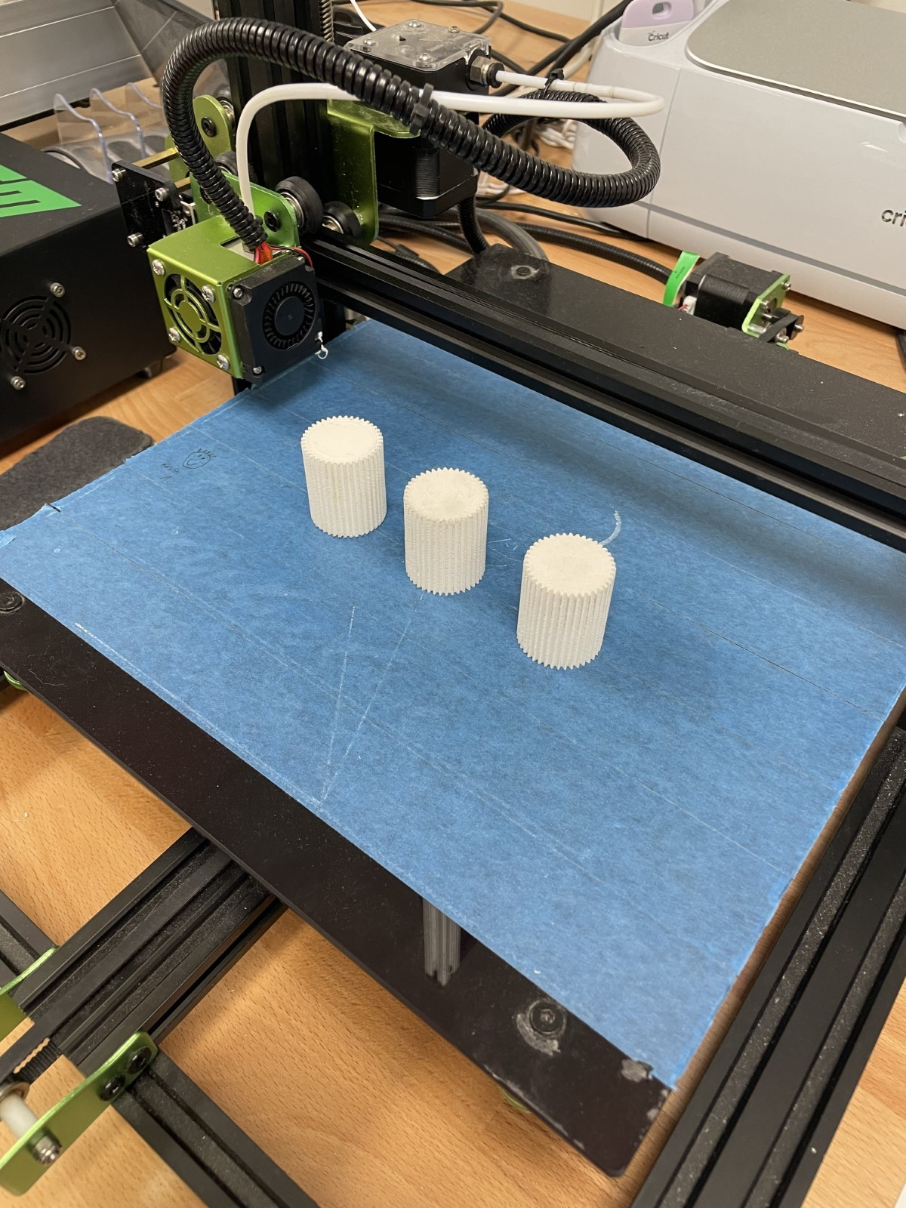 Figure 21: 3D-Print Layout for Planet Gears

Below in Figure 22 is the Harmonic Gear, it is our output gear and drives the entire system. This part experiences the most load in the entire system. The part’s dimensions are shown and can be used to recreate the part in Creo.
Creating the part in Creo starts by drawing the overall profile of the Harmonic Gear that can be seen if you look at the part from the bottom view. Next you can select the drawing you just made and extrude it. Note that the parts external holes are oriented a specific way. 3 holes are arranged to where one is at bottom dead center and the remaining two flank either side 90 degrees from the first hole. The remaining 4 holes are placed 40 degrees from the two flanking holes.
Next you can draw the profile of the compliant mechanism given in the drawing. This profile can be extruded and patterned with a total of 16 profile holes.
Next you can upload the parameters given at the bottom of the note on the drawing by selecting the tool tab and then selecting parameters. Then you can set the relations which are given at the top of the note by selecting the tool tab again and selecting relations after. From here you can use these parameters to make the outer diameter, root diameter, pitch diameter, and base diameter. With these diameters you can use the datum line tool to create an involute profile for the teeth. You can do this by selecting the line datum and selecting datum line by equation. The equation that you will use is the last portion of the not given in the drawing. After making the involute curve you can set a drawing that starts from the edge of the involute curve and travels along the pitch diameter until it reaches the circular tooth thickness. You can then place a datum point halfway on the line. With this datum point you can mirror the involute line to the other side and finish the profile of the gear tooth. Next you can extrude this profile and pattern is around the center axis of the part. There should be 100 teeth for this part.
Finally, you can make the flange that holds the arm by setting a plane on the front plane and offsetting it to the outer shell of the harmonic gear. On this plane you can make a drawing that matches the profile to the interior of the flange with an external offset of 3.175mm (about 0.12 in). You can then extrude this drawing. By using the extrude tool you can make the flange by removing and adding material.
After the part is finished you can save it. After saving you can save a copy of the part and set it as a STL file. From here you can upload the file to whatever slicing software you have. For this part you will set the layer thickness to whatever is appropriate for your printer, set the wall thickness to 3.2 mm (about 0.13 in) and set the infill to 30%. This is the setting we used during testing. For this part support structures are needed. This part should be centered with the bottom of the part on the platform. The way the part is oriented is shown below in Figure 23.

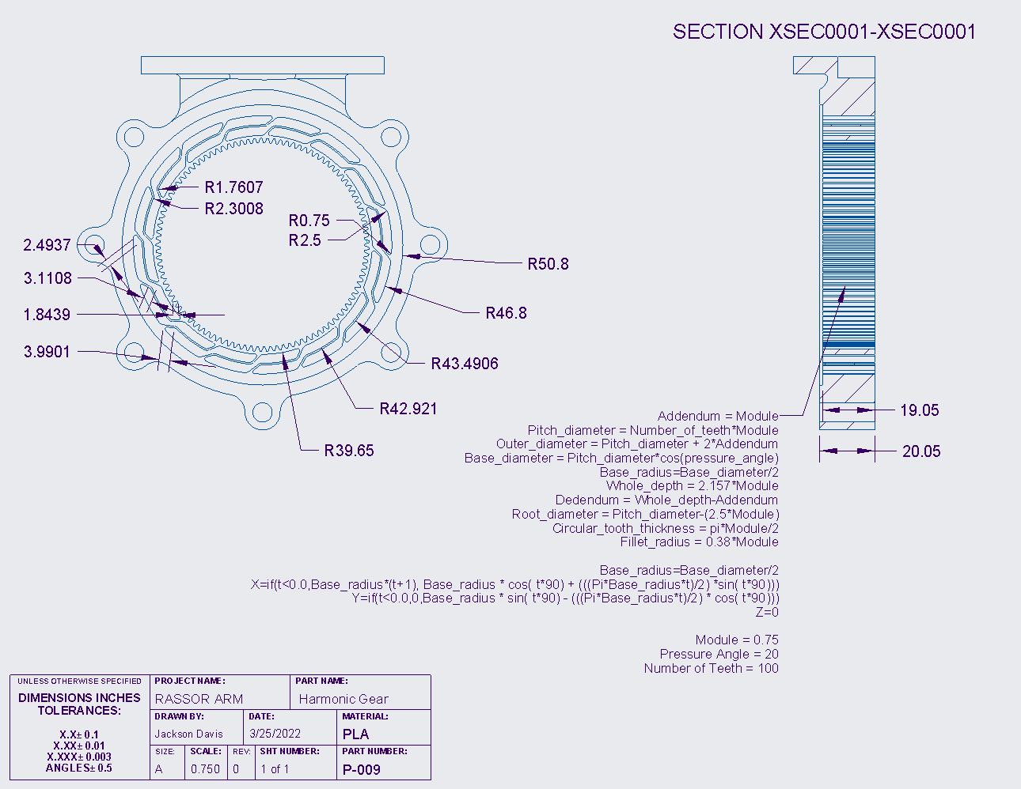 Figure 22: Drawing of Harmonic Gear

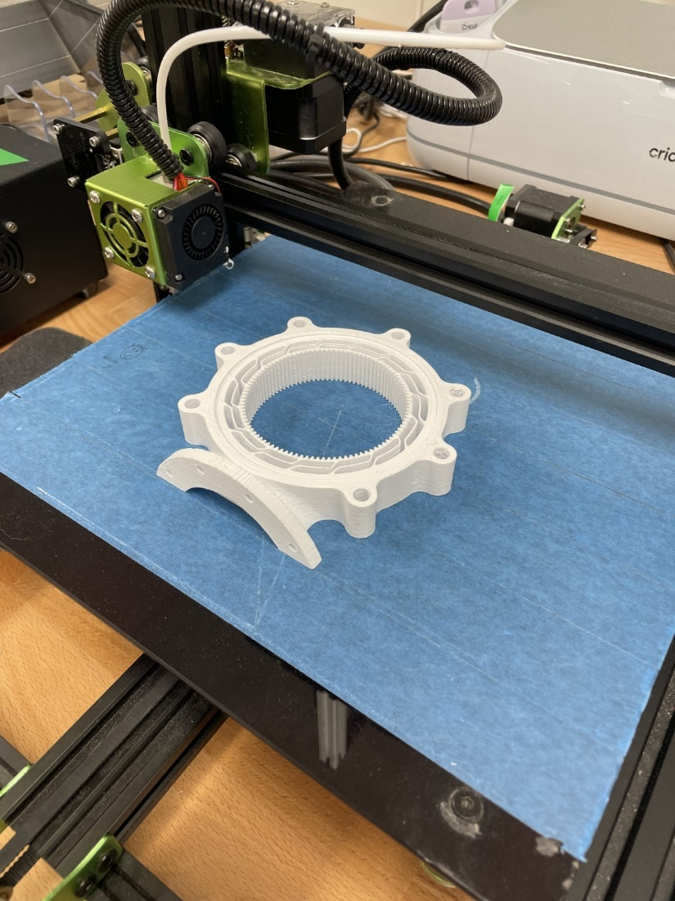
Figure 23: 3D-Print Layout of Harmonic Gear
After all parts have been made you can make an assembly and add the parts that you have made. By setting the proper constraints the assembly should eventually look like Figure 24a-c.
Figure 24a
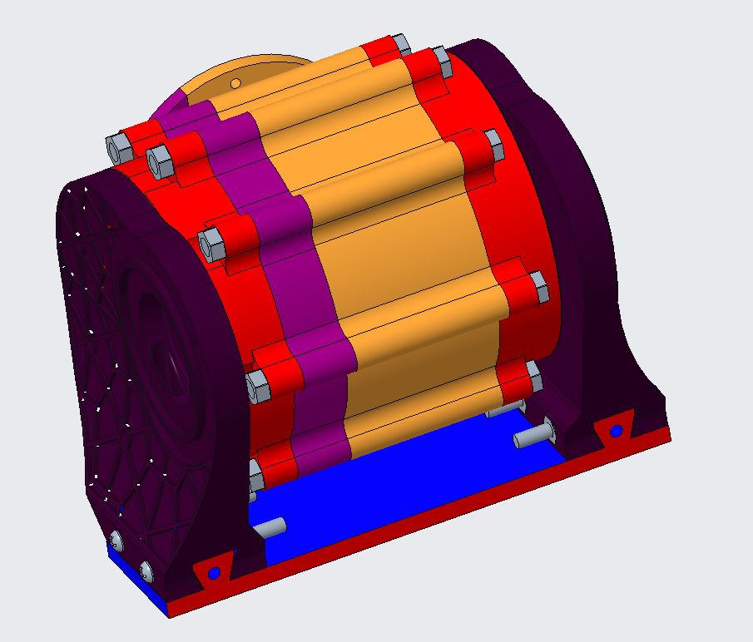
Figure 24b
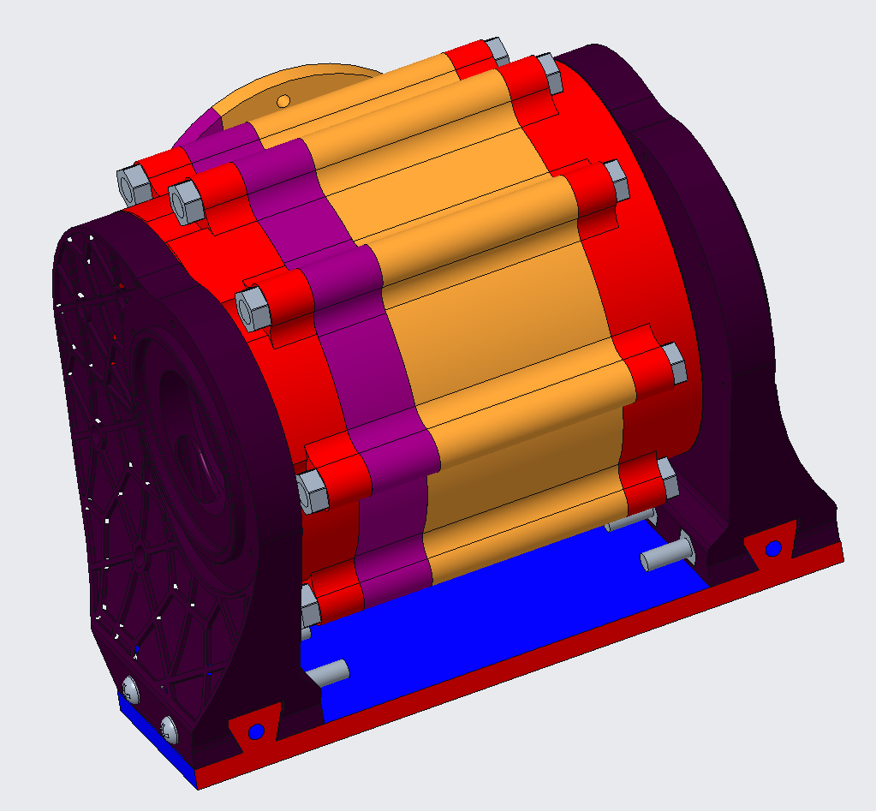
Figure 24c
The additional parts including the motor and nuts and bolts can be purchased off Amazon and Home Depot However they can be ordered from McMaster-Carr and “Other Vendor”. The screws and bolts used were 4 #8-32x1-1/4in Flat head screws, #8-32x1-1/2in Phillips head screws, and an 11mmx5in bolt. The nuts used were a #8-32 nut and an 11mm nut.
The stepper motor is a Nema 23 that puts out 1.9 Nm of torque. It is 77mm in depth with a quarter-inch output shaft. We are running this motor with a RAMPS board. We are also using standard 6mm BB’s that can be purchased at Walmart for the balls for our ball bearings.

Printing Parts
All STL files for this project can be found in the folder below:
https://drive.google.com/drive/folders/1ramL2J5DWkxRTX-dNWjKdK5XjYMY8uas?usp=sharing
Note: Need to print 3 of the “40_tooth_planet_gear” to complete the build
All parts were printed on a Dremel 3D45 Idea Builder using 1.75mm PLA filament (Standard 4mm should work just as well). Below are the parameters used on all the prints:
- Nozzle Diameter: 0.4 mm
- Layer Thickness: 0.3 mm
- Shell Thickness: 1.2 mm (Most parts can be printed with lower thickness to save time)
- Infill: 25%
- Infill pattern: Honeycomb (cubic)
- Extruder Temperature: 205 °C
- Heated Bed Temperature: 55 °C (If no heated bed, painter’s tape is recommended)
- Fan Speed: 100%
- Filament flow: 95%
- Supports: Everywhere
- Support Type: Grid
- Bottom Layer Speed: 10 mm/s
- Print Speed: 40 mm/s
- Traveling Speed: 130 mm/s
- Retraction Distance: 0.8 mm (Stringing still occurs, but with no structural effects)
- Minimal Layer Time: 5 seconds
Figures 5, 9, 12, 14, 17, 19, 21, and 23 demonstrate the correct orientation for printing all parts.
Post processing
- Remove all supports and sand where the supports were connected to make the surfaces smooth.
- Depending on the printer used, sanding will need to be done to the surfaces in contact with the print bed, especially if that surface has gear teeth. Gear teeth in contact with the print bed often print too large on the base layer and need to be sanded or filed down to allow for proper meshing. This is important for the harmonic gear and the planet gears.
Assembly:
Place planet gears (white) around the edge of the harmonic gear (black) and press sun gear (yellow) into the middle of them.
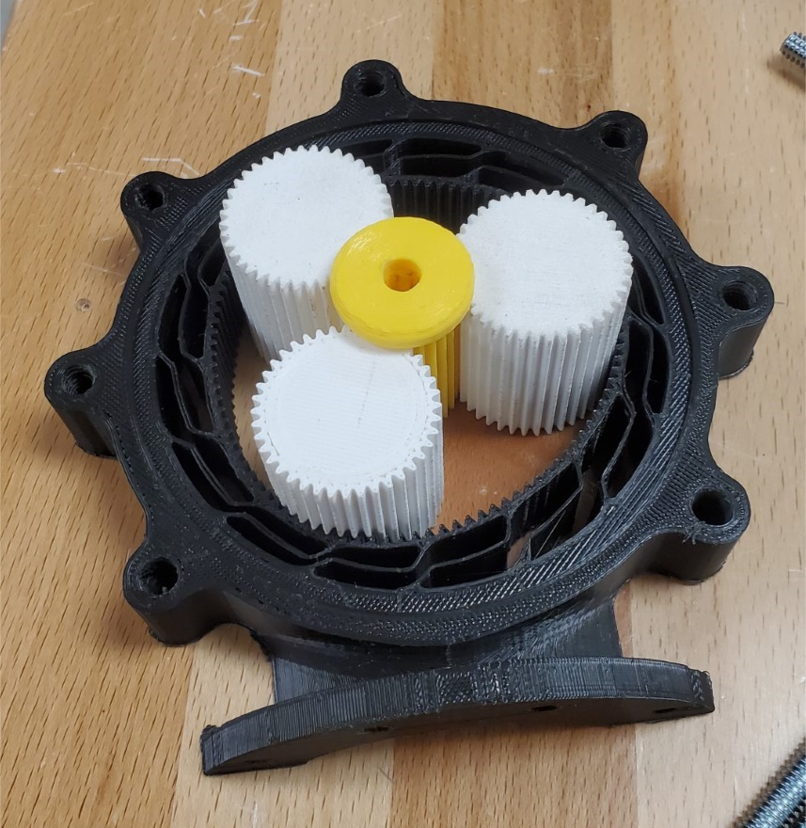
Try to equally space gears around the ring.
Place NEMA23 stepper motor into housing and line up the screw holes.

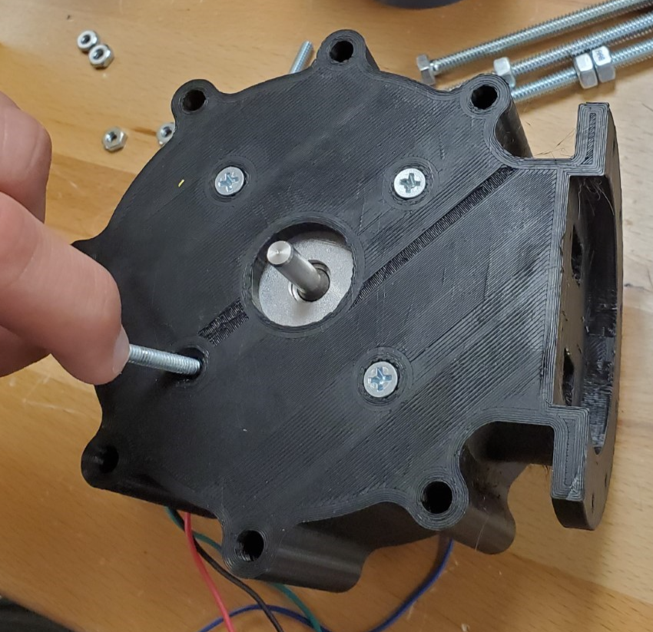
Place screws into the housing so that the heads are flush.
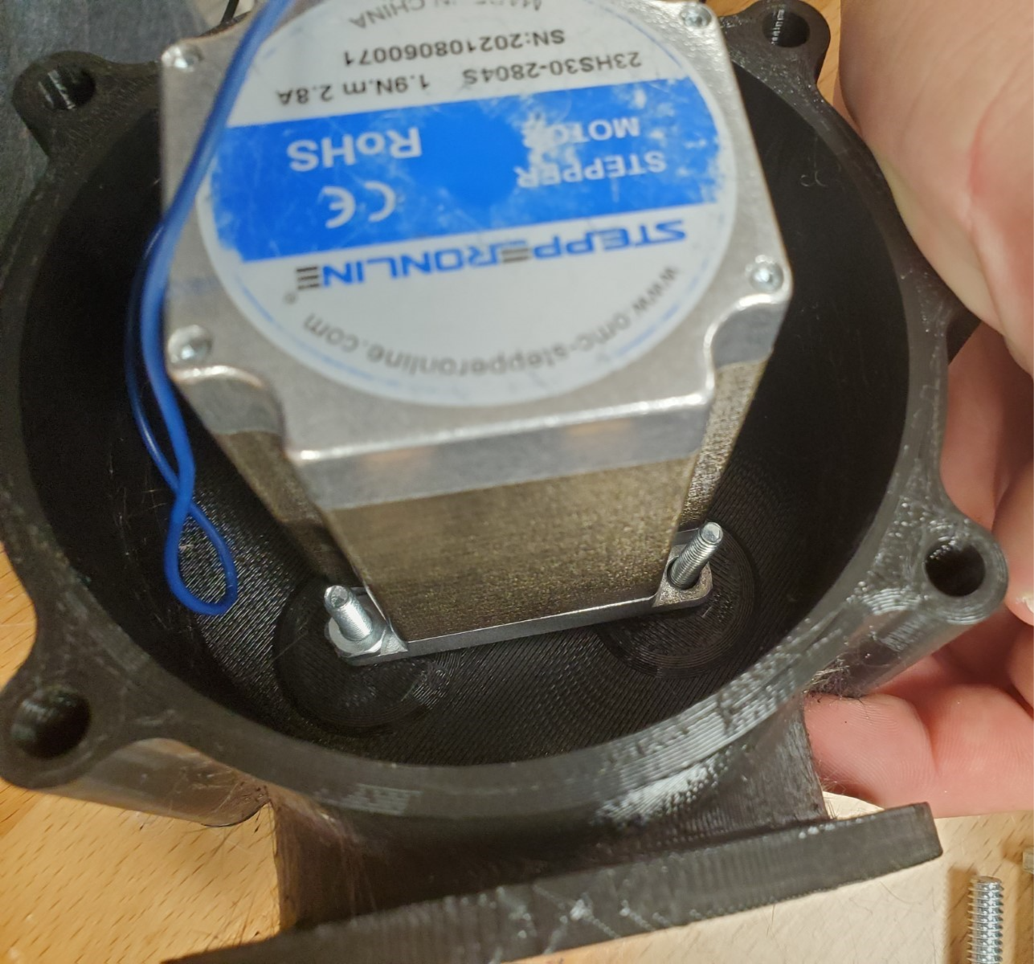
Put nuts on the back end of all four bolts and tighten.
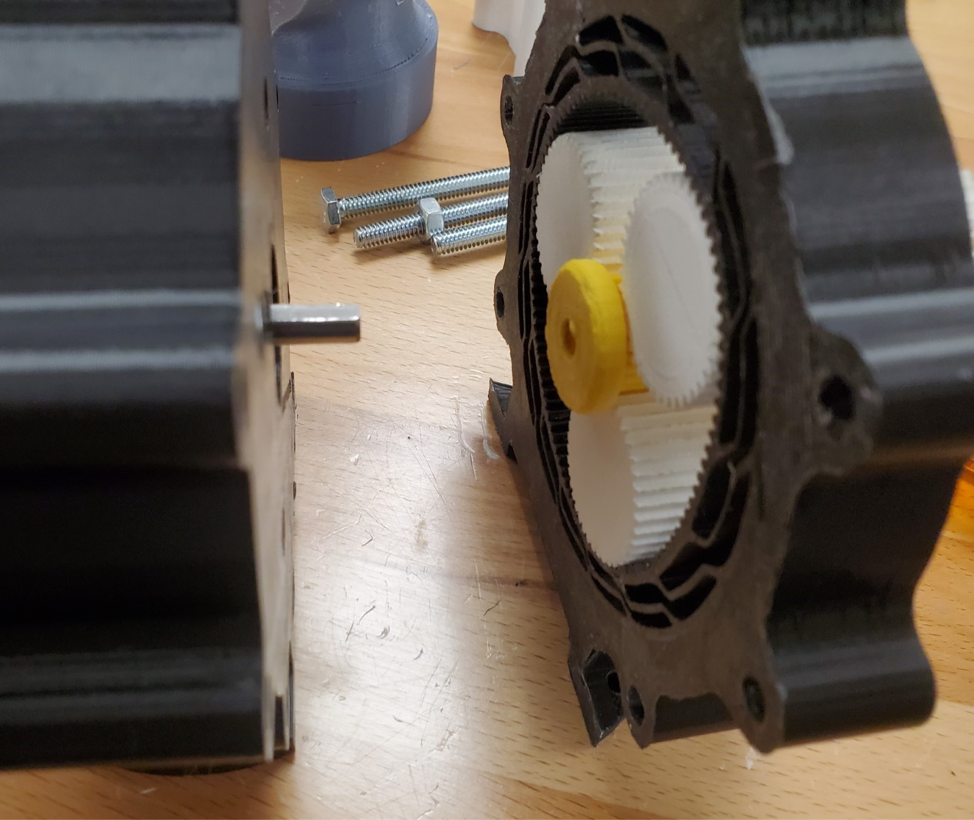
Slide shaft into sun gear (pay attention to orientation of all parts, and line up integrated keyway).
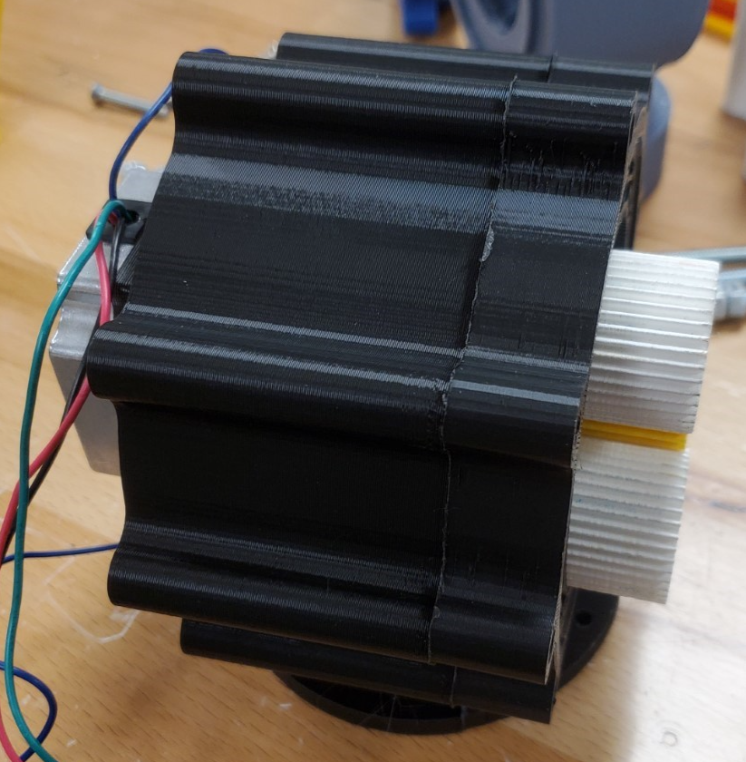
Slide the harmonic gear and the housing flush to each other.
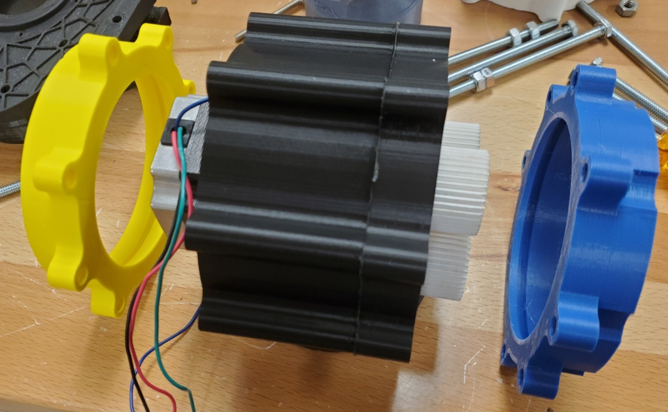
Slide bearing tracks into place, make sure all bolt holes align.
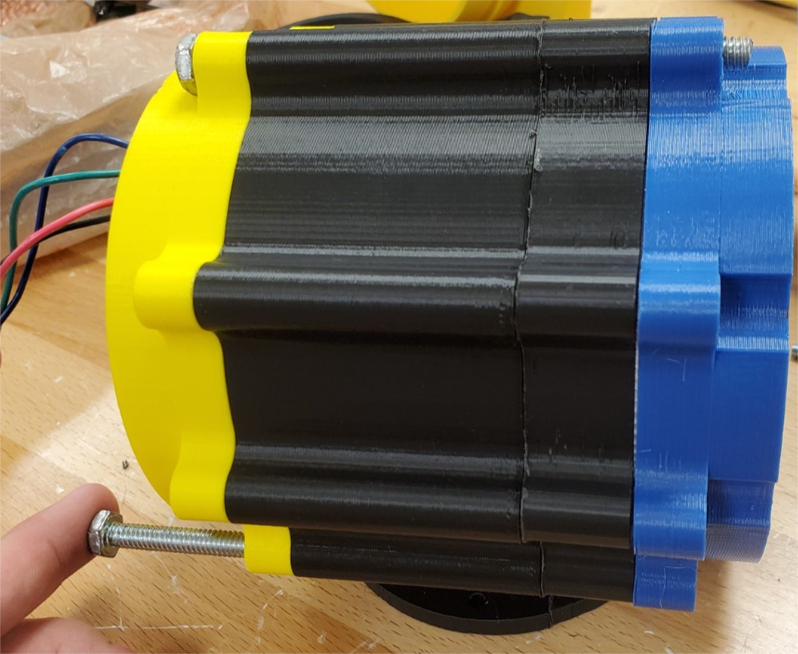
Slide all bolts into housing with threaded end going out the dimpled side.
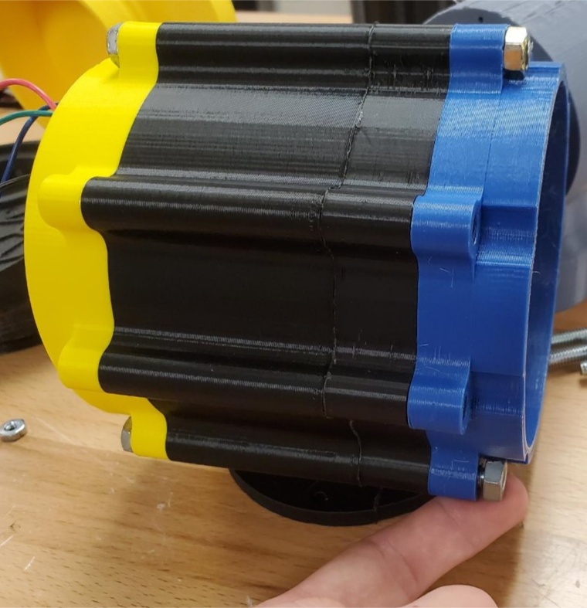
Place nuts on end of bolts and tighten (do not over tighten, just over finger tightness should suffice).
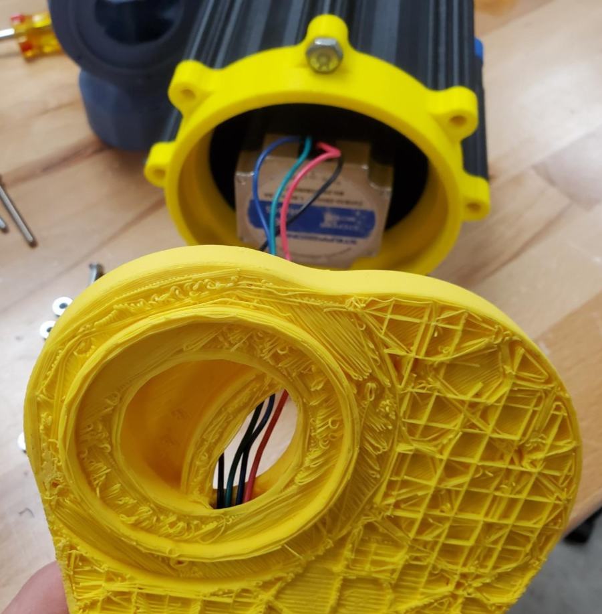
Route stepper motor wires through the hole in shoulder blade.
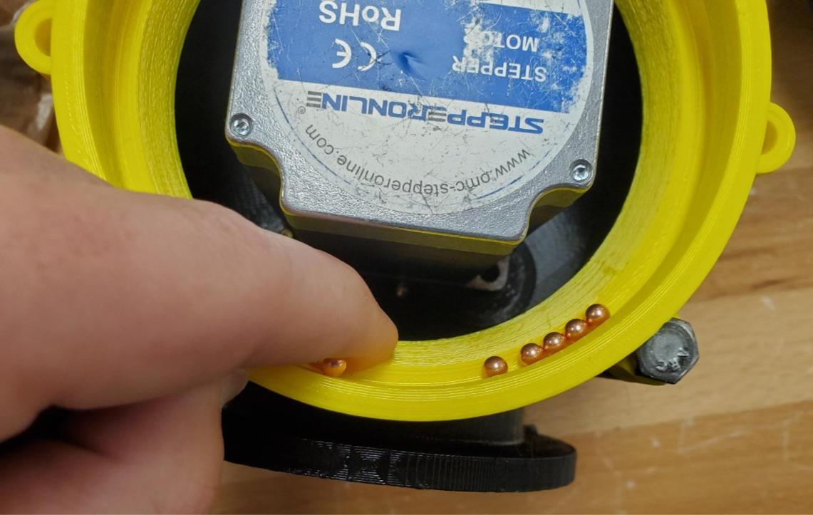
Fill bearing track with 4.5 mm bb’s.
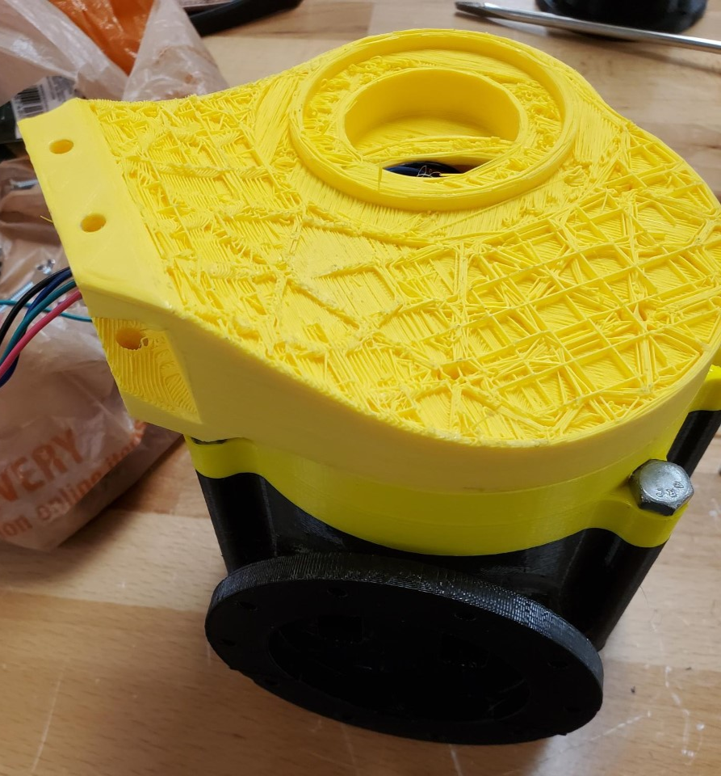
Place shoulder blade on top (MAINTAIN PRESSURE SO THAT BBS DO NOT FALL OUT DURING FURTER ASSEMBLY)
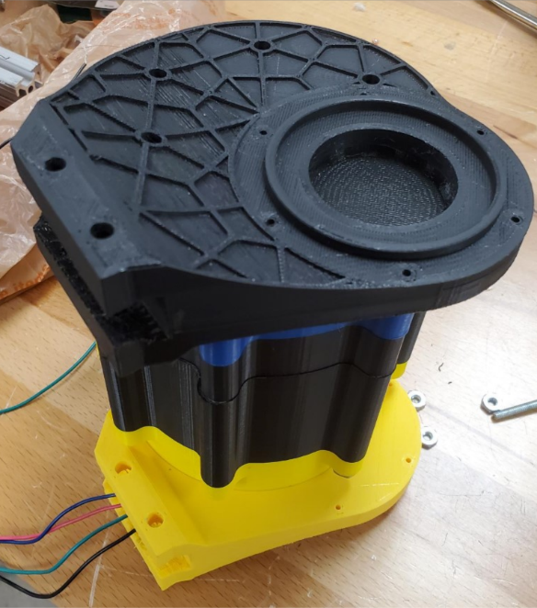
Repeat process in the other bearing track/shoulder blade
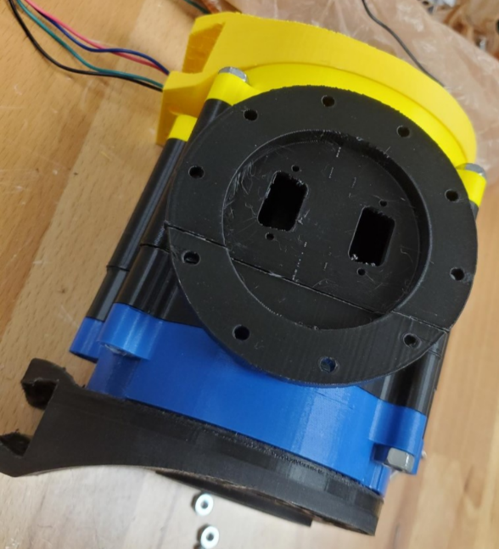
Assembly of the shoulder is complete; you may mount the shoulder system to the body at this point.
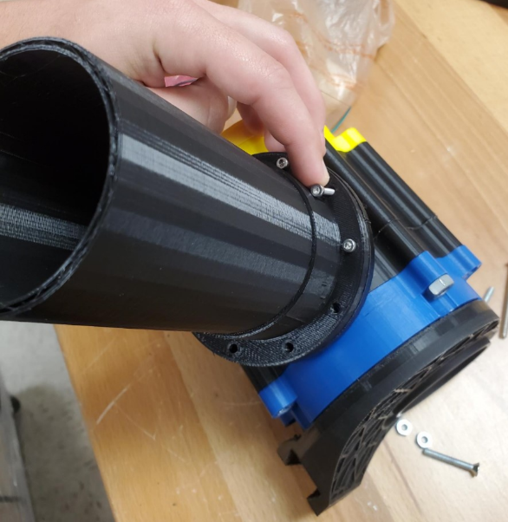
Place and fasten screws around the perimeter of the arm flange
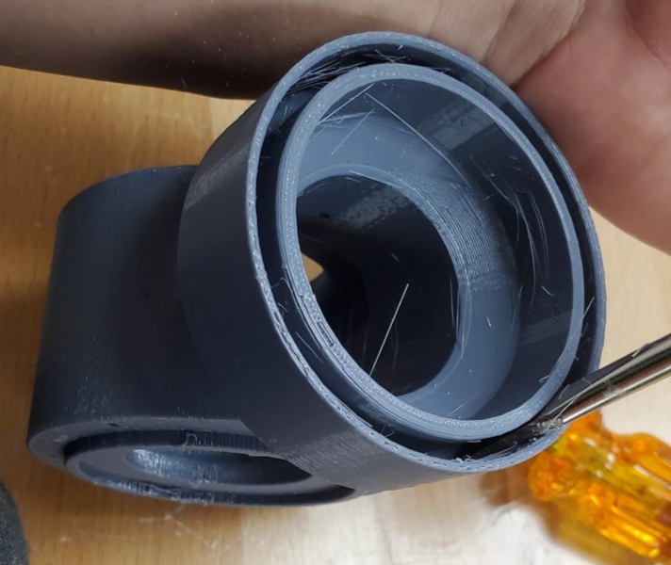
If assembling permanently add glue inside the ring of the knuckle, otherwise a press fit should hold it in place well.
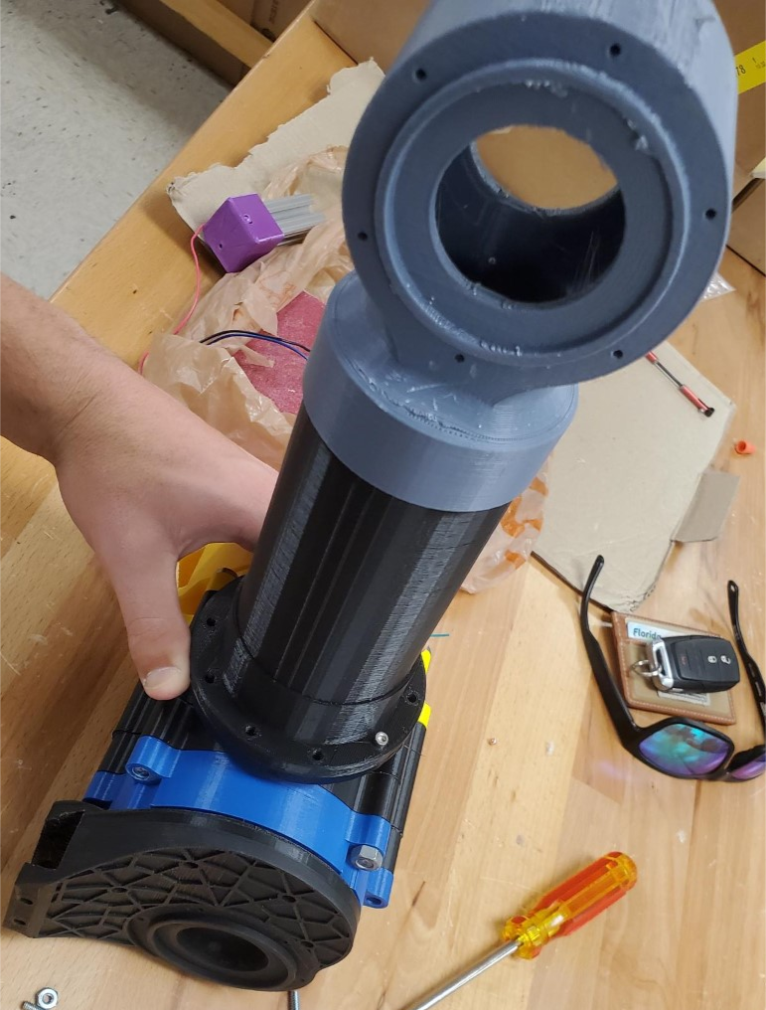
The complete assembly should look like this, ensure the knuckle is perfectly parallel to the shoulder when mounted on the arm before assembling the drum.

Operation
Wiring and Code with a Ramps Board
For this assembly, a RAMPS 1.4, Arduino Mega 2560, (DRIVERS), and Nema 23 are needed. The first step is to align the RAMPS 1.4 pins on top of the Arduino Mega 2560 and join them together.
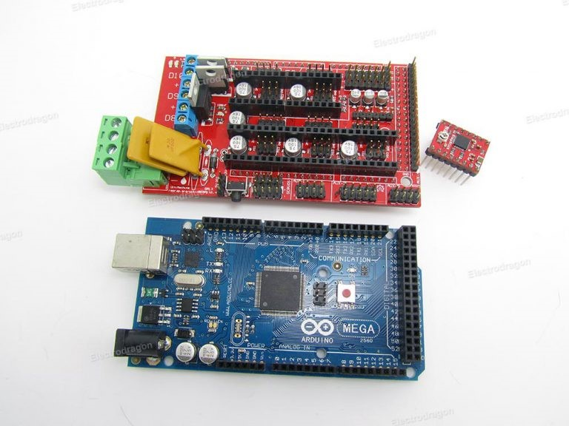
Figure 25
Next place 3 jumpers into the MS 1, 2, and 3 set of pins in X section.
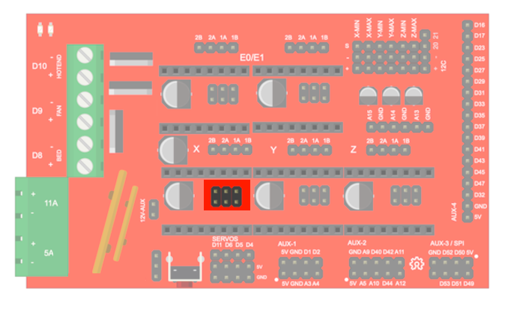
Figure 26
Then connect the driver to these set of pins. Make sure the screw is point away from the power supply.
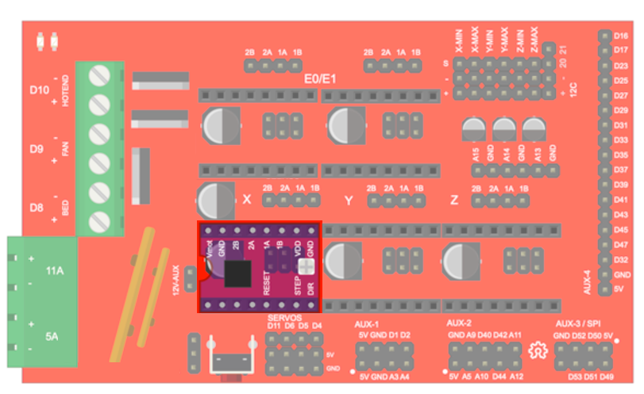 Figure 27
After, connect the stepper motor to 2A 1A 2B 1B with their respective wires in X section. Performing a diode test with two of the wires will tell you if they are a pair.
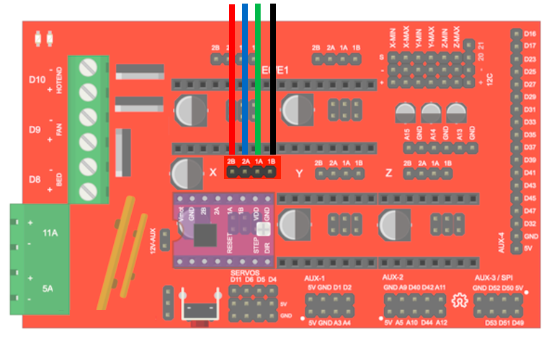
Figure 28
Lastly, with no voltage and current, connect the power supply.
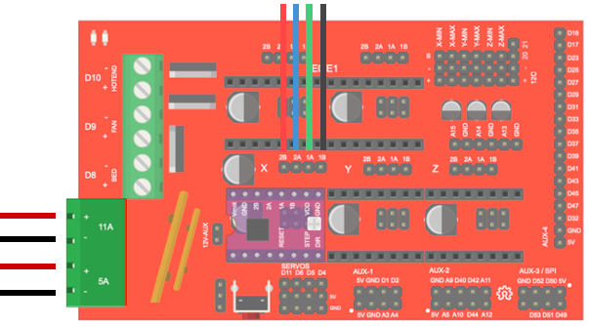
Figure 29
Hook up the Arduino to the computer. When you do, the RAMPS board will signal a light letting you know it is connected. Download https://marlinfw.org/meta/download/ . This code allows the Arduino to communicate to the RAMPS board. Upload the code the Arduino.
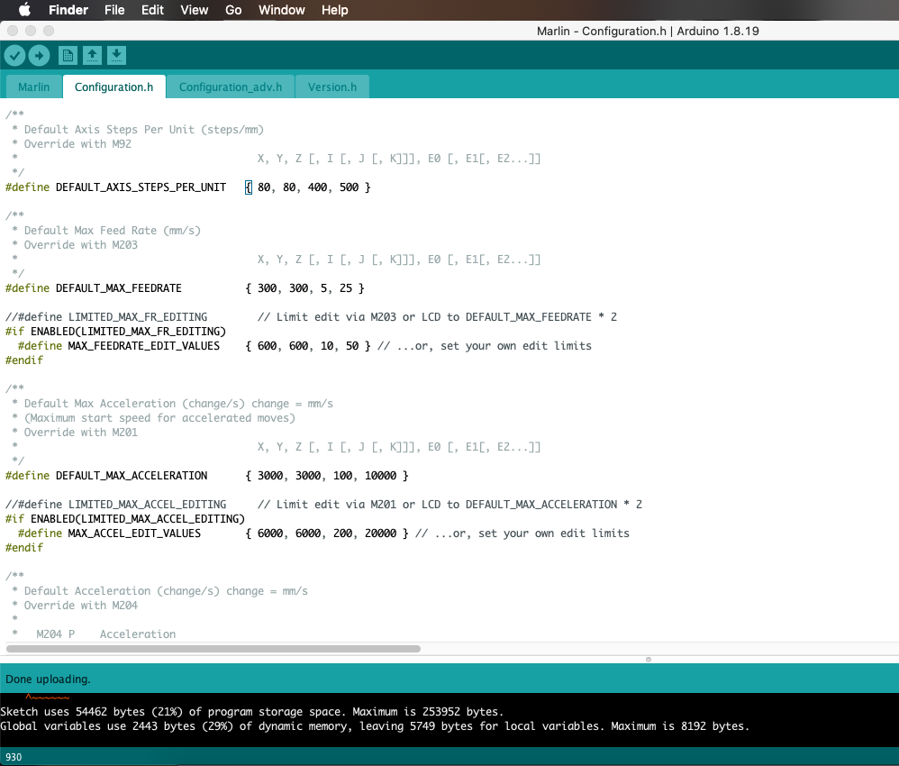
Figure 30: Arduino Code for Ramps Board
Under tools make sure the right board: Arduino Mega or Mega 2560, processor: ATmega2560 (Mega 2560), and port are selected.
Download Pronterface; This software can control up to 6 stepper motors. Make sure that the right port is selected and connected to the device.
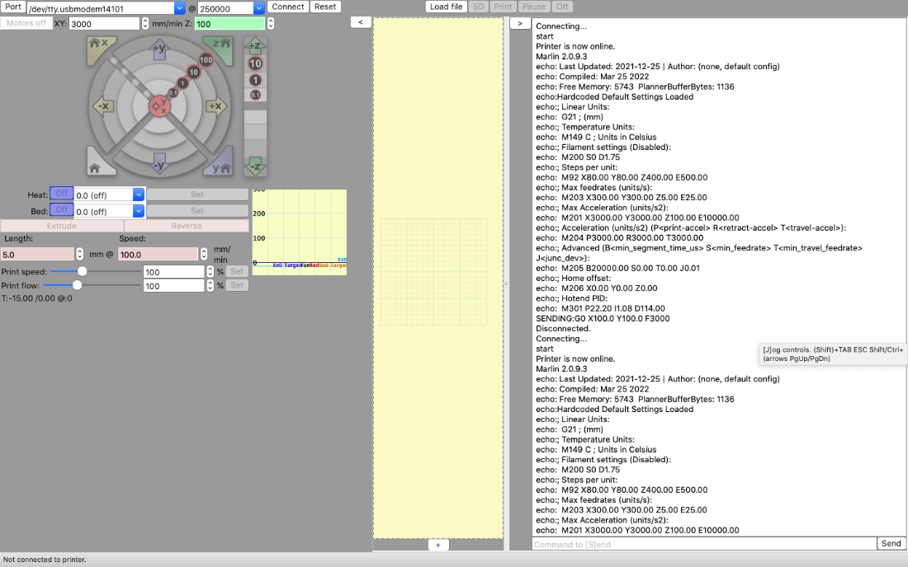
Figure 31: Pronterface Code
Wiring and Code without a Ramps Board
For running this assembly without a ramps board, you will need a Nema 23 stepper motor, L298N Motor Driver, and Arduino Mega. In Figure 32, it shows the wiring diagram for this set up. You will have to ground the motor driver to both power supply and the Arduino board. It will also be hooked up to a positive charge of the power supply apply 12 Volts at 1.2 Amperes. To drive the motor driver then the jumpers must be on both ENA and ENB. The Arduino needs four digital pins to be hooked up to the motor driver. The pins that were chosen are 22-25. Pin 22 is connected to IN1and going down to pin 25 connected to IN4. Lastly, the stepper motor must be connected to the motor driver. Start with A1 being connected to output 1, A2 being connected to output 2, B1 being connected to output 4, and finally B2 being connected to output 3. Once this is all set up the Arduino code must be written to therefore run the motor and cause the arm to move.

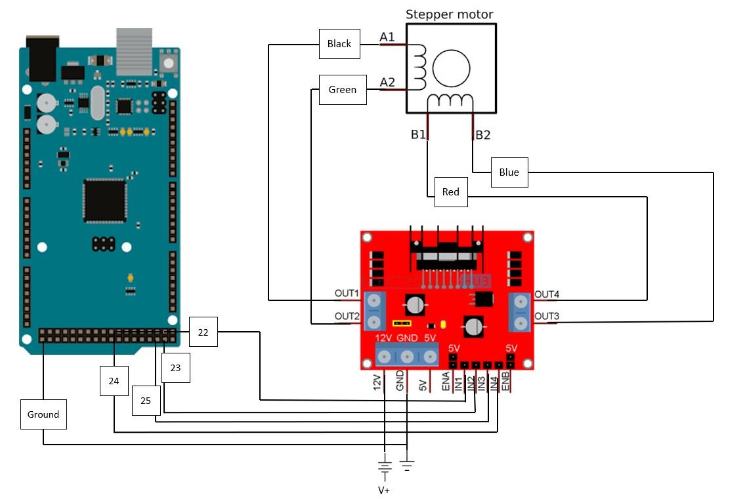Figure 32: Wire Diagram
After the set-up is completed, code must be written so that the motor can move. In Figure 33, it shows the Arduino code that was used to run the motor. The library Stepper.h must be installed and used to run the motor. The code uses a count called ticks to know when to switch the arm from lifting to moving down. After 20 iterations the motor will move back down to go to its original position. This code was used to test the motor and the strength of the gearbox to figure out what alterations need to be made for the final project.
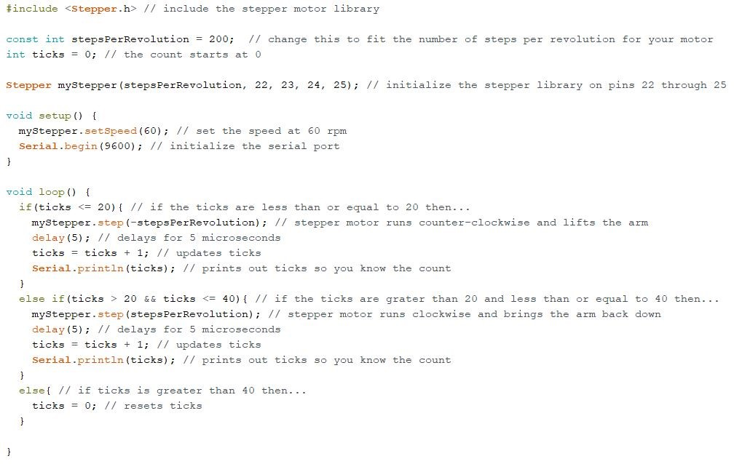Figure 33: Arduino Code

Troubleshooting
With many components, it is important to isolate each system.

Power Supply
The first system to access is the power supply; With a multimeter the voltage and current can be measured. The system is meant to run on 10 Volts and 1.3 Amps.
Make sure your voltage and current falls with the range of the ramps board and motor are manufactured to withstand. Be careful not to exceed the recommended voltage and current given by specification of the ramps board and motor. Exceeding the recommended voltage and current will result in damage to the component and others in the circuit. Keep in mind that current will heat up the components.

Circuit
If the power supply is working, the next system to investigate is the circuit. Be careful on short circuiting the system. This occurs when a positive charged (typically red) wire touches a ground wire (typically black).
Connect the ramps board to the power supply and check the output voltage and current. Make sure the code is uploaded to the Arduino board; if not the RAMPS board will not be able to communicate with the motor effectively.
Once established that the right voltage and current are flowing, turn off the power supply and connect the motor. Make sure the motor wires are connected to the right pins. Also ensure that the wires are properly adhered to the board.
After checking each wire placement, turn on the power supply. The motor should be spinning in the intended direction; A detachable tag (post it note, tape, etc.) can be attached to the shaft to visualize the direction of the motor. If the motor is not spinning in the desired direction, re-check the code and wiring. Note that the motor should be capable of spinning in both directions.

MOTOR
The design is intended for a stepper motor; A DC motor should not be used because it lacks the precision and torque a stepper motor can supply.
The stepper motor shaft should twist easily with force from a hand. If the stepper motor is not twisting with ease, the type of motor should be considered. A stepper motor that has permanent magnets will need more external force (twisting with your hand) than one without. The Nema 23 should twist with the force of a hand.
If the shaft is vibrating or shaking when it is connected, check if it is properly connected. Note that the driver might be overheating; If this is the case, let it cool and try again.
Take note when reading the specification of the motor that the given output torque will vary based on the supplied voltage and current supplied. A calibration can calculate the torque that the motor should be outputting.
Testing the motor’s torque can be conducted with a mount and scale. For this test, the motor should be grounded with a mount; this can be on a sturdy table. Then with an attached lever, the motor should be connected to the ramps board and power supply and powered on. With the lever on top of the scale, the motor will rotate and push down on the scale, resulting a force reading on the scale. The torque can then be calculated.

3D PARTS
Make sure the sun gear fits the motor shaft securely and is not slipping. If slipping occurs, the rest of the gearbox will not rotate; Therefore, check the shape of the hole. The flat surface should align with the motor's flat edge.
Note when 3D printing, holes should be slightly bigger than the required diameter to allow for tolerance. (All files included here have already accounted for this)
If creating STL files from the STEP/Creo files, ensure that your mesh has high resolution and quality; Failure to do so will print out the wrong shapes affecting the motion of the gear set. 3D printed gears will have lipping that need to be filed/sanded down to mesh correctly.

Appendix F: Engineering Drawings

Appendix G: Calculations
First Configuration:
Ring gear
104 teeth
0.75 module
20* pressure angle
Planet gear
40 teeth
0.75 module
20* pressure angle
Sun gear
24 teeth
0.75 module
20* pressure angle
Harmonic gear
101 teeth
0.75 module
20* pressure angle

Ratios:
RPMs = 160
P/S = 24/128
RPMy = 30
H/P = 1/30

Individual Gear Design Calculations:
A = M
PD = N*M
OD = PD + 2*A
BD = PD*cos(PA)
WD = 2.157*M
D = WD-A
RD = OD-(2*WD)
CTT = pi*M/2
FR = 0.38*M

Tooth Profile Equation \ Involute Curve: Specific to Creo
BR=BD/2
X=if(t<0.0,BR*(t+1), BR * cos( t*90) + (((Pi*BR*t)/2) *sin( t*90)))
Z=if(t<0.0,0,BR * sin( t*90) - (((Pi*BR*t)/2) * cos( t*90)))
Y=0

Meshing and Configuration Equations:
R = 2*P + S
(R+S)*RPMy = R*RPMr + RPMs*S
(R+S)/NPG = to a whole number
Angle = 360*n/(R+S)
n = 20 or 21

Rule:
Harmonic gear needs to be at least 3 less teeth than ring gear.

Determining forces on Harmonic gear:
Initial idle measurement based on creo(X1): 7.15mm
Initial X1: 7.77mm
Final X2: 5.68mm
Final_gear X3: 5.5mm
Test_Force Ft: 3.38*9.81 = 33.1578N
Spring force: Fs = k*x
Delta_X1 = X1 - X2 = 2.09mm = 0.00209m
K: 15864.9761 N/m or 15.8649 N/mm
Delta_X2 = X1-X3 = 2.27mm = 0.00227m
Force acting on planetary gears: Fs = 15864.9761*0.00174 = 36.0135N
Static friction: 0.6
Kinetic friction: 0.4
Force of friction on gears

Stepper Motor 1:
τ = Wgl
W = 0.2 kg
g = 9.81 m/s²
l = 90 mm
τ = 0.2 Nm

$$W=\frac{F}{g}$$
F = 0.6 N
g = 9.81 m/s²
W = 0.0612 kg

Stepper Motor 2:
τ = Wgl
W = 2.1 kg
g = 9.81 m/s²
l = 90 mm
τ = 1.85 Nm

$$W=\frac{F}{g}$$
F = 3.6 N
g = 9.81 m/s²
W = 0.567 kg

Appendix H: Risk Assessment
Lab Safety Expectations/ Rules
Senior design projects provide wonderful hands-on experiences for students. The following safety rules will help to ensure every student has a safe, rewarding and valuable educational experience in the lab.
- At least two people should be present in the lab when equipment and/or tools are in use.
- Always ask if you are unsure about something.
- Long pants and closed toed shoes are required in the lab when equipment and/or tools are in use.
- In the event of an injury or exposure to a chemical, regardless of severity, the lab user must report to the instructor and complete an accident report. In the event of serious/severe injuries or exposures call 9-1-1 immediately for medical attention.
- Do not attempt to remove foreign objects from the eye or body. Seek medical attention immediately. If chemicals are splashed into the eyes, utilize an eyewash station to rinse eyes for 15 minutes before seeking medical attention.
- Report any damage or missing parts to tools/equipment to the instructor immediately.
- During repair, cleaning or oiling, machines and equipment MUST be shut off and locked out to ensure unauthorized startup does not occur.
- Neck ties, loose clothing, jewelry, gloves, etc. are prohibited around moving or rotating machinery. Long hair must be tied back or covered to keep it away from moving machinery.
- A brush, hook or specialized tool is preferred for removal of chips, shaving, etc. from work areas. Never use hands to clear work areas.
- Maintain the lab in a clean and orderly manner.
- Keep the floor clean, dry and free from trip and slip hazards.
- Food and drinks are prohibited in the lab.
- Review the Safety Data Sheet (SDS) for all chemicals used.
- Store oily rags in approved containers only.
- Used chemicals should never be poured down the drain or disposed outdoors. Contact Environmental Health & Safety for chemical disposal services.
- Clean up solvent and chemical spills immediately. In the event of a large spill, contact Environmental Health & Safety emergency response team for cleanup services.
- Know the location of the fire extinguisher, eyewash station, first aid kit, and fire escape route for your room.
FAMU-FSU College of Engineering
Project Hazard Assessment Policy and Procedures
INTRODUCTION
University laboratories are not without safety hazards. Those circumstances or conditions that might go wrong must be predicted and reasonable control methods must be determined to prevent incident and injury. The FAMU-FSU College of Engineering is committed to achieving and maintaining safety in all levels of work activities.

PROJECT HAZARD ASSESSMENT POLICY
Principal investigator (PI)/instructor are responsible and accountable for safety in the research and teaching laboratory. Prior to starting an experiment, laboratory workers must conduct a project hazard assessment (PHA) to identify health, environmental and property hazards and the proper control methods to eliminate, reduce or control those hazards. PI/instructor must review, approve, and sign the written PHA and provide the identified hazard control measures. PI/instructor continually monitor projects to ensure proper controls and safety measures are available, implemented, and followed. PI/instructor are required to reevaluate a project anytime there is a change in scope or scale of a project and at least annually after the initial review.

PROJECT HAZARD ASSESSMENT PROCEDURES
It is FAMU-FSU College of Engineering policy to implement followings:
- Laboratory workers (i.e. graduate students, undergraduate students, postdoctoral, volunteers, etc.) performing a research in FAMU-FSU College of Engineering are required to conduct PHA prior to commencement of an experiment or any project change in order to identify existing or potential hazards and to determine proper measures to control those hazards.
- PI/instructor must review, approve and sign the written PHA.
- PI/instructor must ensure all the control methods identified in PHA are available and implemented in the laboratory.
- In the event laboratory personnel are not following the safety precautions, PI/instructor must take firm actions (e.g. stop the work, set a meeting to discuss potential hazards and consequences, ask personnel to review the safety rules, etc.) to clarify the safety expectations.
- PI/instructor must document all the incidents/accidents happened in the laboratory along with the PHA document to ensure that PHA is reviewed/modified to prevent reoccurrence. In the event of PHA modification a revision number should be given to the PHA, so project members know the latest PHA revision they should follow.
- PI/instructor must ensure that those findings in PHA are communicated with other students working in the same laboratory (affected users).
- PI/instructor must ensure that approved methods and precautions are being followed by :
- Performing periodic laboratory visits to prevent the development of unsafe practice.
- Quick reviewing of the safety rules and precautions in the laboratory members meetings.
- Assigning a safety representative to assist in implementing the expectations.
- Etc.
- A copy of this PHA must be kept in a binder inside the laboratory or PI/instructor’s office (if experiment steps are confidential).

Project Hazard Assessment Worksheet
PI/instructor: Dr. Patrick Hollis | Phone #: (850) 410-6319 | Dept.: Mechanical | Start Date: 11/17/2021 | Revision number: 1
Project: T505 RE-RASSOR |  |  | Location(s): FAMU-FSU College of Engineering
Team member(s): Evaline Cantarero, Jackson Davis, Grace Busch, David Nowicki |  |  | Phone #: 4072729828 | Email: rassort505@gmail.com

Experiment Steps | Location | Person assigned | Identify hazards or potential failure points | Control method | PPE | List proper method(s) of hazardous waste disposal, if any. | Residual Risk | Specific rules based on the residual risk
Printing filaments with harmful fumes. | Sr. Design Lab  A212 | GB | Inhalation of harmful fumes | Wearing masks, Keeping the printer in an enclosed glass case. Operating the printer within a properly ventilated environment. | N95 mask | Ventilation | HAZARD: 3  CONSEQ: Significant | Wear N95 Mask
 |  |  |  |  |  |  | Residual: Simple
Hot extruder tips. | Sr. Design Lab  A212 | EC | Burn risk | Be careful around the extruder tip. Wear gloves that can insulate against heat. | gloves | N/A | HAZARD: 2  CONSEQ: Moderate | No touching extruder
 |  |  |  |  |  |  | Residual: Moderate
Hot soldering iron | Sr. Design Lab  A212 | JD | Burn risk | Be careful around the extruder tip. Wear gloves that can insulate against heat. | gloves | N/A | HAZARD: 2  CONSEQ: Moderate | No touching front of soldering iron
 |  |  |  |  |  |  | Residual: Moderate
Documentation, report, and code writing | All locations | DN | Carpal tunnel | Proper pacing of typing, preferably a break every hour. | Wrist rest | N/A | HAZARD: 1  CONSEQ: Negligible | No typing for more than one hour at a time
 |  |  |  |  |  |  | Residual: Simple
Strength testing parts | Sr. Design Lab  A212 | DN | Shrapnel hitting eyes from parts breaking. Pinching | Wearing Safety goggles and staying a safe distance away from the test.  Closed-toed shoes, pants, put hair up. | goggles, hair ties, closed-toed shoes, pants. | N/A | HAZARD: 3  CONSEQ: Significant  Residual: Difficult | Standing a certain distance away from the testing area
Drilling Screws in | Sr. Design Lab  A212 | EC | The drill penetrating a body part | Using the drill as properly intended, and keeping your fingers and hands at a safe distances | gloves | N/A | HAZARD: 3  CONSEQ: Significant  Residual: Difficult | Be mindful where the drill is drilling through and where in relation the fingers are
Sanding/Dremill | Sr.  Design  Lab  A212 | EC | Sanding of the skin | While using the demil, make sure you don't inhale the materials and your eyes are protected from debris. | Mask and goggles and gloves | N/A | HAZARD: 3  CONSEQ: Significant  Residual: Difficult | Be mindful of what the sander is sanding. Do not sand your skin.
Principal investigator(s)/ instructor PHA: I have reviewed and approved the PHA worksheet.
Team members: I certify that I have reviewed the PHA worksheet, am aware of the hazards, and will ensure the control measures are followed.
Copy this page if more space is needed.

DEFINITIONS:
Hazard: Any situation, object, or behavior that exists, or that can potentially cause ill health, injury, loss or property damage e.g. electricity, chemicals, biohazard materials, sharp objects, noise, wet floor, etc. OSHA defines hazards as “any source of potential damage, harm or adverse health effects on something or someone". A list of hazard types and examples are provided in appendix A.
Hazard control: Hazard control refers to workplace measures to eliminate/minimize adverse health effects, injury, loss, and property damage. Hazard control practices are often categorized into following three groups (priority as listed):
- Engineering control: physical modifications to a process, equipment, or installation of a barrier into a system to minimize worker exposure to a hazard. Examples are ventilation (fume hood, biological safety cabinet), containment (glove box, sealed containers, barriers), substitution/elimination (consider less hazardous alternative materials), process controls (safety valves, gauges, temperature sensor, regulators, alarms, monitors, electrical grounding and bonding), etc.
- Administrative control: changes in work procedures to reduce exposure and mitigate hazards. Examples are reducing scale of process (micro-scale experiments), reducing time of personal exposure to process, providing training on proper techniques, writing safety policies, supervision, requesting experts to perform the task, etc.
- Personal protective equipment (PPE): equipment worn to minimize exposure to hazards. Examples are gloves, safety glasses, goggles, steel toe shoes, earplugs or muffs, hard hats, respirators, vests, full body suits, laboratory coats, etc.
Team member(s): Everyone who works on the project (i.e. grads, undergrads, postdocs, etc.). The primary contact must be listed first and provide phone number and email for contact.
Safety representative: Each laboratory is encouraged to have a safety representative, preferably a graduate student, in order to facilitate the implementation of the safety expectations in the laboratory. Duties include (but are not limited to):
- Act as a point of contact between the laboratory members and the college safety committee members.
- Ensure laboratory members are following the safety rules.
- Conduct periodic safety inspection of the laboratory.
- Schedule laboratory clean up dates with the laboratory members.
- Request for hazardous waste pick up.
Residual risk: Residual Risk Assessment Matrix are used to determine project’s risk level. The hazard assessment matrix (table 1) and the residual risk assessment matrix (table2) are used to identify the residual risk category.
The instructions to use hazard assessment matrix (table 1) are listed below:
- Define the workers familiarity level to perform the task and the complexity of the task.
- Find the value associated with familiarity/complexity (1 – 5) and enter value next to: HAZARD on the PHA worksheet.
Table 1. Hazard assessment matrix.
 |  | Complexity
 |  | Simple | Moderate | Difficult
Familiarity Level | Very Familiar | 1 | 2 | 3
 | Somewhat Familiar | 2 | 3 | 4
 | Unfamiliar | 3 | 4 | 5

The instructions to use residual risk assessment matrix (table 2) are listed below:
- Identify the row associated with the familiarity/complexity value (1 – 5).
- Identify the consequences and enter value next to: CONSEQ on the PHA worksheet. Consequences are determined by defining what would happen in a worst case scenario if controls fail.
- Negligible: minor injury resulting in basic first aid treatment that can be provided on site.
- Minor: minor injury resulting in advanced first aid treatment administered by a physician.
- Moderate: injuries that require treatment above first aid but do not require hospitalization.
- Significant: severe injuries requiring hospitalization.
- Severe: death or permanent disability.
- Find the residual risk value associated with assessed hazard/consequences: Low –Low Med – Med– Med High – High.
- Enter value next to: RESIDUAL on the PHA worksheet.
Table 2. Residual risk assessment matrix.
Assessed Hazard Level | Consequences
 | Negligible | Minor | Moderate | Significant | Severe
5 | Low Med | Medium | Med High | High | High
4 | Low | Low Med | Medium | Med High | High
3 | Low | Low Med | Medium | Med High | Med High
2 | Low | Low Med | Low Med | Medium | Medium
1 | Low | Low | Low Med | Low Med | Medium

Specific rules for each category of the residual risk:
Low:
- Safety controls are planned by both the worker and supervisor.
- Proceed with supervisor authorization.
Low Med:
- Safety controls are planned by both the worker and supervisor.
- A second worker must be in place before work can proceed (buddy system).
- Proceed with supervisor authorization.
Med:
- After approval by the PI, a copy must be sent to the Safety Committee.
- A written Project Hazard Control is required and must be approved by the PI before proceeding. A copy must be sent to the Safety Committee.
- A second worker must be in place before work can proceed (buddy system).
- Limit the number of authorized workers in the hazard area.
Med High:
- After approval by the PI, the Safety Committee and/or EHS must review and approve the completed PHA.
- A written Project Hazard Control is required and must be approved by the PI and the Safety Committee before proceeding.
- Two qualified workers must be in place before work can proceed.
- Limit the number of authorized workers in the hazard area.
High:
- The activity will not be performed. The activity must be redesigned to fall in a lower hazard category.

Appendix A: Hazard types and examples
Types of Hazard | Example
Physical hazards | Wet floors, loose electrical cables objects protruding in walkways or doorways
Ergonomic hazards | Lifting heavy objects Stretching the body  Twisting the body  Poor desk seating
Psychological hazards | Heights, loud sounds, tunnels, bright lights
Environmental hazards | Room temperature, ventilation contaminated air, photocopiers, some office plants acids
Hazardous substances | Alkalis solvents
Biological hazards | Hepatitis B, new strain influenza
Radiation hazards | Electric welding flashes Sunburn
Chemical hazards | Effects on central nervous system, lungs, digestive system, circulatory system, skin, reproductive system. Short term (acute) effects such as burns, rashes, irritation, feeling unwell, coma and death.  Long term (chronic) effects such as mutagenic (affects cell structure), carcinogenic (cancer), teratogenic (reproductive effect), dermatitis of the skin, and occupational asthma and lung damage.
Noise | High levels of industrial noise will cause irritation in the short term, and industrial deafness in the long term.
Temperature | Personal comfort is best between temperatures of 16°C and 30°C, better between 21°C and 26°C.  Working outside these temperature ranges: may lead to becoming chilled, even hypothermia (deep body cooling) in the colder temperatures, and may lead to dehydration, cramps, heat exhaustion, and hyperthermia (heat stroke) in the warmer temperatures.
Being struck by | This hazard could be a projectile, moving object or material. The health effect could be lacerations, bruising, breaks, eye injuries, and possibly death.
Crushed by | A typical example of this hazard is tractor rollover. Death is usually the result
Entangled by | Becoming entangled in machinery. Effects could be crushing, lacerations, bruising, breaks amputation and death.
High energy sources | Explosions, high pressure gases, liquids and dusts, fires, electricity and sources such as lasers can all have serious effects on the body, even death.
Vibration | Vibration can affect the human body in the hand arm with `white-finger' or Raynaud's Syndrome, and the whole body with motion sickness, giddiness, damage to bones and audits, blood pressure and nervous system problems.
Slips, trips and falls | A very common workplace hazard from tripping on floors, falling off structures or down stairs, and slipping on spills.
Radiation | Radiation can have serious health effects. Skin cancer, other cancers, sterility, birth deformities, blood changes, skin burns and eye damage are examples.
Physical | Excessive effort, poor posture and repetition can all lead to muscular pain, tendon damage and deterioration to bones and related structures
Psychological | Stress, anxiety, tiredness, poor concentration, headaches, back pain and heart disease can be the health effects
Biological | More common in the health, food and agricultural industries. Effects such as infectious disease, rashes and allergic response.

Project Hazard Control- For Projects with Medium and Higher Risks
Name of Project: |  |  | Date of submission:
Team member | Phone number |  | e-mail
Grace Busch | (850) 377-0725 |  | gpb18@my.fsu.edu
Evaline Cantarero | (407) 272-9828 |  | esc18c@my.fsu.edu
Jackson Davis | (904) 629-8055 |  | jsd18bs@my.fsu.edu
David Nowicki | (303) 250-9832 |  | dpn17@my.fsu.edu
Faculty mentor | Phone number |  | e-mail
Dr. Patrick Hollis | (850) 410-6319 |  | hollis@eng.famu.fsu.edu
Dr. Shayne McConomy | (850) 410-6624 |  | smcconomy@eng.famu.fsu.edu
Rewrite the project steps to include all safety measures taken for each step or combination of steps. Be specific (don’t just state “be careful”).
To ensure not breathing harmful fumes, 3D printing will take place in a ventilated place while wearing a mask. While 3D printing, the hot tip will not be touched with bare hands. When using the soldering tools, do not touch the hot side of the iron when the tool is on. When writing reports and code, make sure to take breaks to avoid hand cramping. When building prototypes, stay cautious with your hands, hair, and losing clothing to avoid clamping and pitching of the gears and parts.
Thinking about the accidents that have occurred or that you have identified as a risk, describe emergency response procedures to use.
If minor burns occur, run cool tap water over the affected area. If a more serious burn happens, visit a physician. If shrapnel gets in your eyes go to the emergency room. If fumes are inhaled, get to fresh air immediately. Report the incident to Dr. Shayne McConomy.
List emergency response contact information:
- Call 911 for injuries, fires or other emergency situations
- Call your department representative to report a facility concern
Name | Phone number | Faculty or other COE emergency contact | Phone number
Grace Busch | (850) 377-0725 | Dr. Patrick Hollis | (850) 410-6319
Evaline Cantarero | (407) 272-9828 | Dr. Shayne McConomy | (850) 410-6624
Jackson Davis | (904) 629-8055
David Nowicki | (303) 250-9832
Safety review signatures
Team member | Date | Faculty mentor | Date
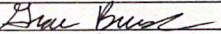 | 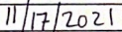 | 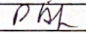
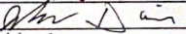 | 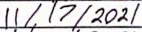
 | 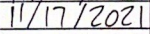
Report all accidents and near misses to the faculty mentor.

